# Advanced Generators and Coroutines in Python 3

## Generators

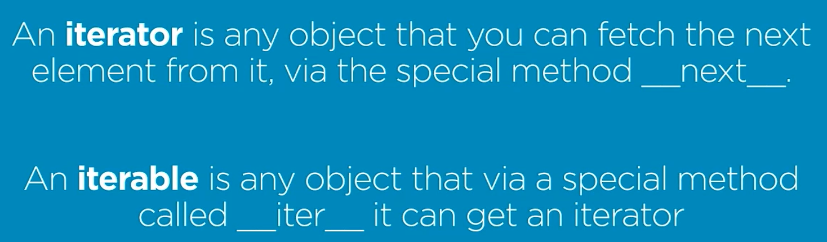

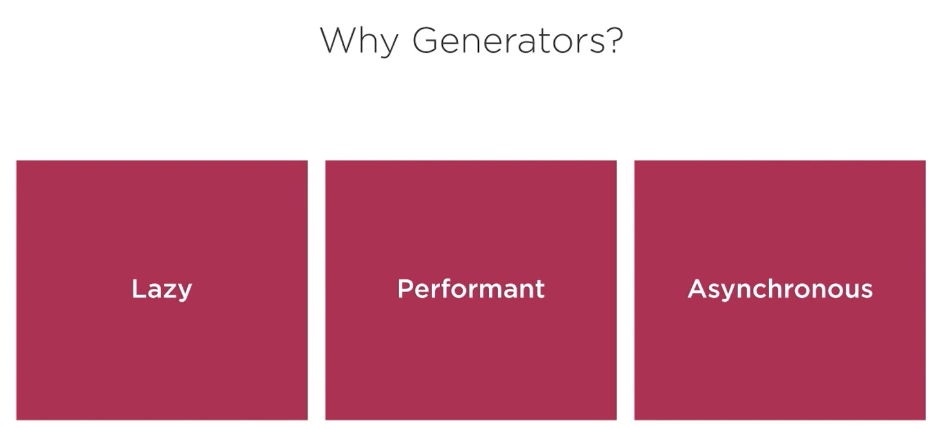

**A generator is any python function that has yield statement.**

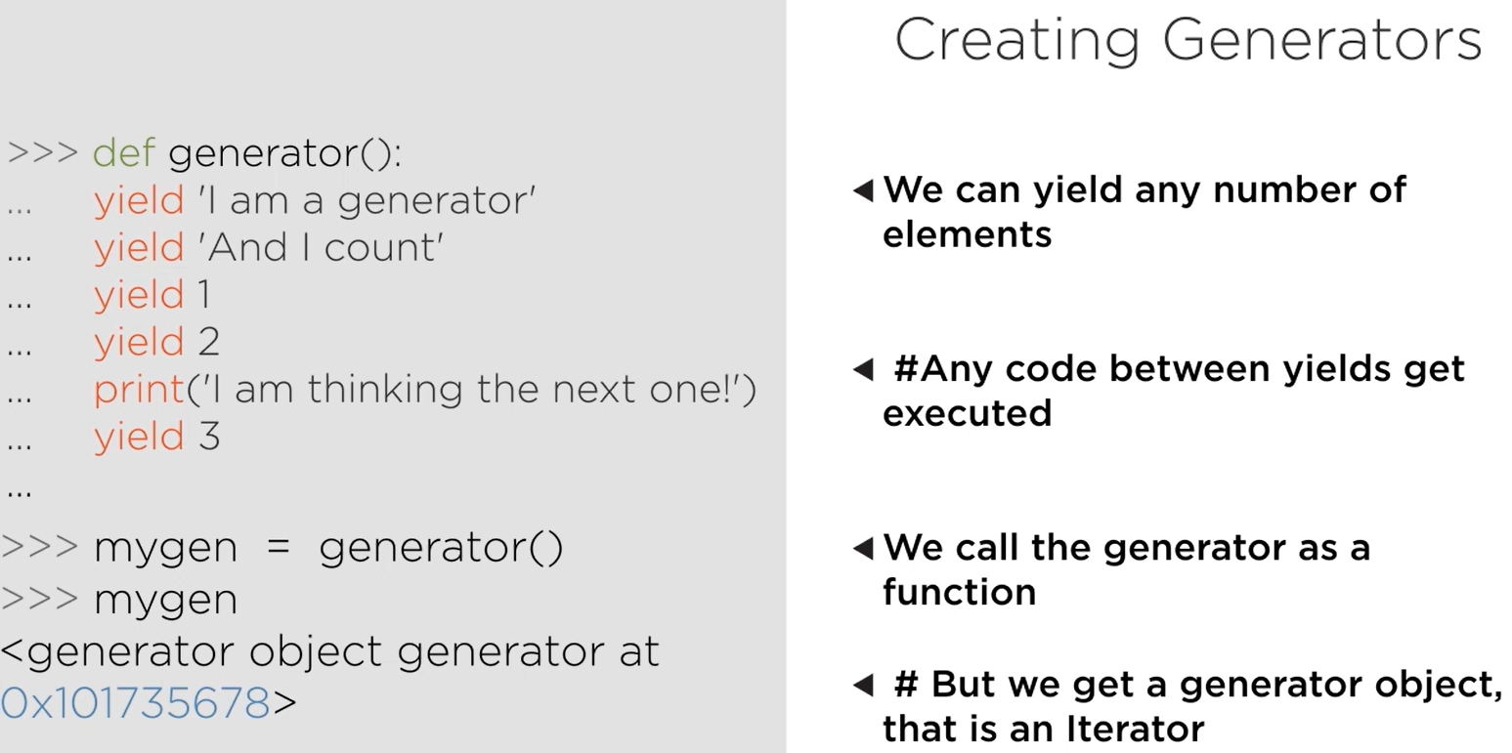

Generator Expression:

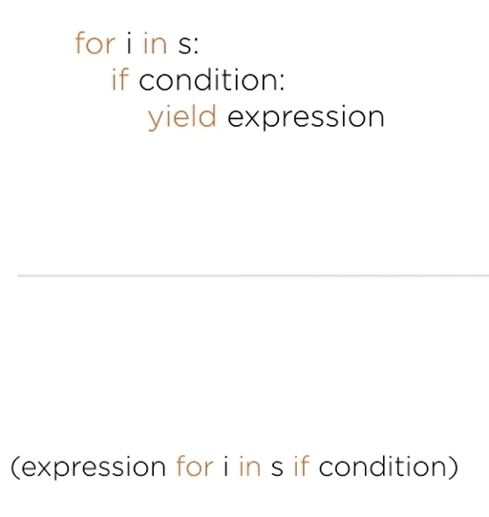

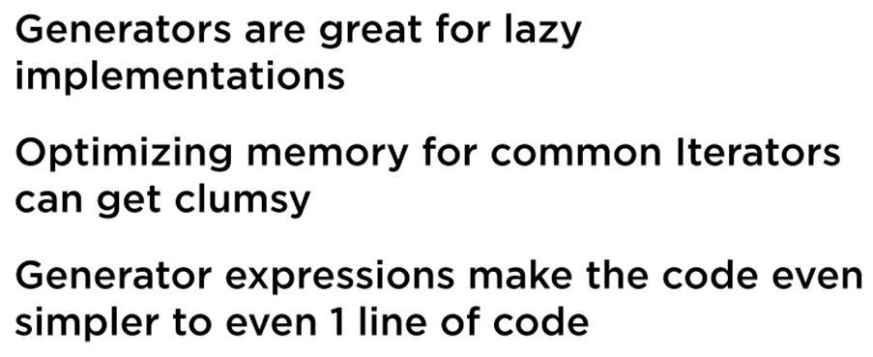

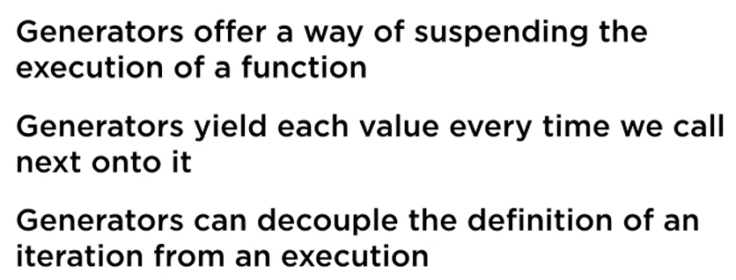

## Generator Based Data Pipeline

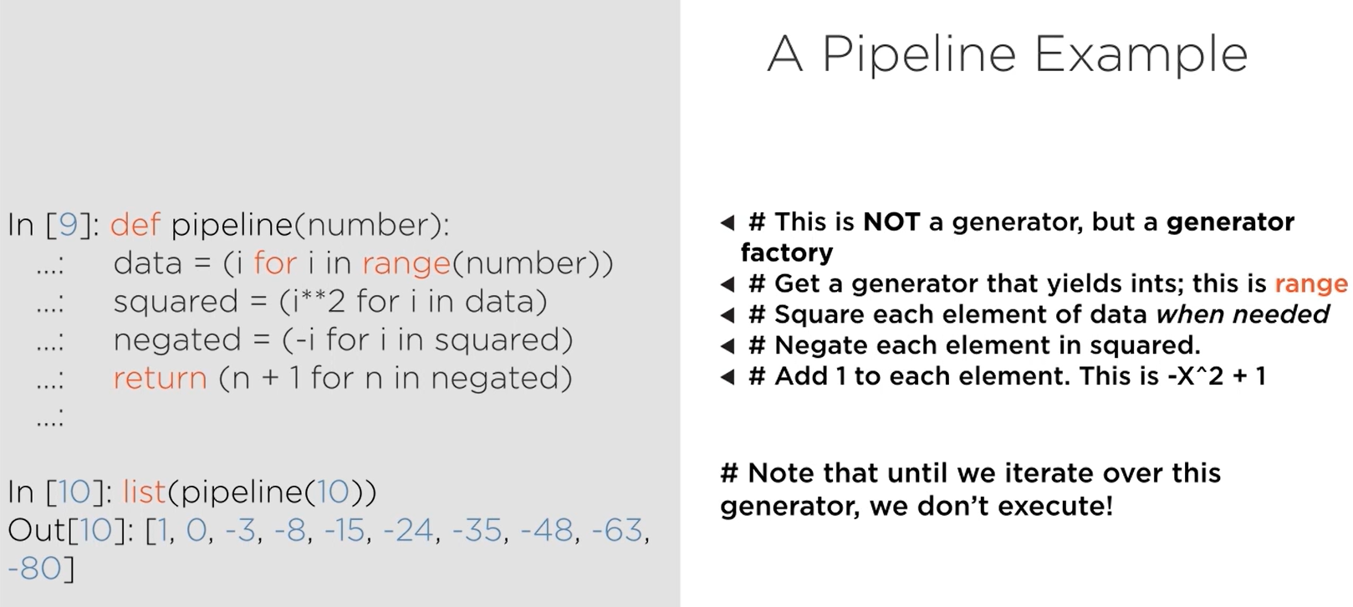

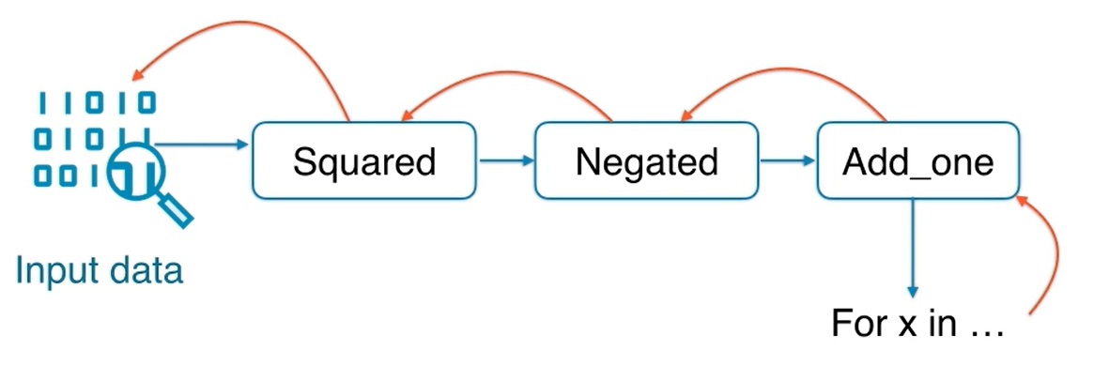

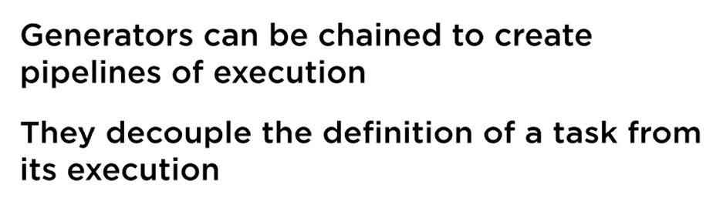

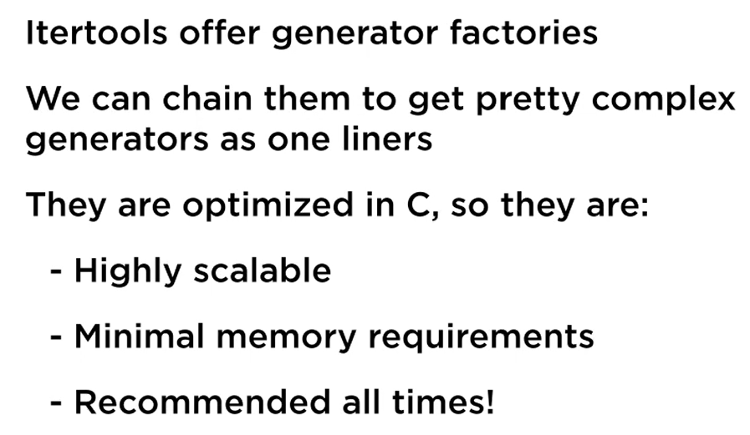

## Generators Counterpart: Coroutines

Beyond the scope of this doc

# Unit Testing with Python 3

## Unit Test Fundamentals

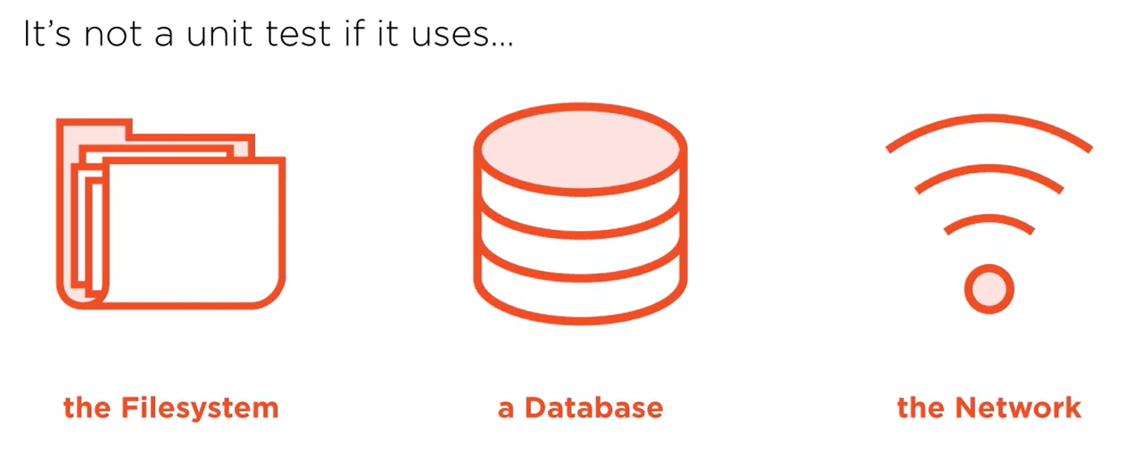

Problem Statement:

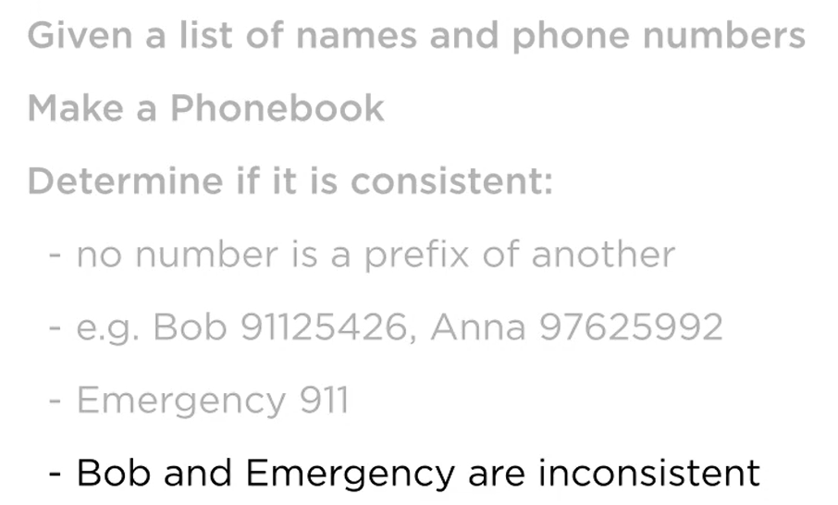

Refer folder unit_test.

To run the test, make sure pwd has the test file and then execute this at terminal:

python -m unittest

python -m pytest

You can also take advantage of built in test runner in VSCode for running tests.

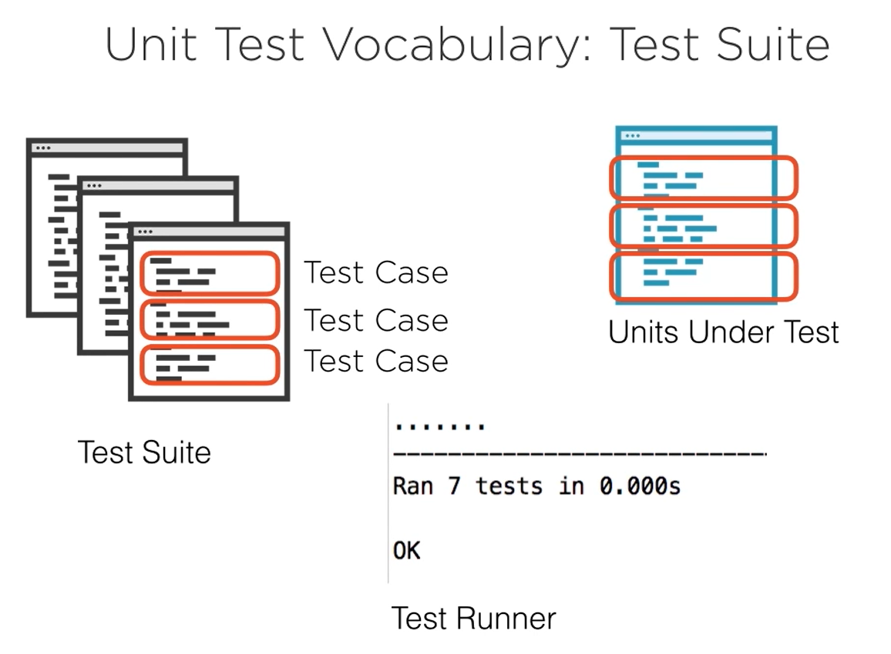

Test Suite can be made up of multiple test cases from several different classes.

Skip a unit test from being executed by annotating the test with:

**@unittest.skip(“reason”)**

method setUp() called before every test method in the class (can be used for data setup for every test, resource allocation)

method tearDown() called after every test method in the class (can be used to release resources that were set up in setup method like database connection, file resource, etc)

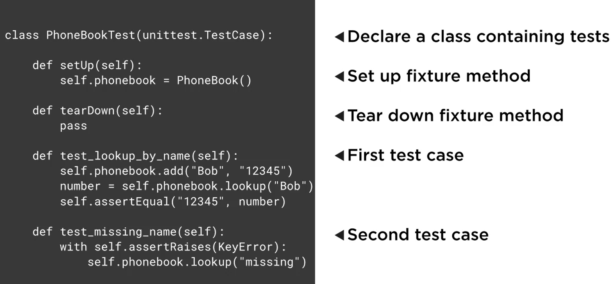

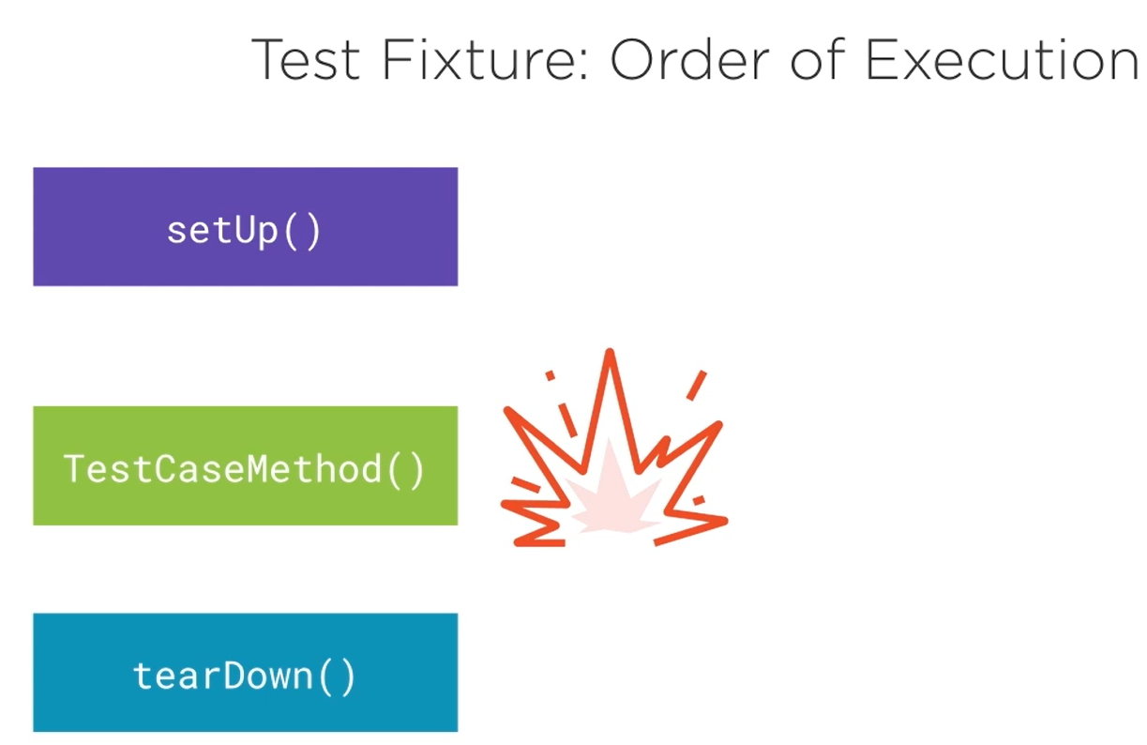

If there is any error in setUp method, none of the other methods will be called

If there is error in the TestCaseMethod, teardown method will still be called

While designing test case, do not test multiple things in one test case (do not try to club more than one scenario in a test case)

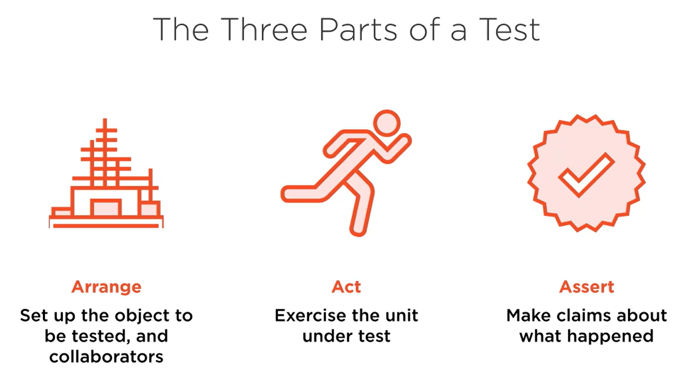

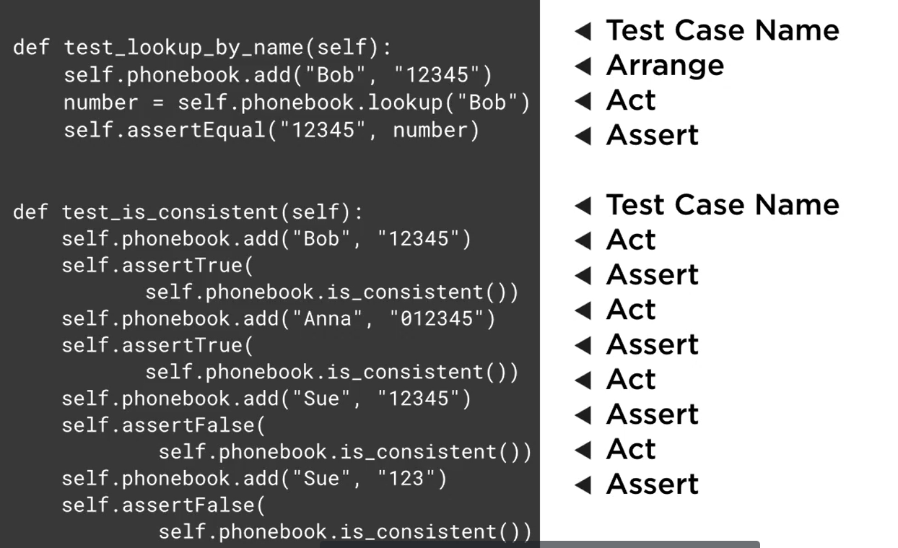

The first example has a good design, the second one has bad design.

## Unit Testing Why and When

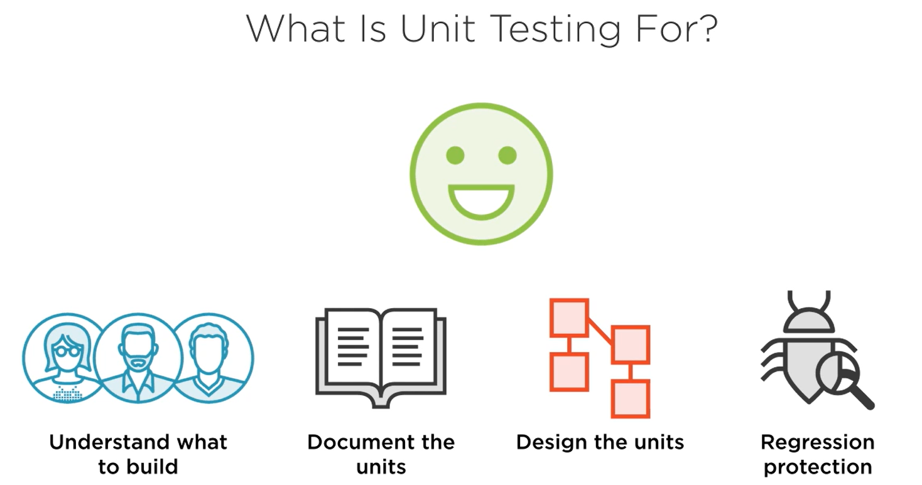

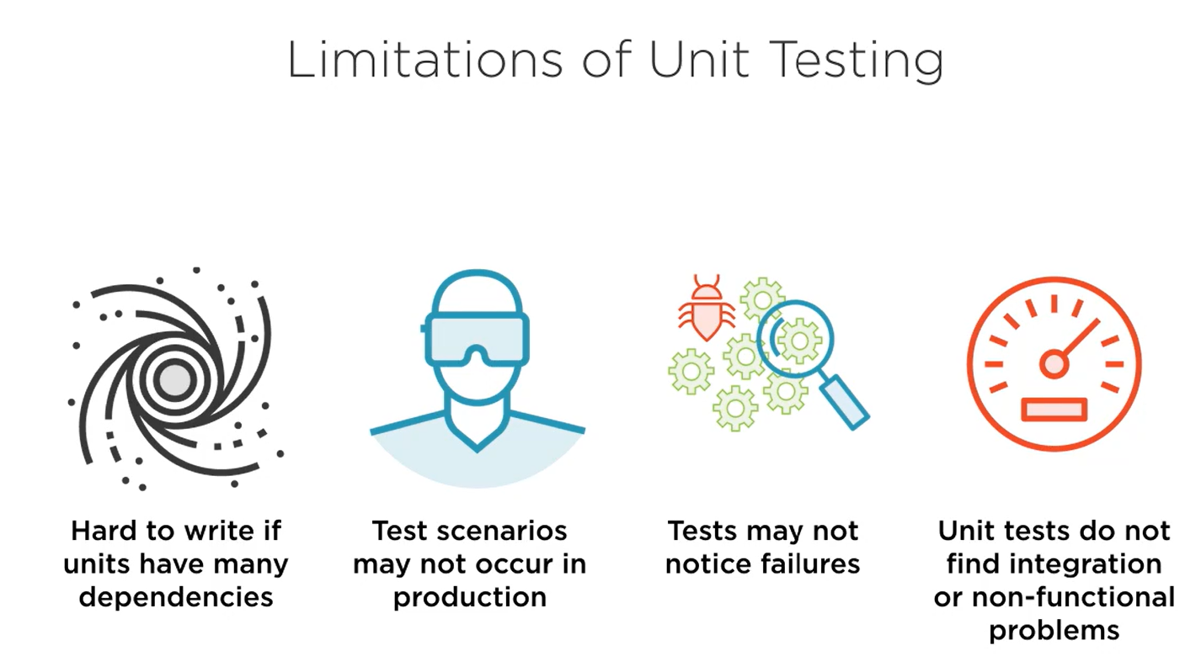

When to write tests

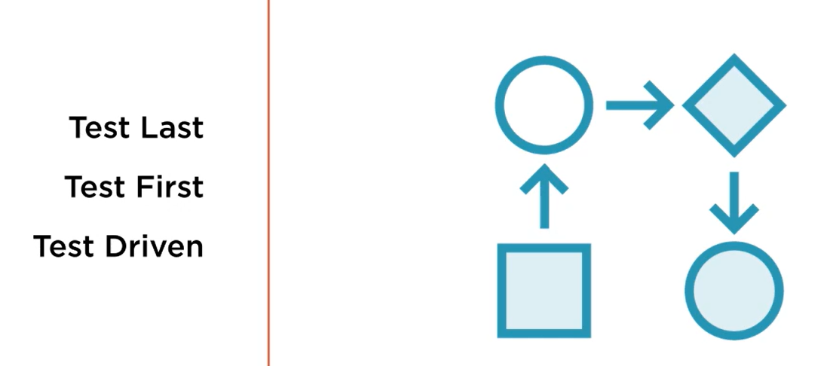

### Test Last

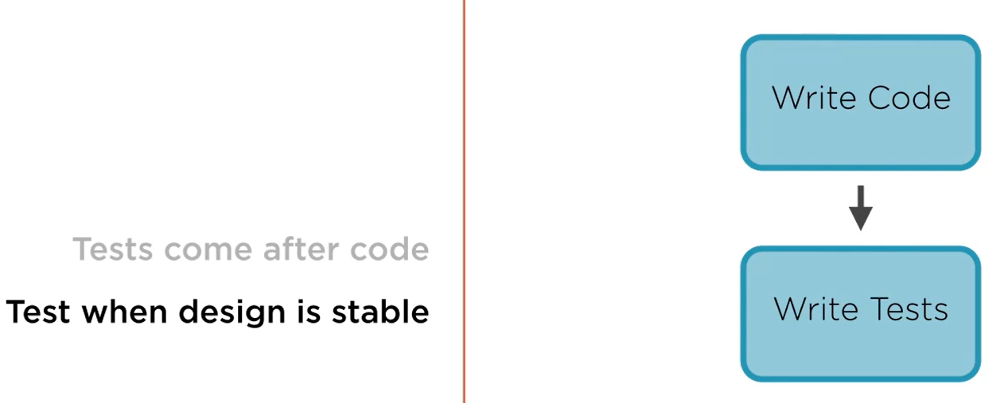

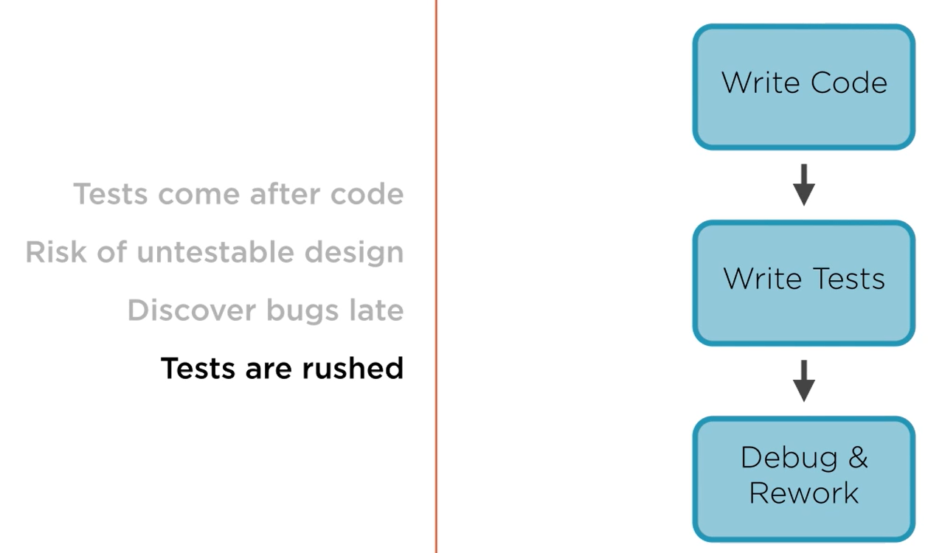

### Test First

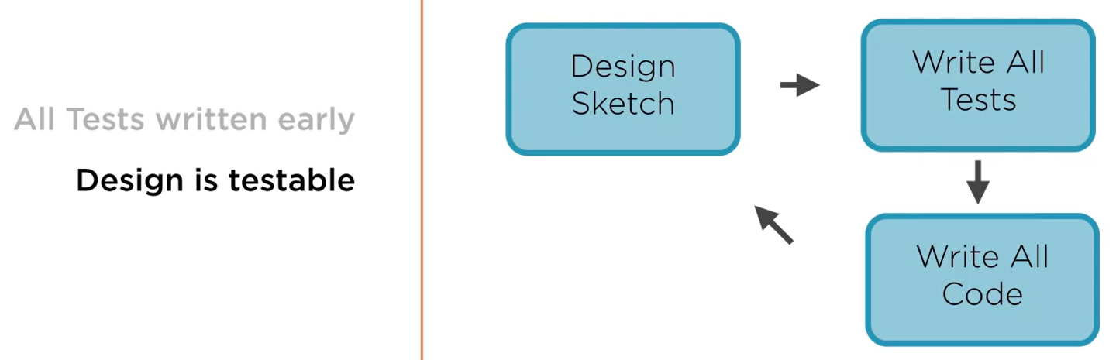

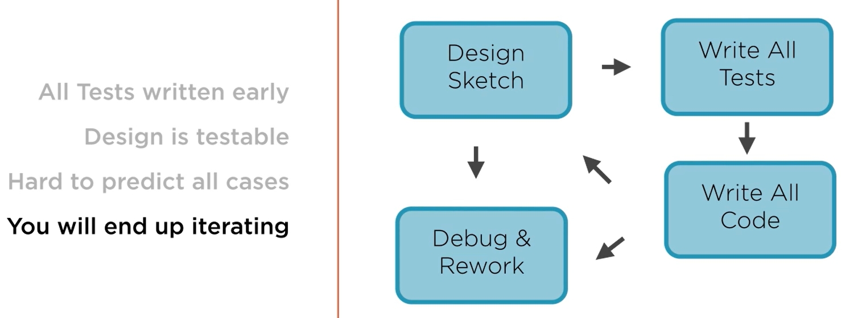

### Test Driven Development

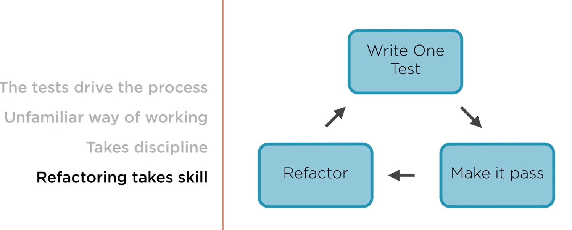

## Unit Testing with pytest

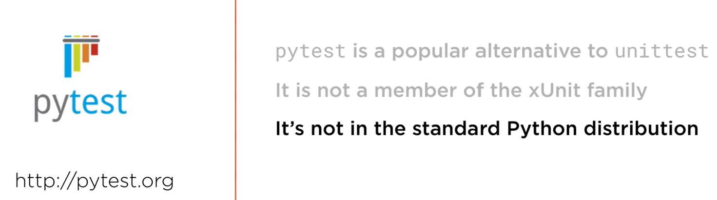

To run the test, make sure pwd has the test file and then execute this at terminal:

python -m pytest

You can also take advantage of built in test runner in VSCode for running tests.

### Test Fixture

In unittest:

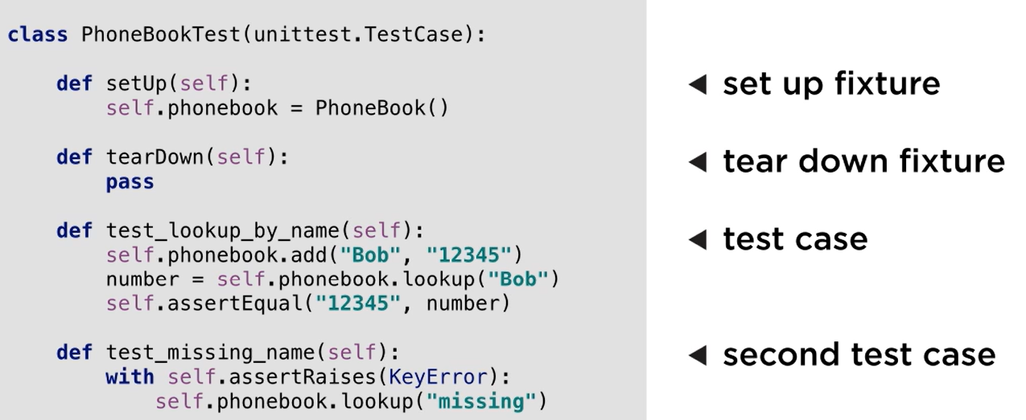

In pytest:

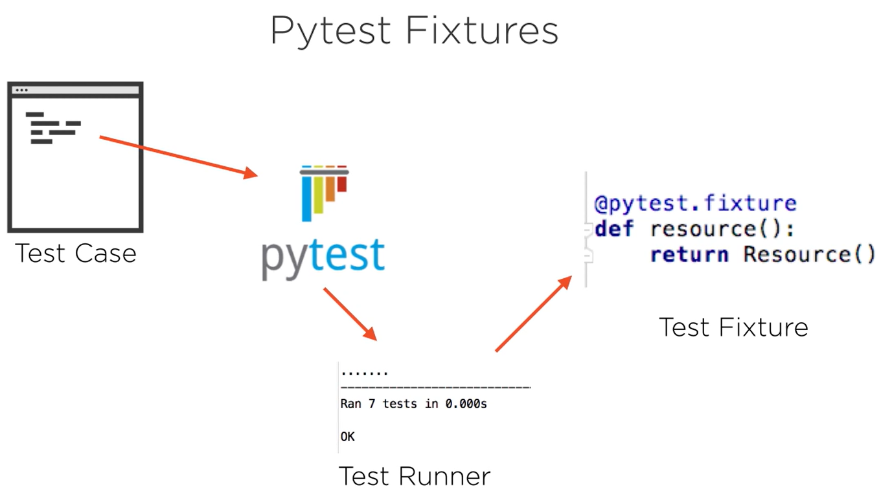

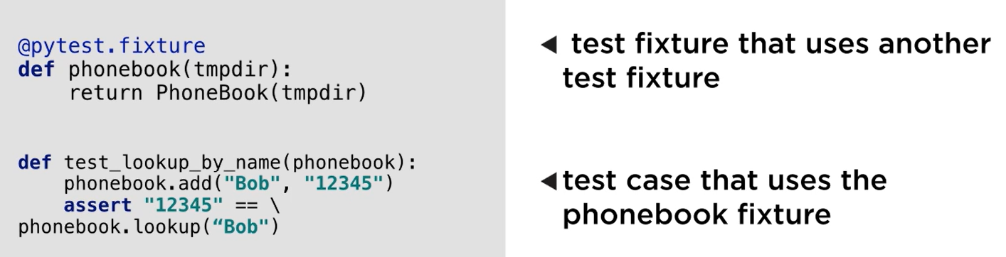

To get a list of fixtures supported by pytest, run the following command:

**pytest –fixtures**

**There is a way to parametrize a fixture, which can be found in test_example.py.**

### Organizing Test Code for larger Programs

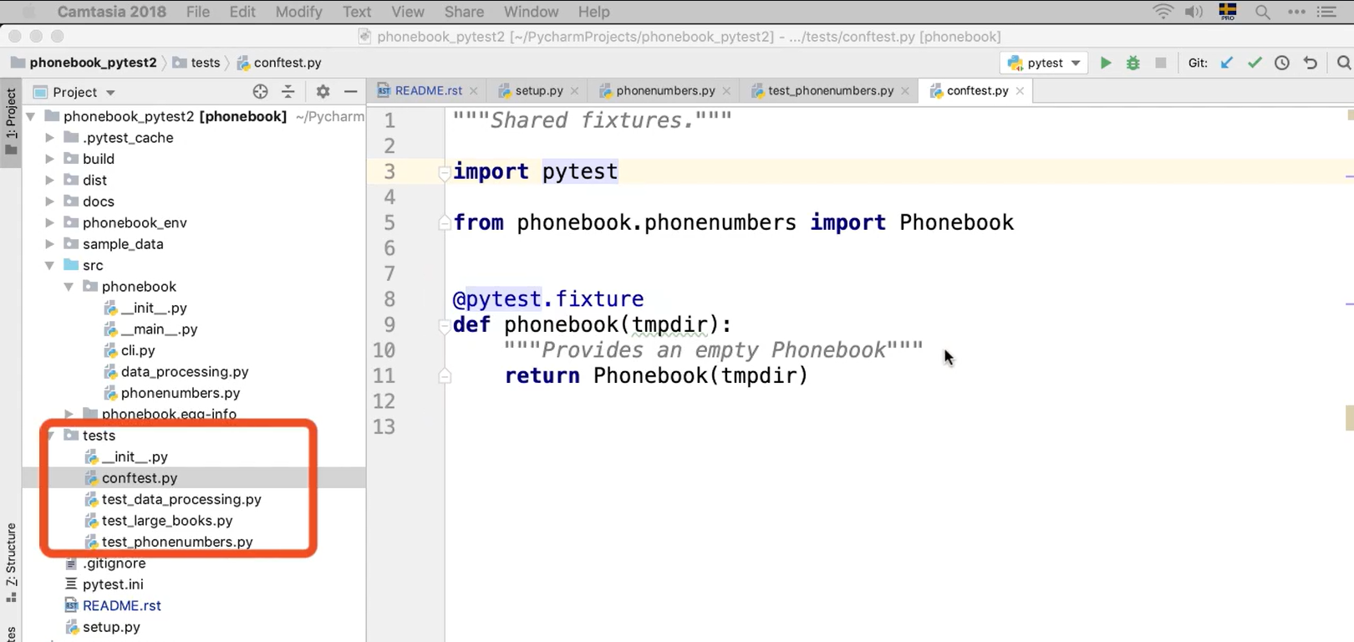

conftest.py is a file which contains all the fixtures and the fixtures defined here are accessible to all the files in this folder as well as sub-folders.

|  |  |  |
| --- | --- | --- |
|  | **unittest** | **pytest** |
| **Test Fixture** | Methods:   * setup() * tearDown() | Chart  Description automatically generated  Use resource as argument in the test methods  To get all the fixtures, run:  **pytest --fixtures** |
| **Skip Test** | @unittest.skip(“reason”) | @pytest.mark.skip(“reason”)  @pytest.mark.skipif(condition, “reason”)  Use markers  To get all markers, run  **python -m pytest --markers** |

## Testable documentation with doctest

Refer folder YatzyGameWithDocTest

To run doctest, execute either of the following:

* python -m doctest <filename_with_extension> -v
* python -m pytest --doctest-modules

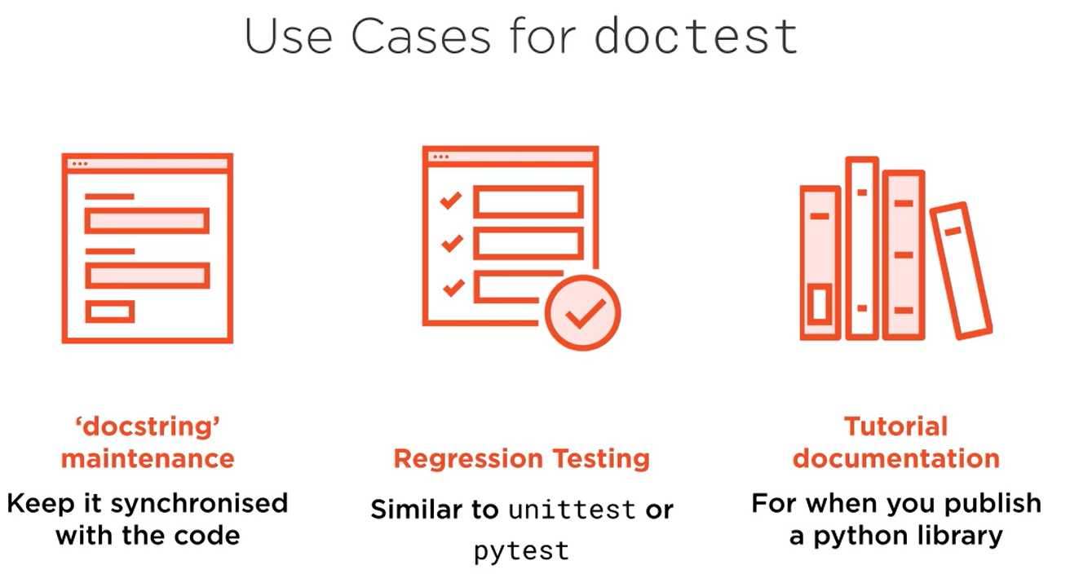

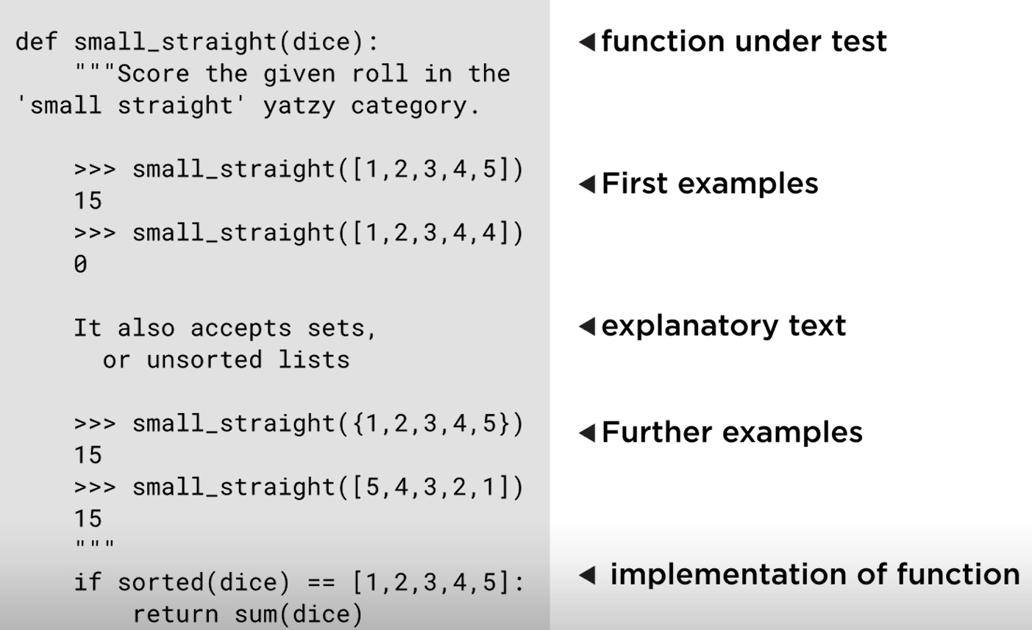

There is more to this section which I think Is not required at the moment.

Handling Output that Varies using a Wildcard

Handling Random Numbers

## Using Test Doubles: Mocks, Stubs & Fakes

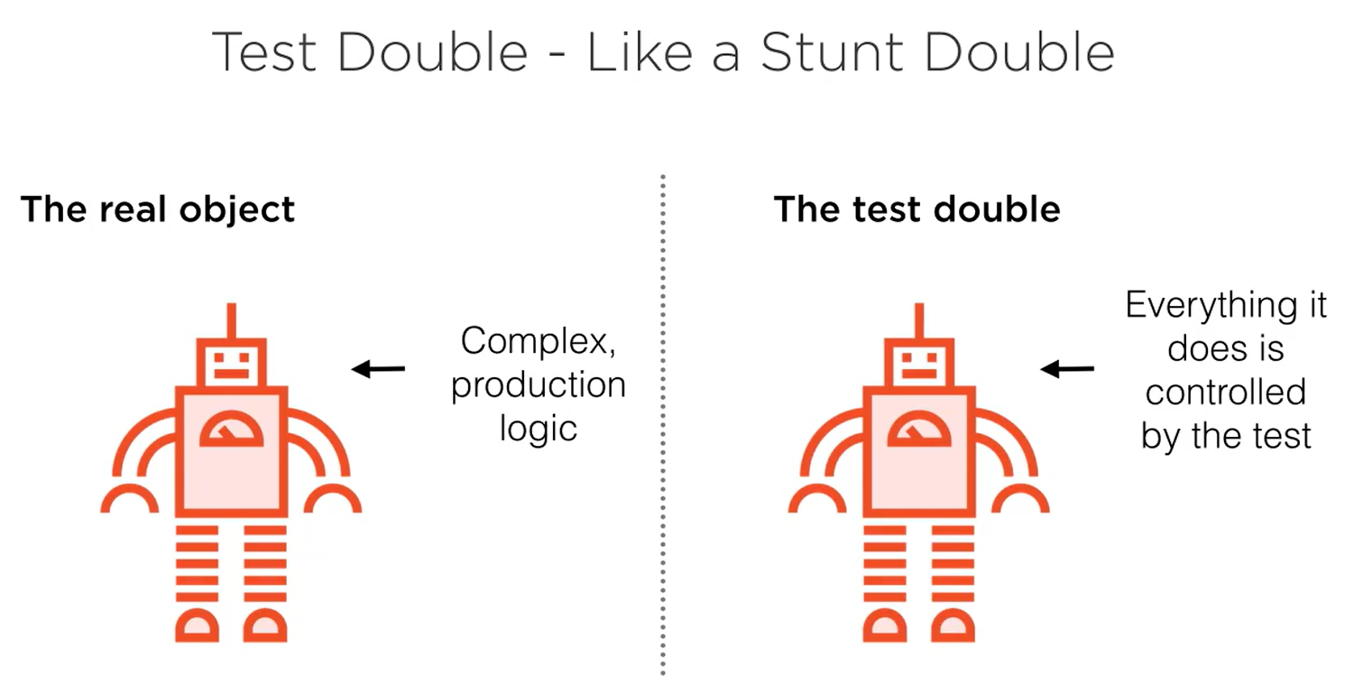

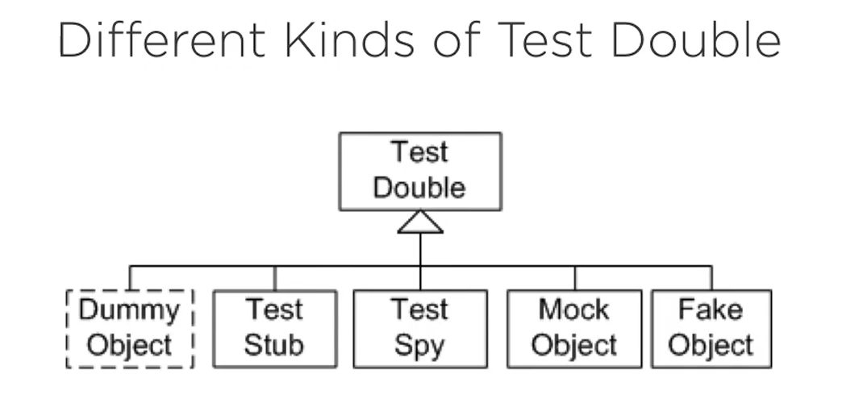

dummy is None

stub, spy, mock are all similar and created using unitest.Mock

fake is more similar to exact implementation

Refer folder TirePressure

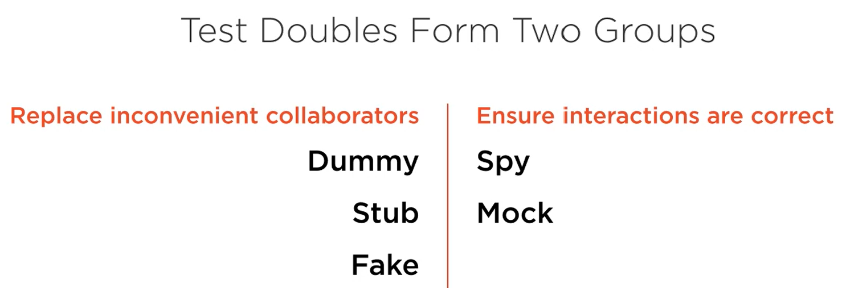

### Stub

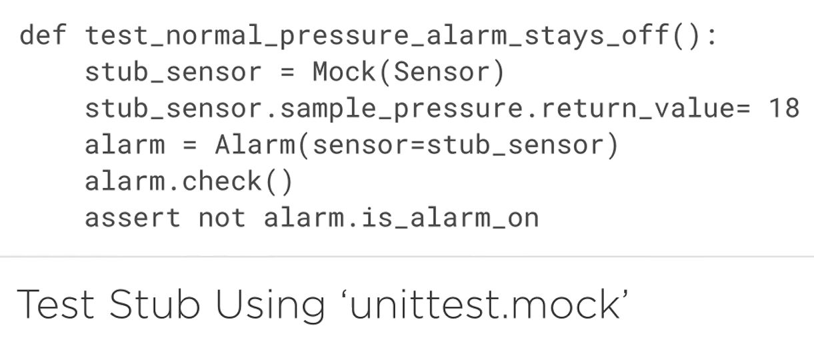

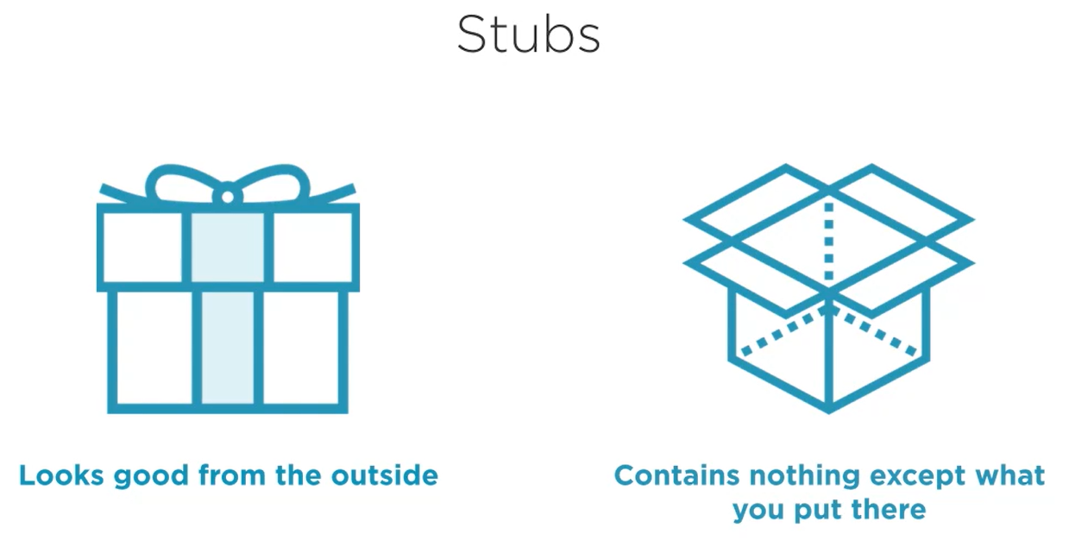

### Fake

When there are a lot of methods, stub does not make a lot of sense as you will have to take care of all the methods. Fakes make it easier.

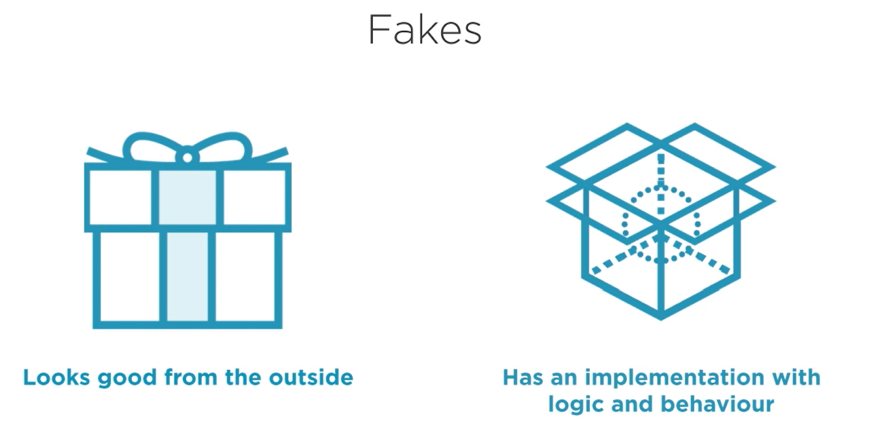

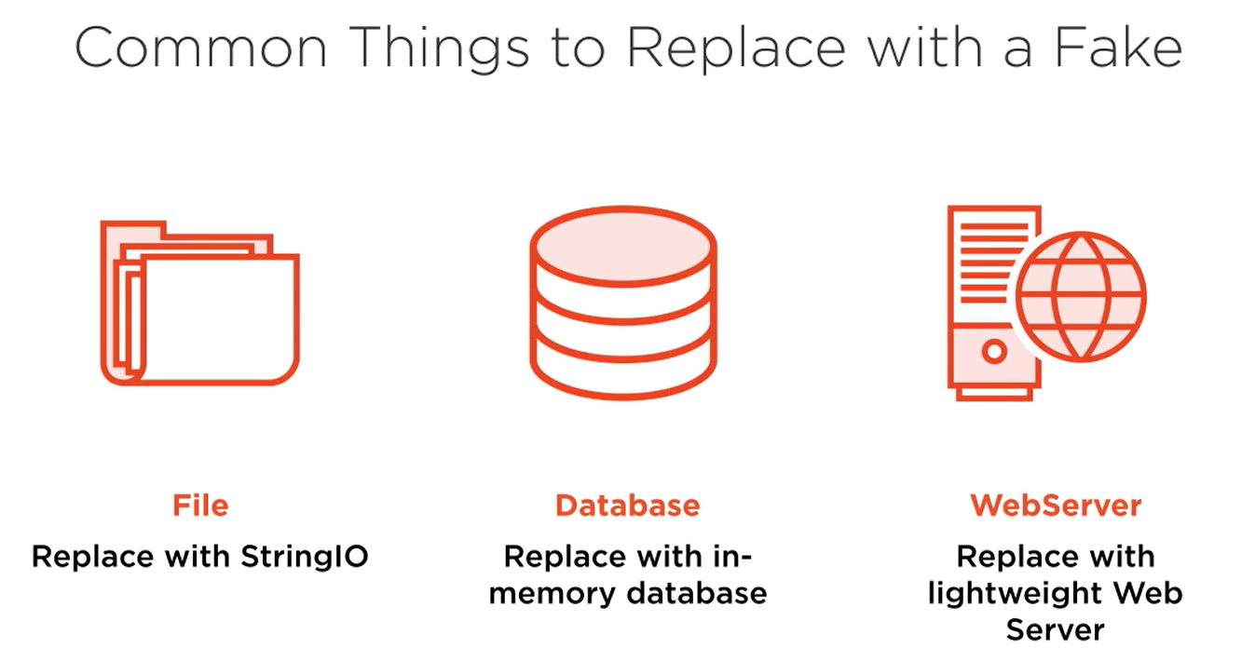

### Dummy

You use a dummy when you are forced to pass an argument to the method or function on the test, but that collaborator isn’t used in the scenario you are testing.

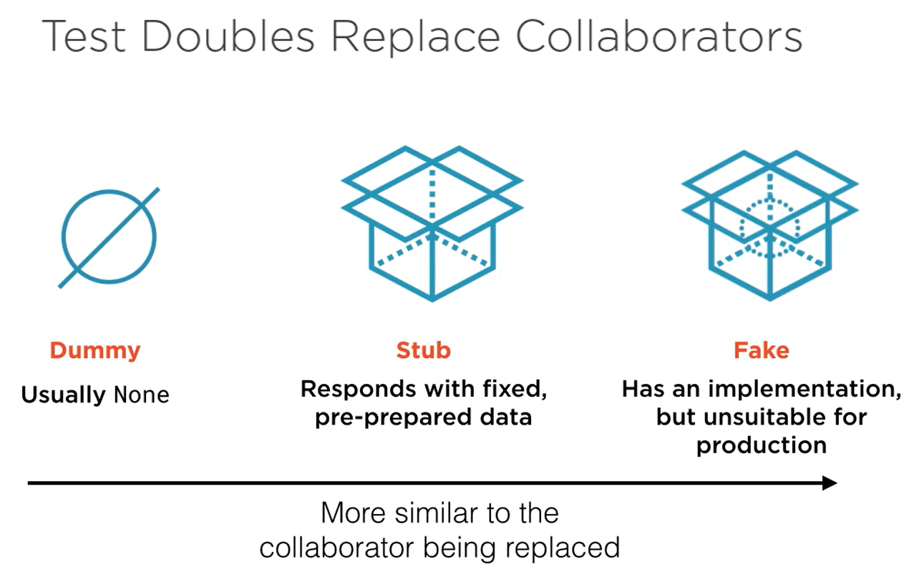

### Spies

Spy acts exactly like spy. Verifies if a method was called in another method that is being tested.

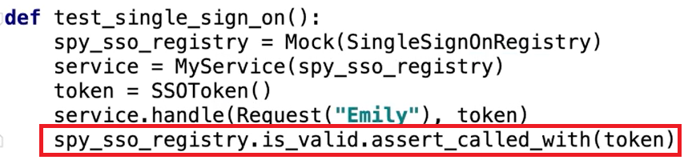

Here, we are trying to testing the method handle but we do want to make sure that the method is_valid is called with argument token while executing the handle method.

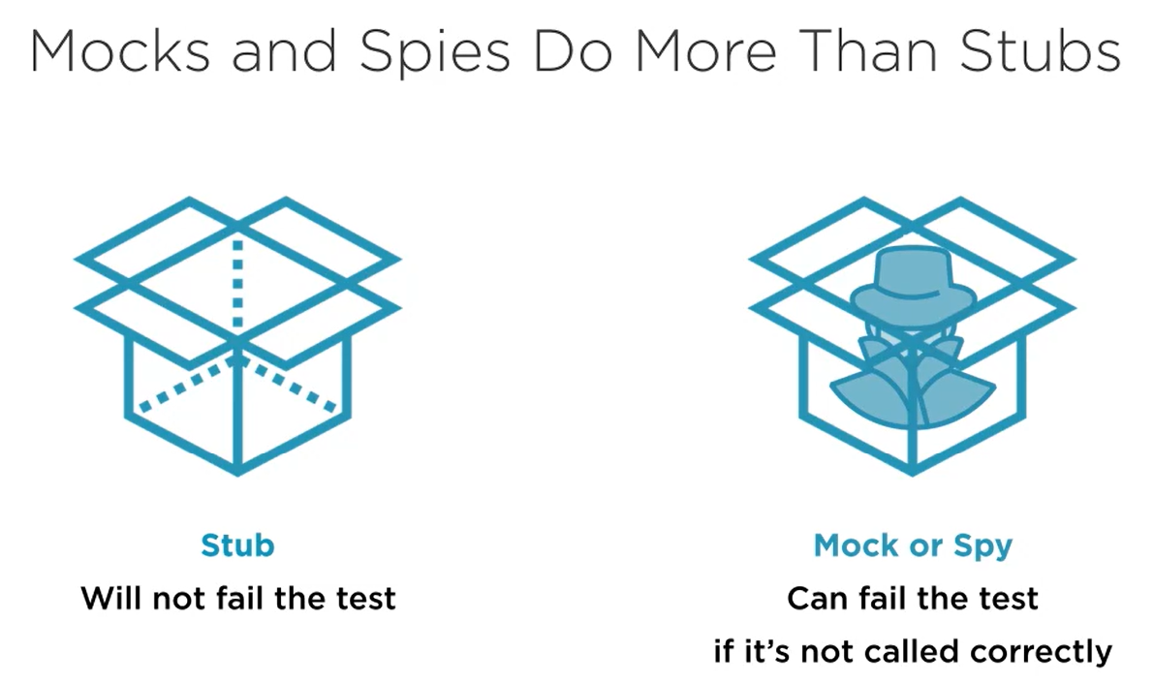

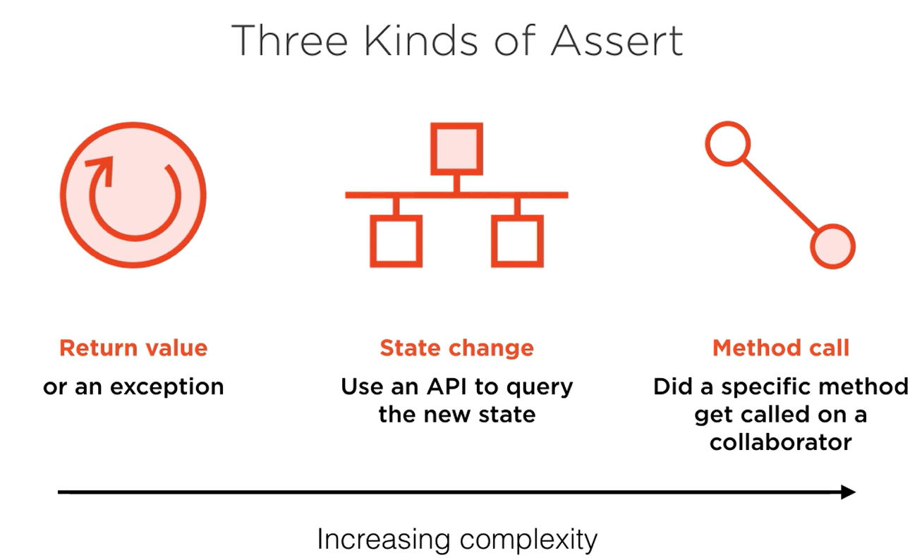

### Mocks

Mock is just like a spy but the main difference is that the mock has expectations about what method will be called and with what arguments and it will enforce those expectations as soon as it receives the wrong call. You don’t have to wait to the end of the test case like you do with a spy and interrogate it about what happens. It will blow up straight away.

So, you use a mock when you want to make sure that the interactions between two objects are happening correctly and you want the test to fail fast, as soon as any incorrect interaction happens, and that gives you a nice stack trace leading right back to where the incorrect call was made.

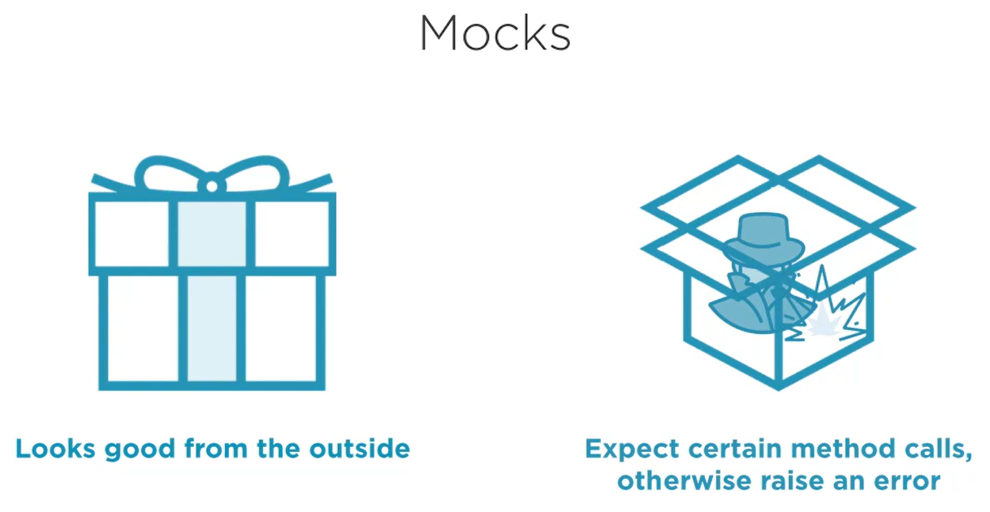

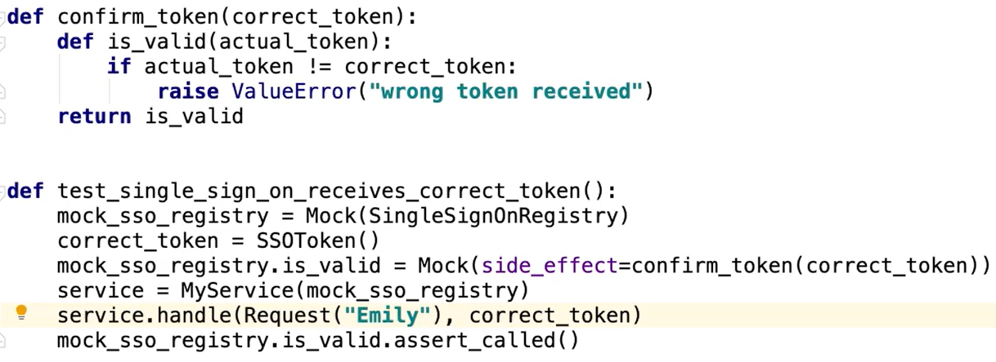

### Monkeypatching

Used to inject test doubles if there isn’t an easy way to do it.

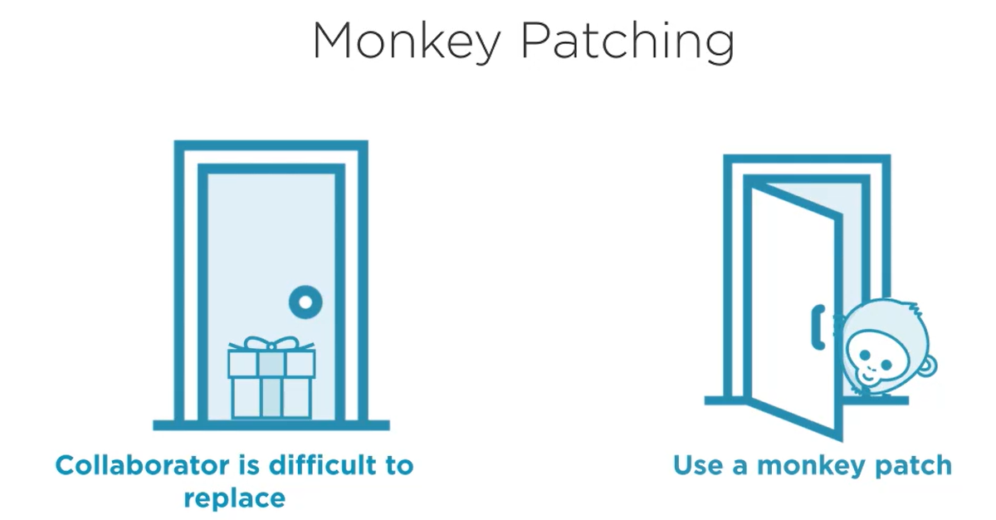

Refer TirePressure/test_alarm.py

## Parameterized Tests & Test Coverage

### Parameterized Tests

Refer folder ParameterizedTennis

* Helps to reduce the number of tests that you write
* When you have the same test code for multiple test functions with only slight parameters varying, use parameterized test to account for that difference
* Annotation to be used: @pytest.mark.parametrize(“<parameter>”, [<possible_values>])

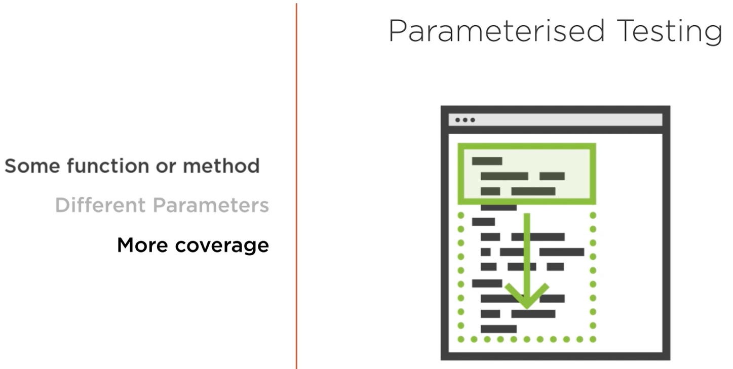

Parametrized Test with pytest

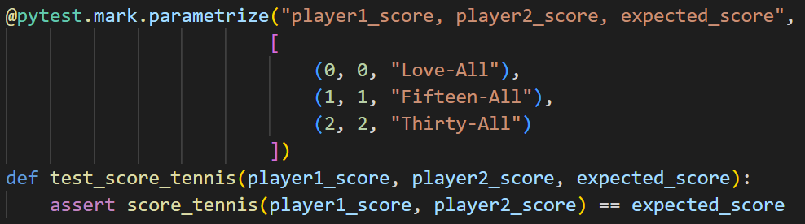

Parametrized Test with unittest

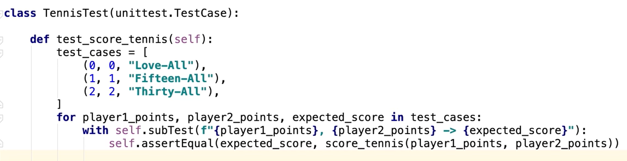

### Test Coverage

* Two packages required:
  + coverage
  + pytest-cov
* Run the following command:
  + coverage run -m pytest
  + coverage html

or

* + pytest --cov-report html:cov_html --cov-branch --cov=<module> <folder>

example:



* You will see a folder named **htmlcov**, open the **index.html** file inside it in a web browser
* Note: the branch coverage gives you more detailed report which we see in the last command shown in screenshot
* The percentage will go down only if some line of code is not covered by any of the test
* Having 100% code coverage does not mean that your code is perfect or that your tests are perfect

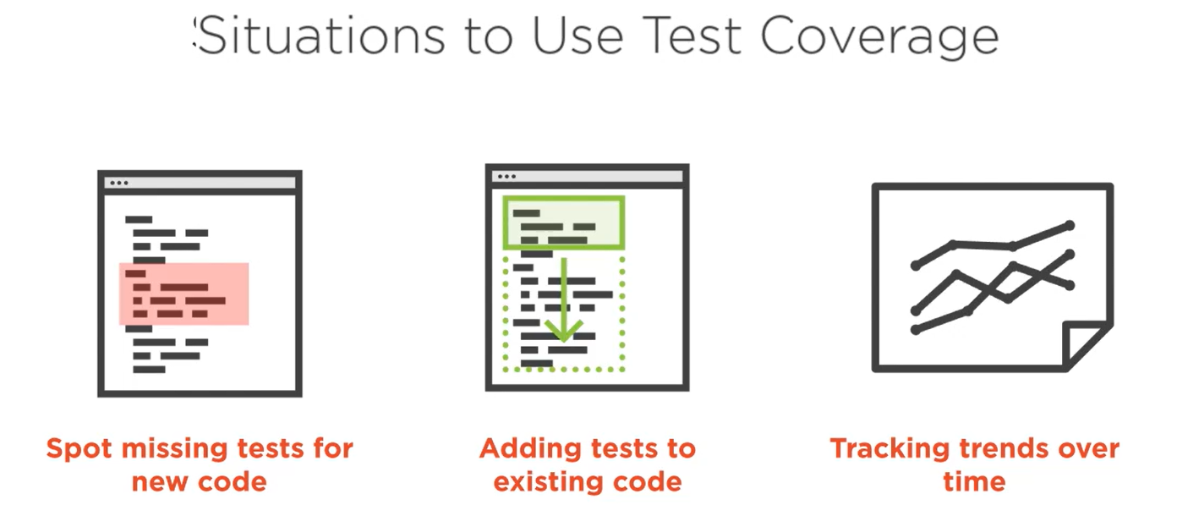

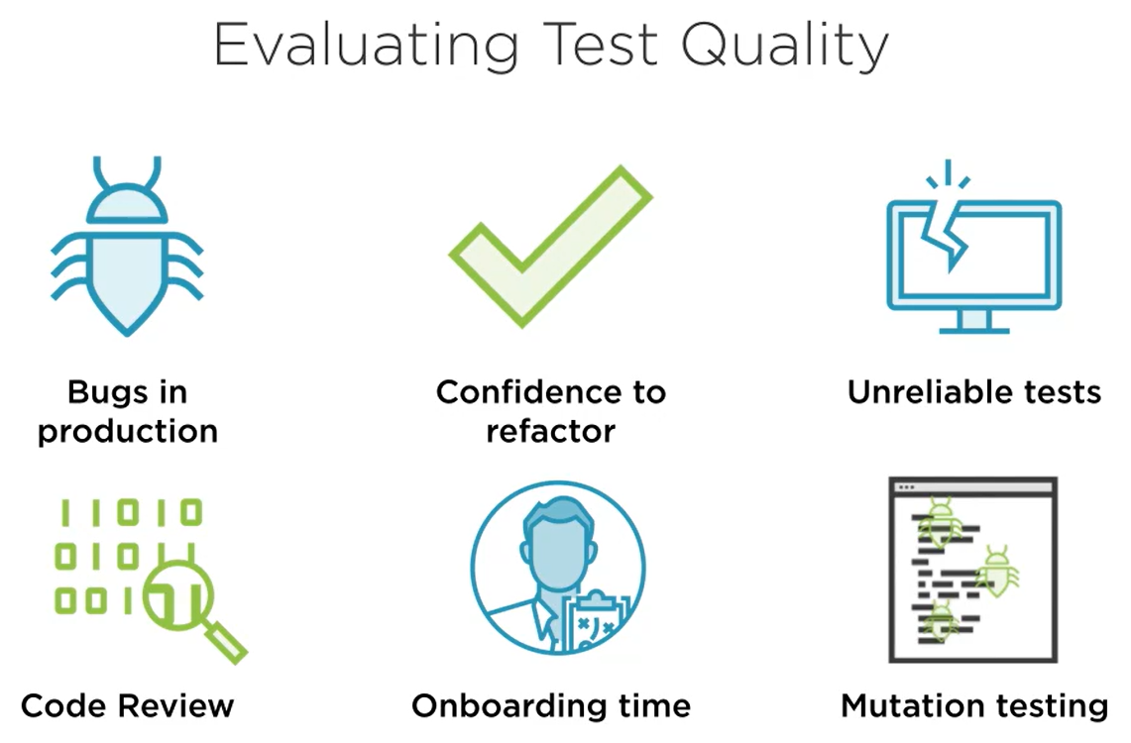

# Managing Python Packages & Virtual Environments

## Where are packages installed

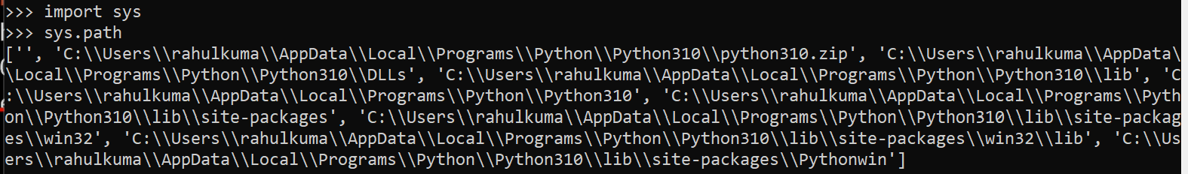

Installed in either of the directories listed in above screenshot.

Better way to find where a package is installed:

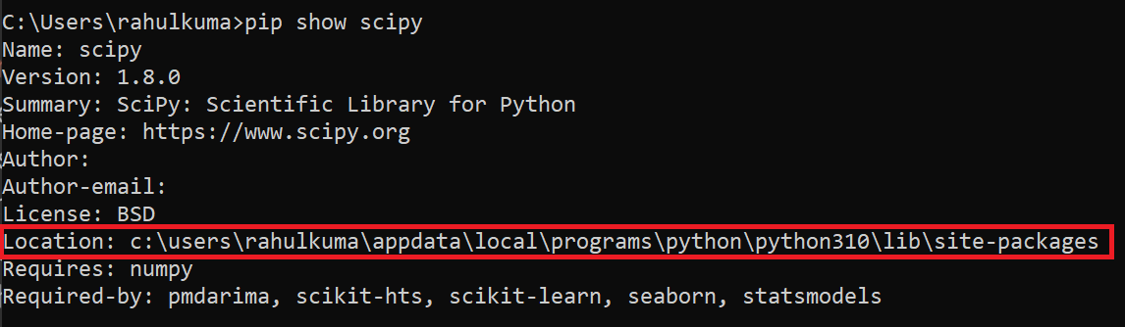

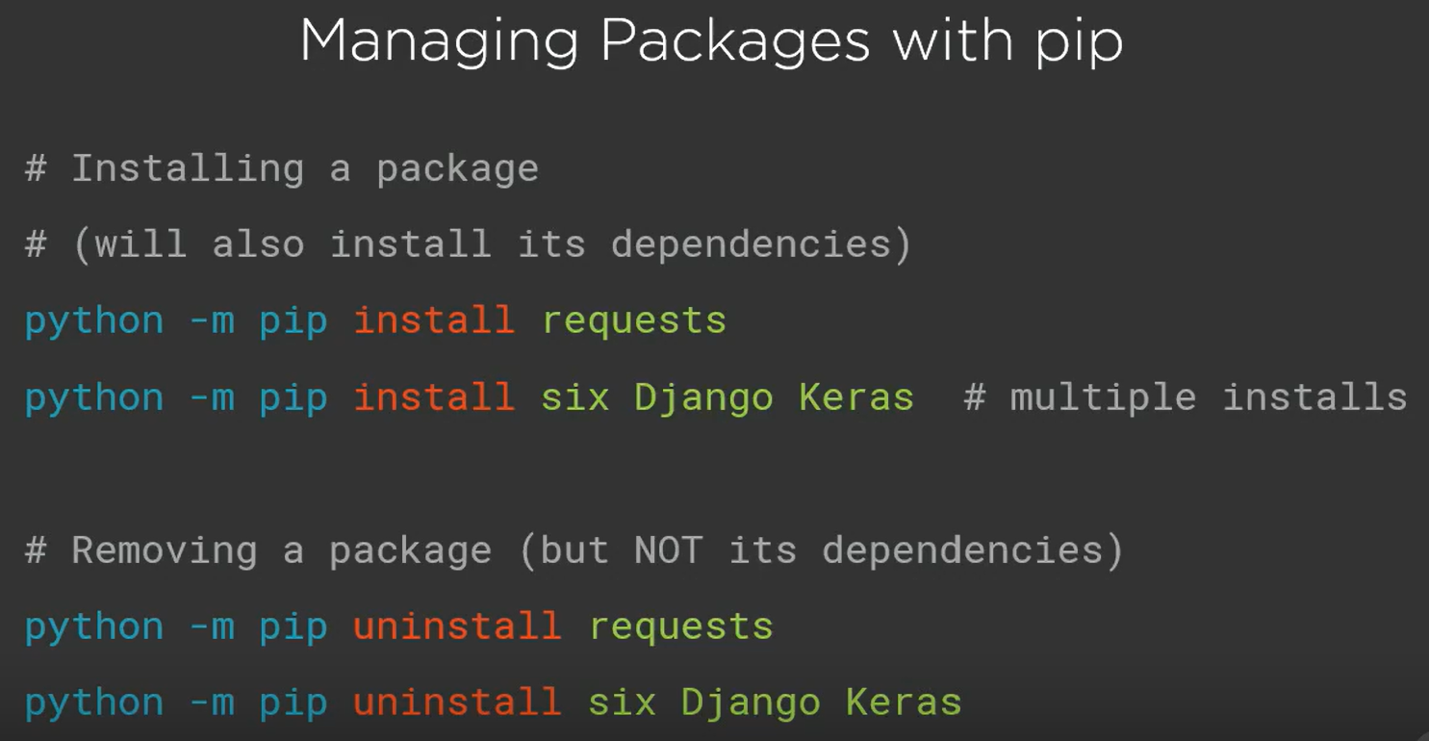

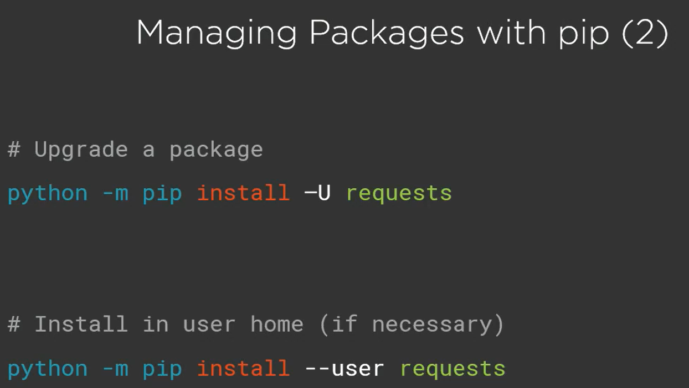

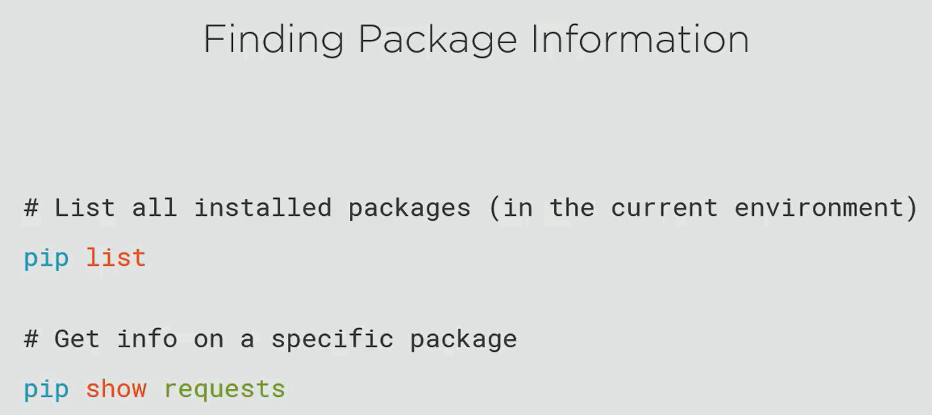

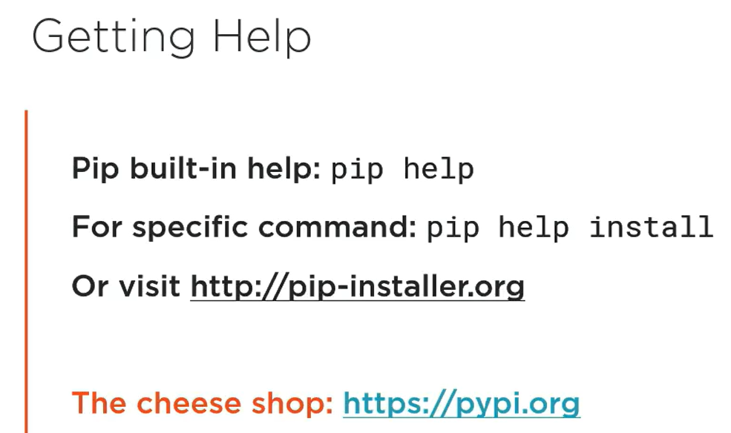

## Virtual Environments

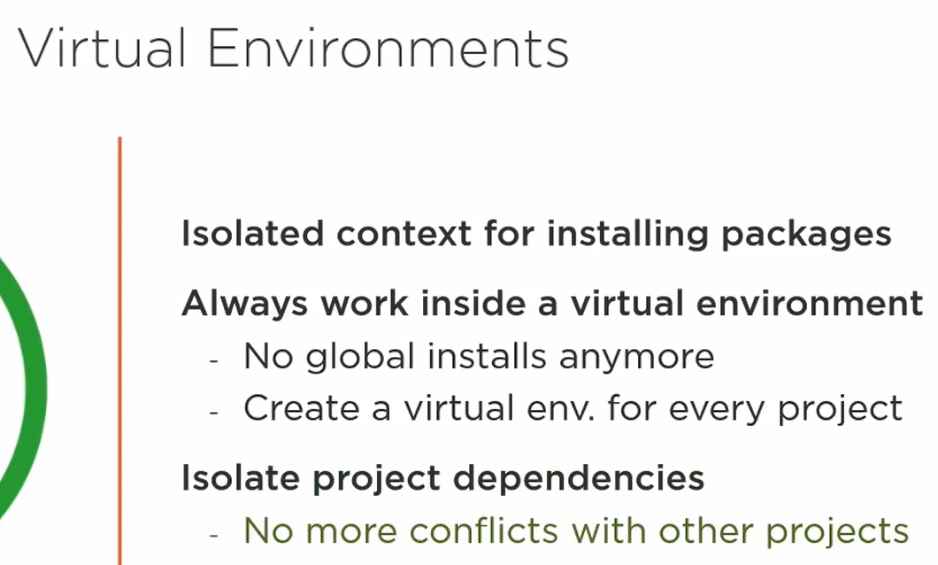

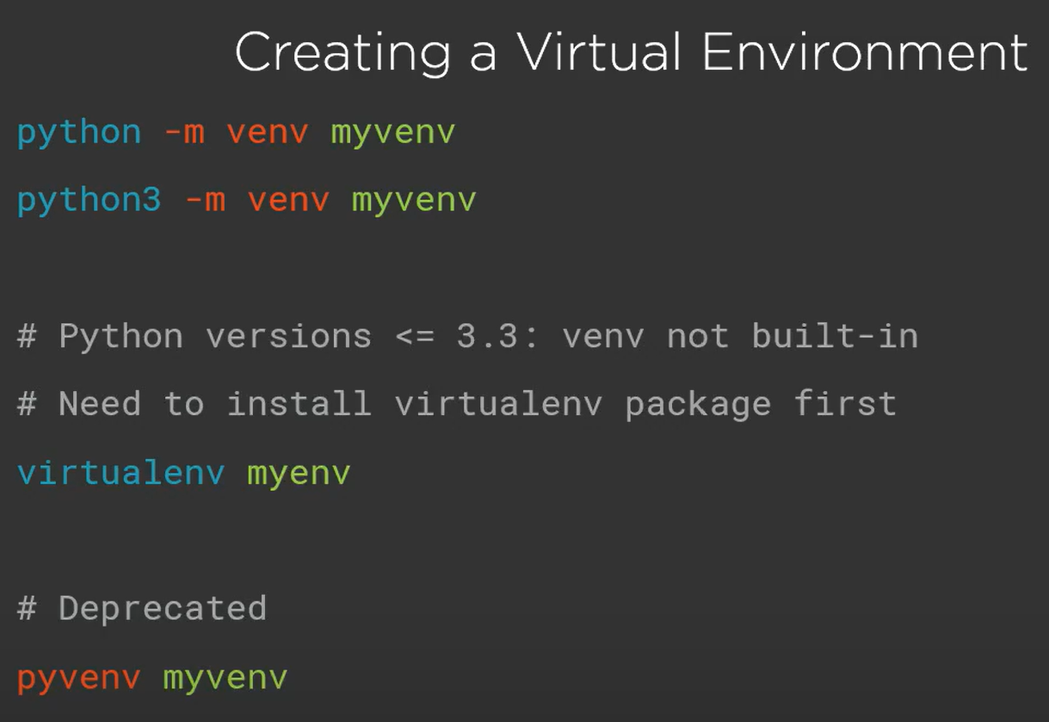

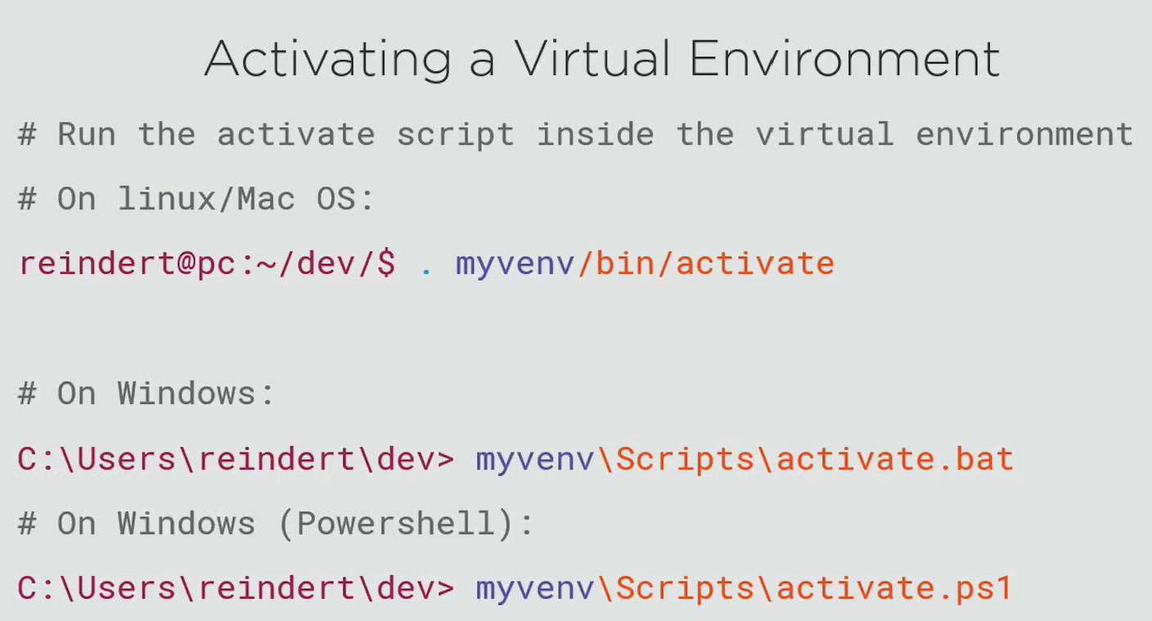

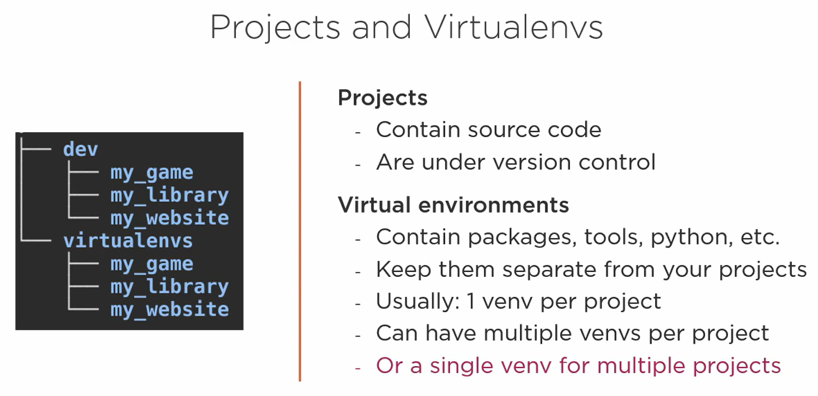

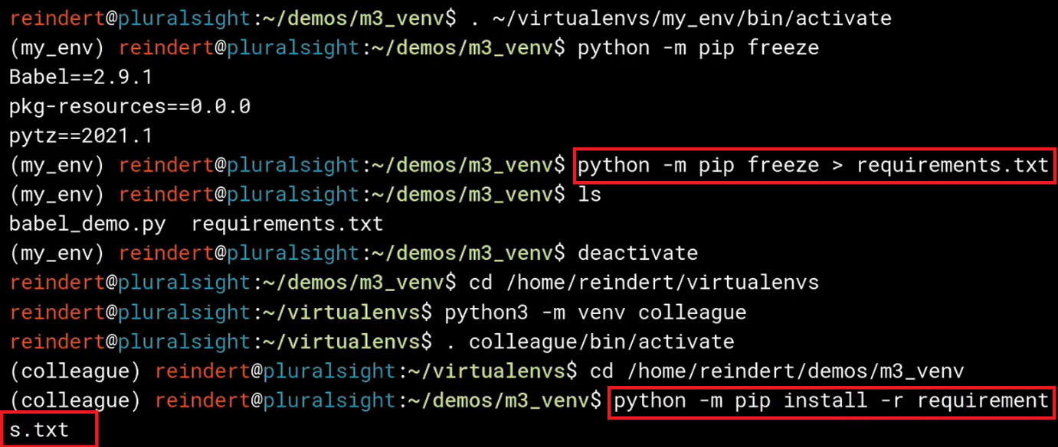

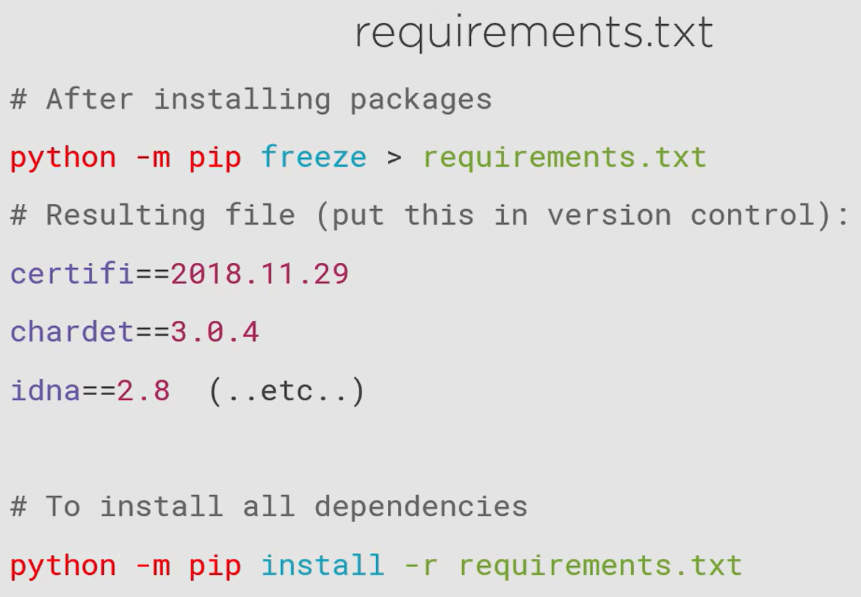

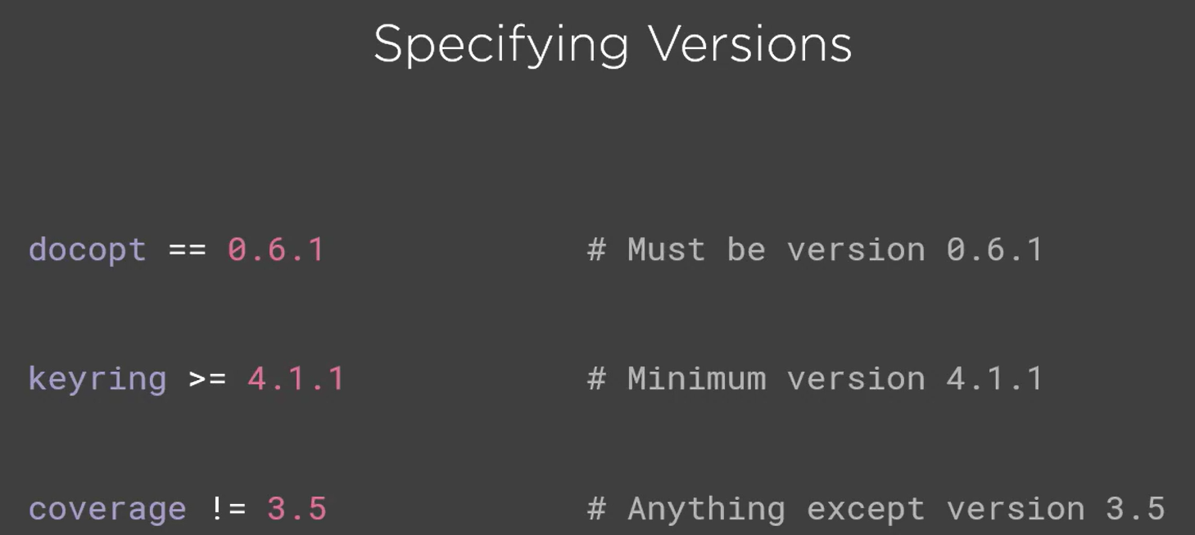

pip will install the latest version of a package that satisfies the condition.

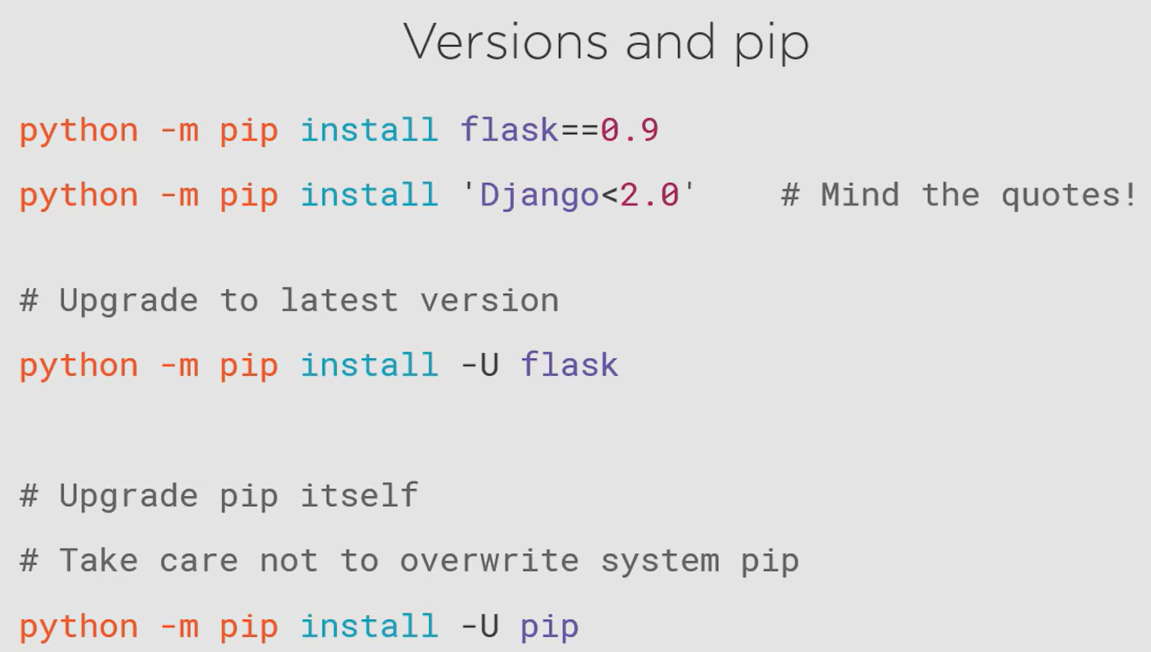

## virtualenvwrapper

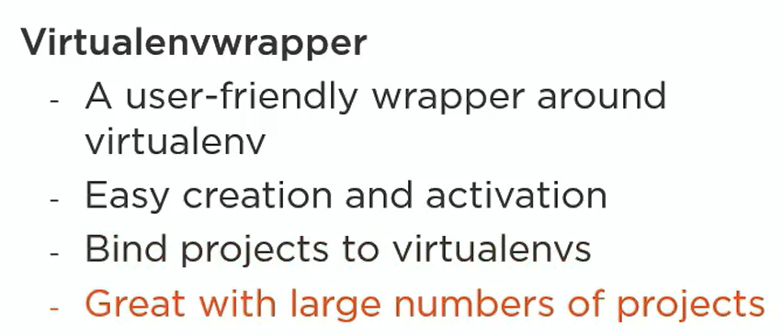

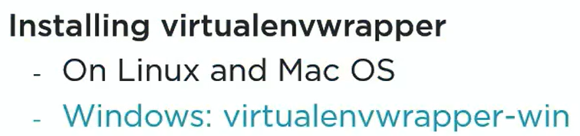

This is one of the packages that must be installed system wide and not in any specific virtual environments as this des not belong to one. This will be used to manage virtual environments.

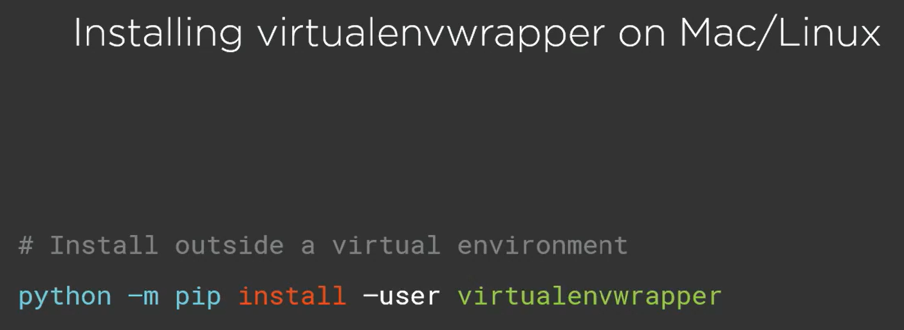

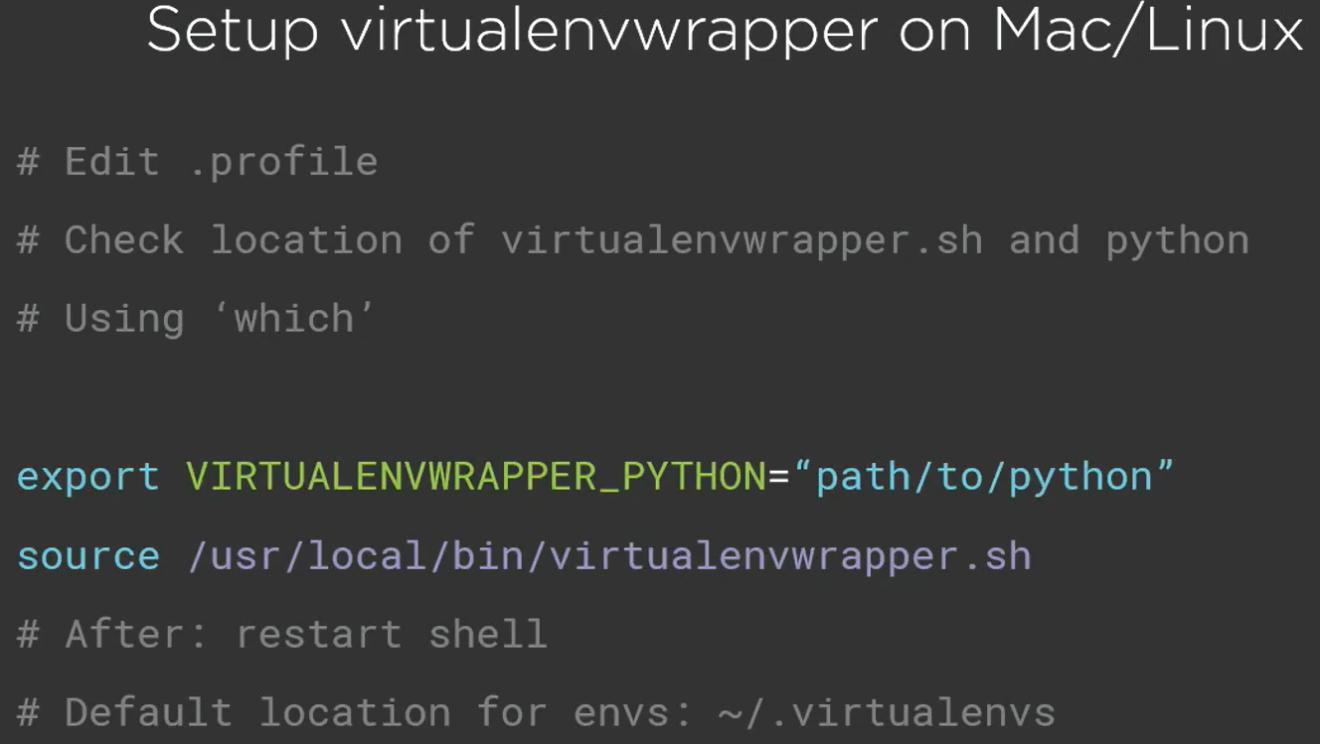

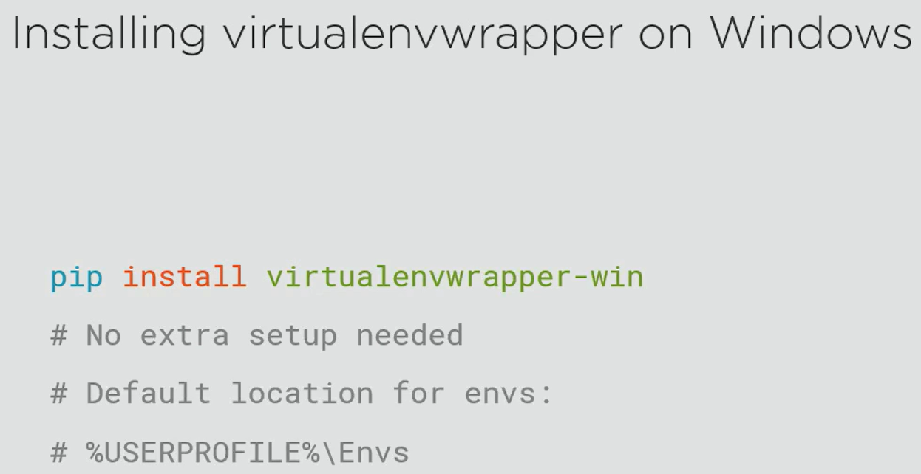

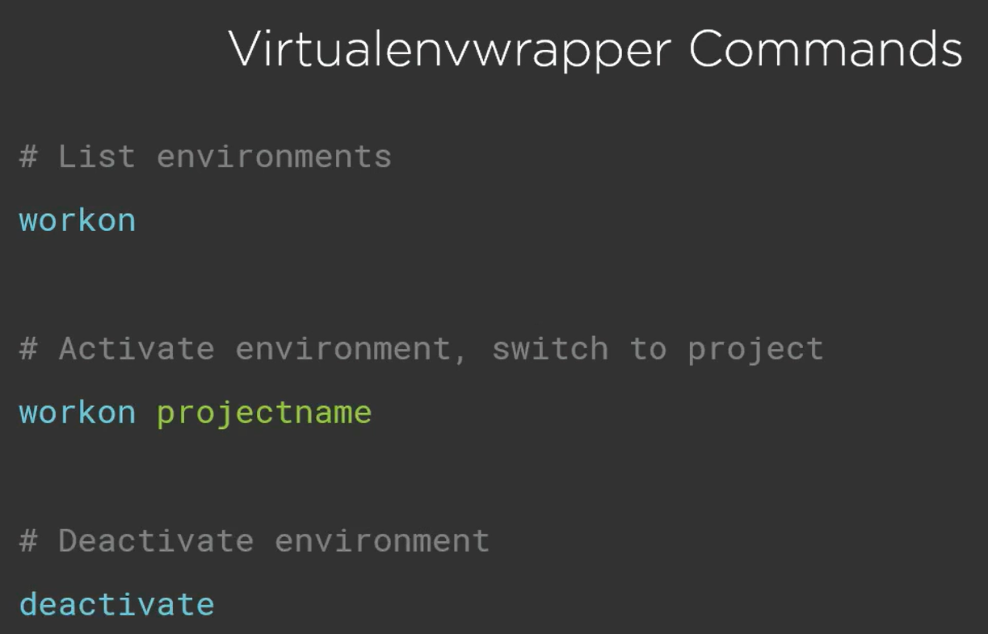

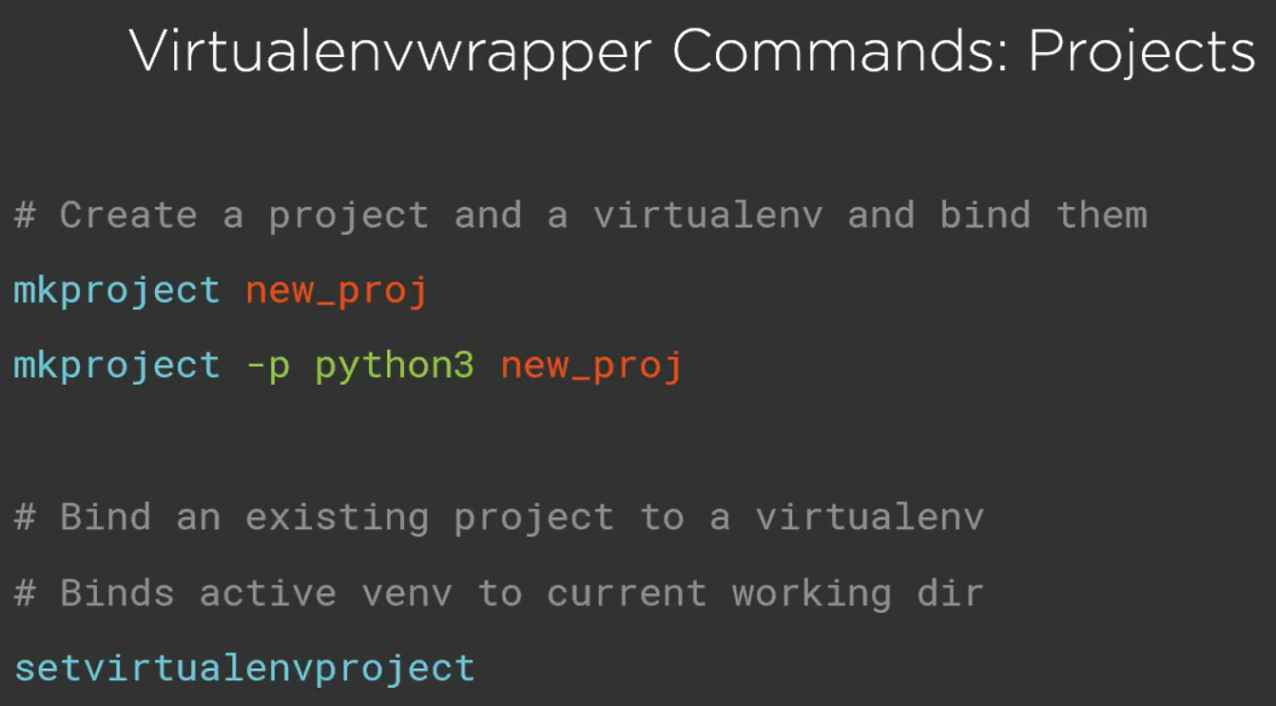

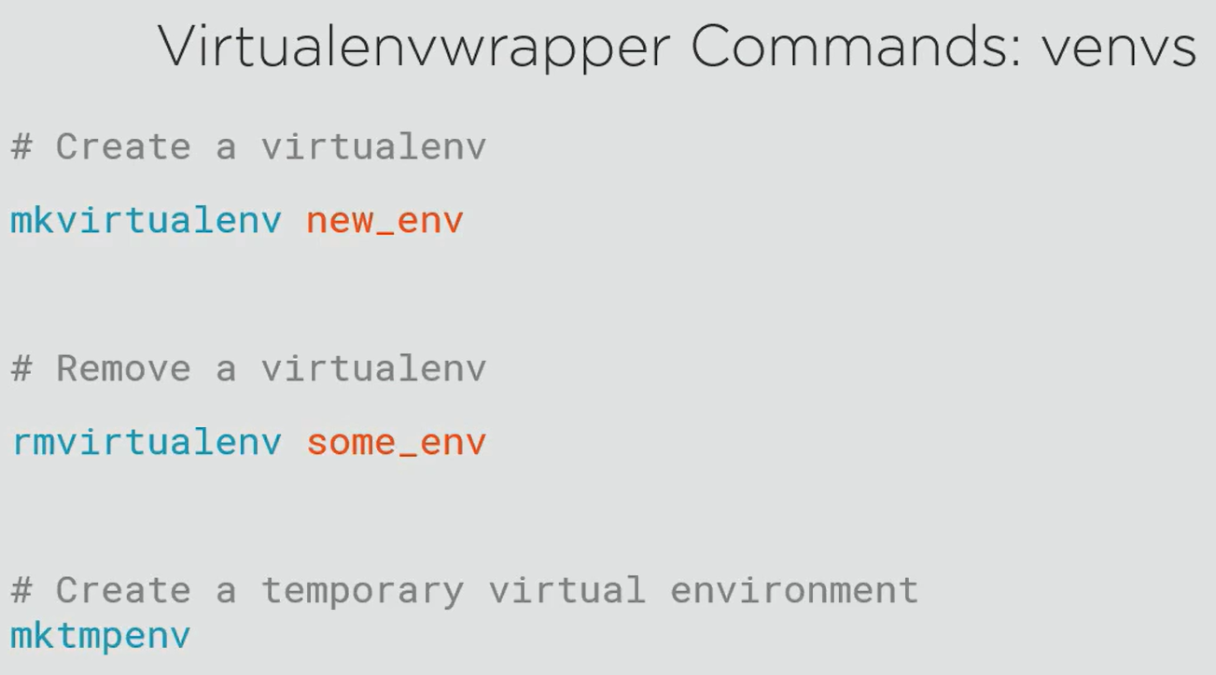

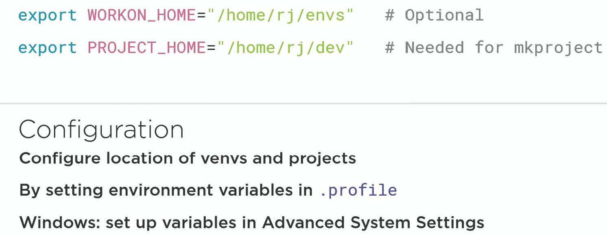

## Choosing the right tools

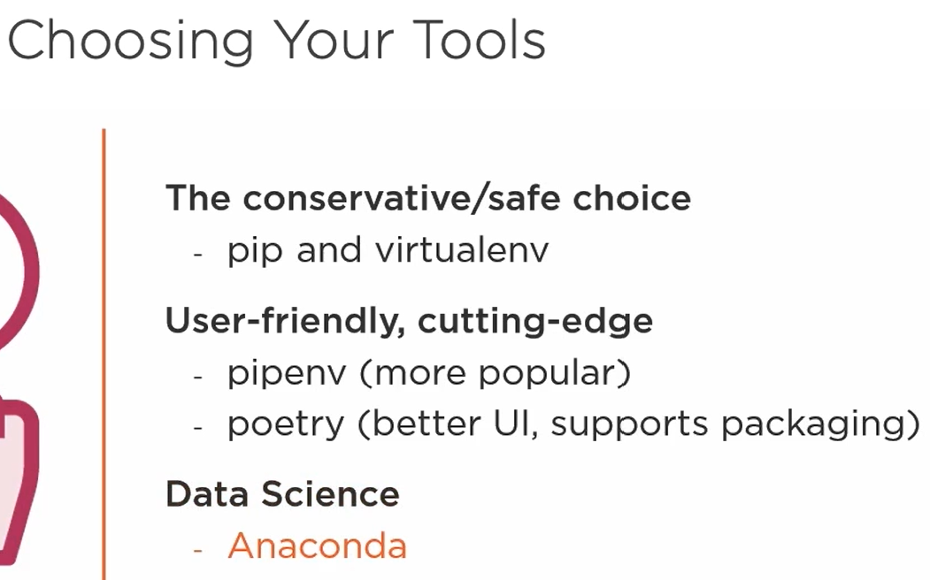

# Python Best Practices for Code Quality

## Python Style Guidelines: PEP8 and Pylint

### PEP8

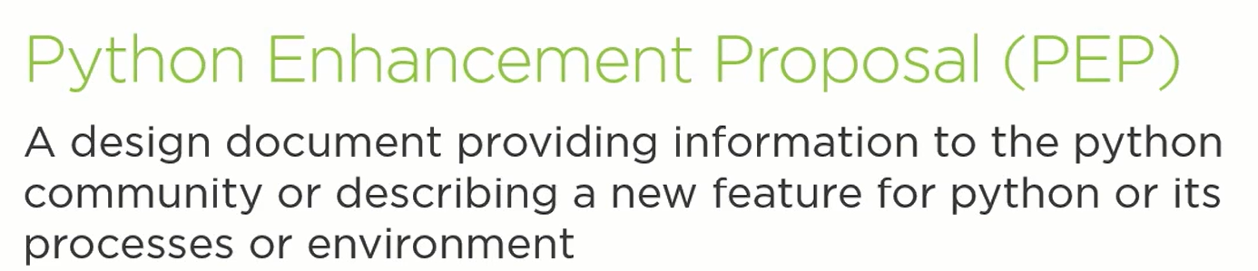

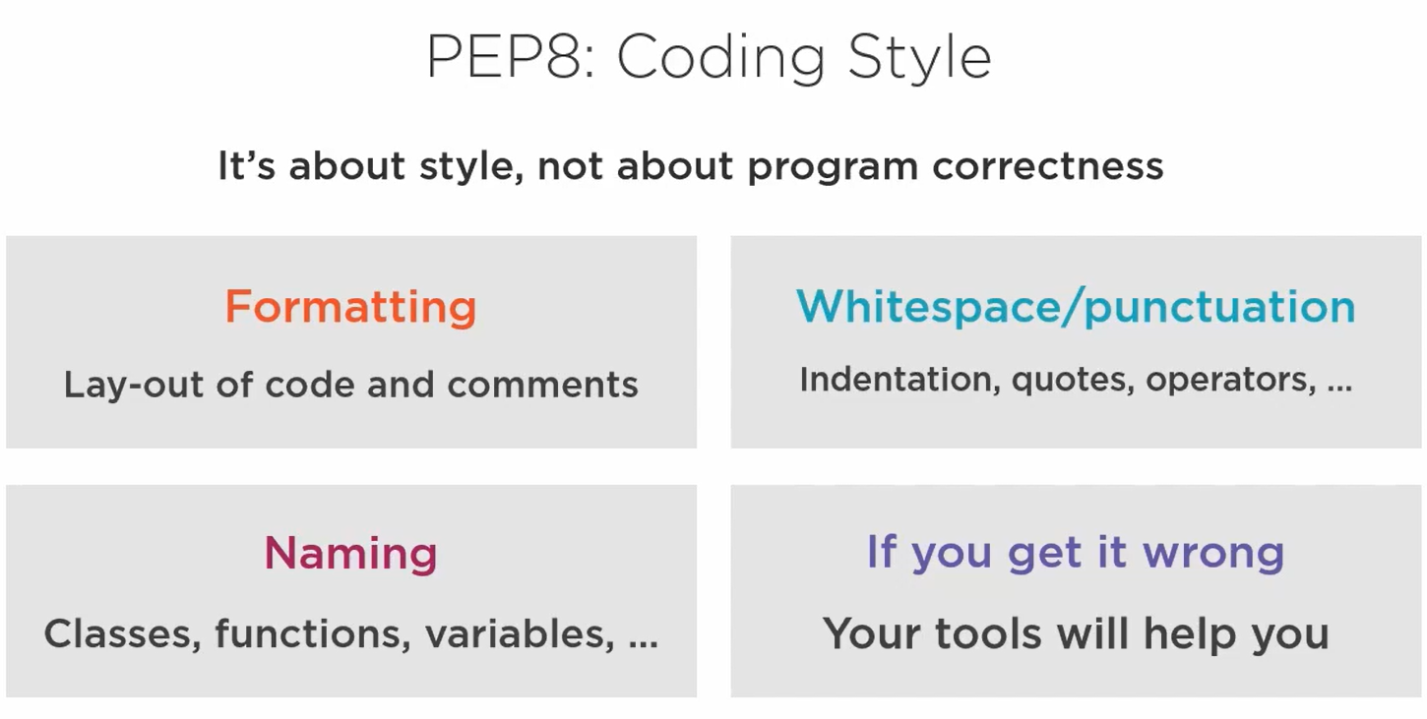

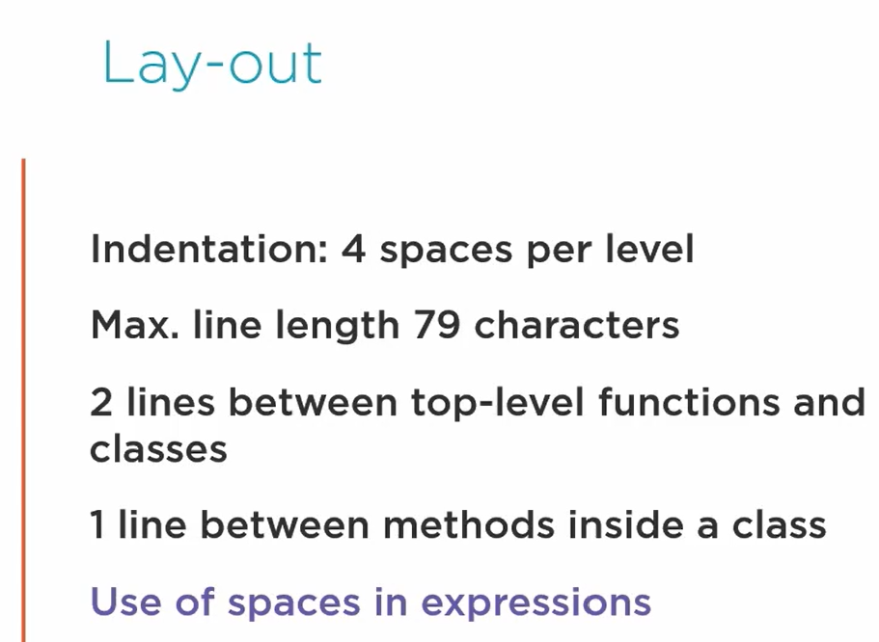

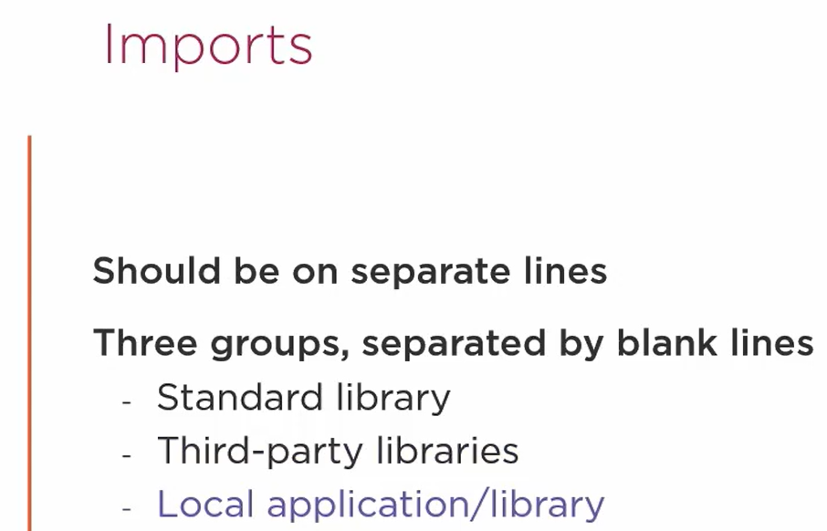

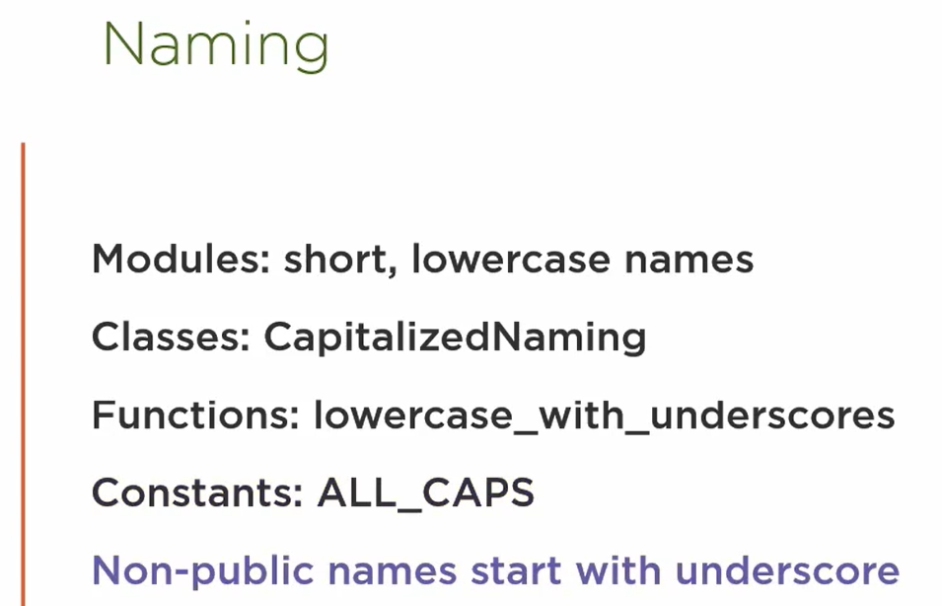

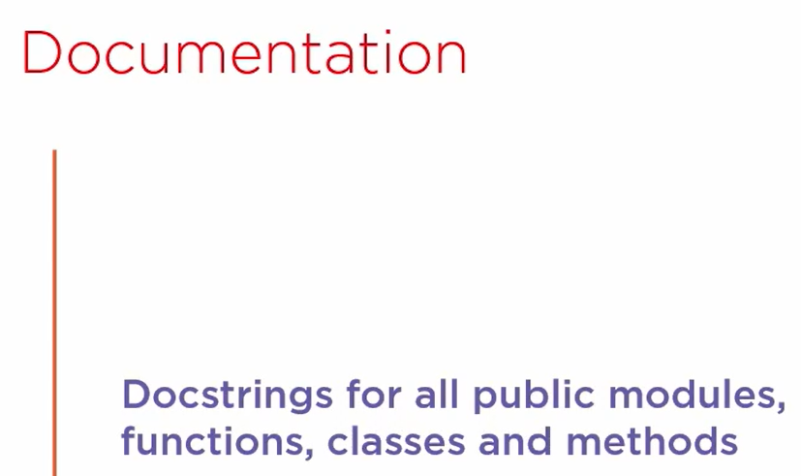

### Other Tools

* **pylint**
* Install the package pylint using pip
* Note that it evaluates based on PEP8 + additional guidelines
* Run the following command to check code quality:
  + pylint <folder_or_filename_with_extension>
* How can I decide which warnings I want to see (customize code style)?
  + Run the following command to generate rc file
    - pylint --generate-rcfile > pylintrc
  + Make changes in the pylintrc file and save it
  + Run the pylint command to check code quality (it is customized and you will see warnings based on your customization)
* **pycodestyle**
  + Install the package pycodestyle using pip
  + Note that it evaluates based on PEP8 only
  + Run the following command to check code quality:
    - pycodestyle <folder_or_filename_with_extension>
  + Only shows PEP8 warnings
  + Less popular than pylint
* **black**
* Install the package black using pip
* Run the following command to fix PEP8 code quality warnings:
  + black <folder_or_filename_with_extension>
* Run the pylint command to see all the PEP8 warnings have been fixed (there might be additional warnings still present which are not PEP8)

## Documenting your Project

### Docstrings

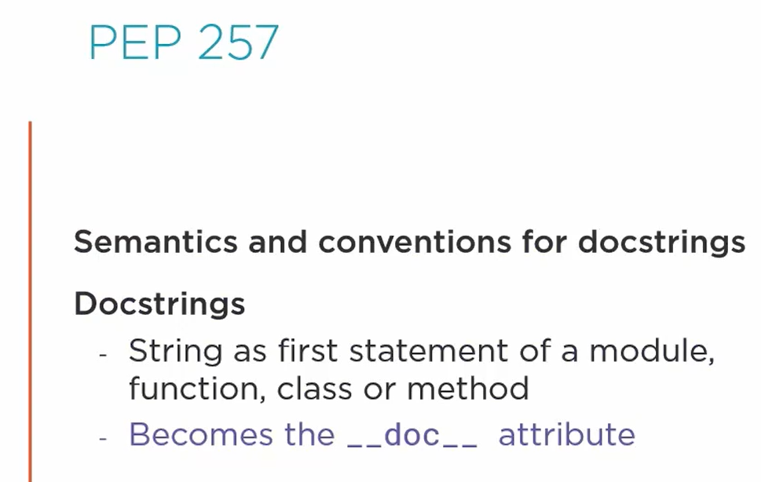

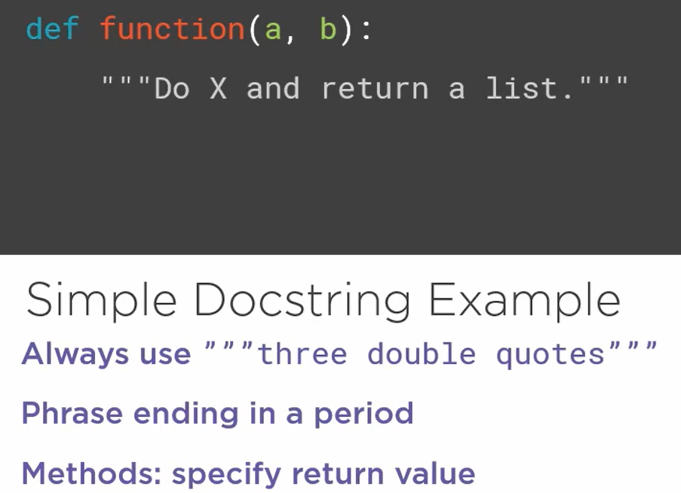

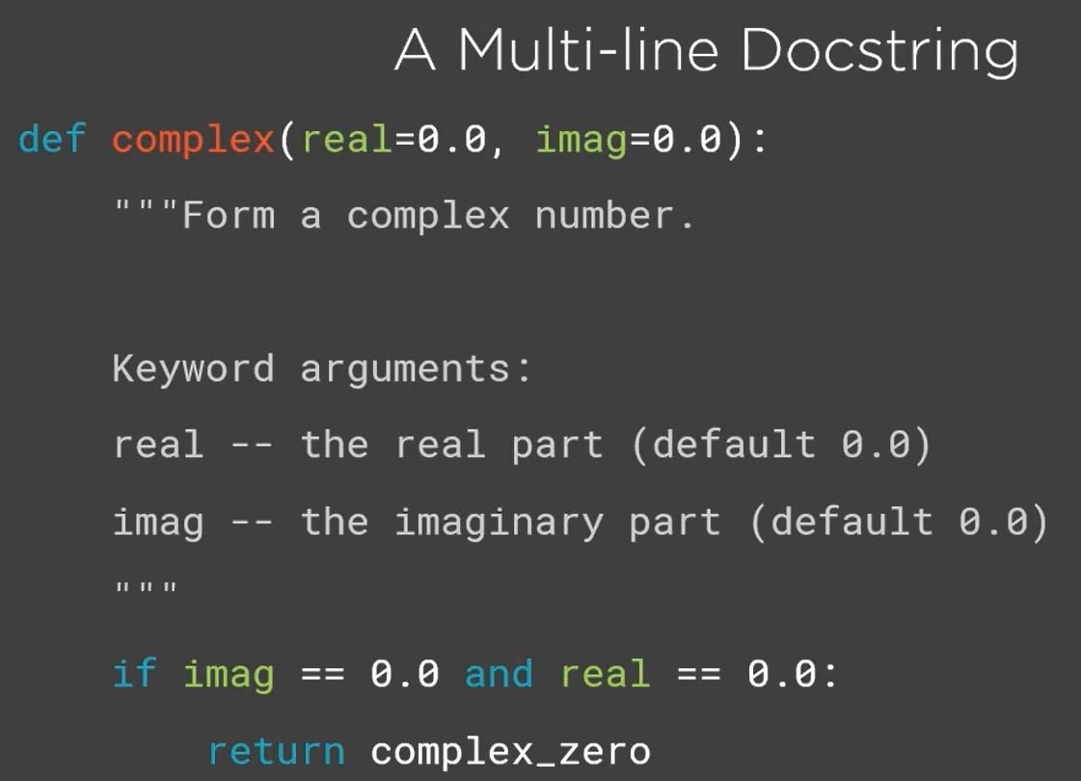

### Sphinx

* Need to install package sphinx using pip
* Move to the directory where you want to generate documentation
* Run the following command and fill in the details that are being asked:

sphinx-quickstart

* Configuration that you enter (details that you entered) are stored in conf.py which can be edited alter if required

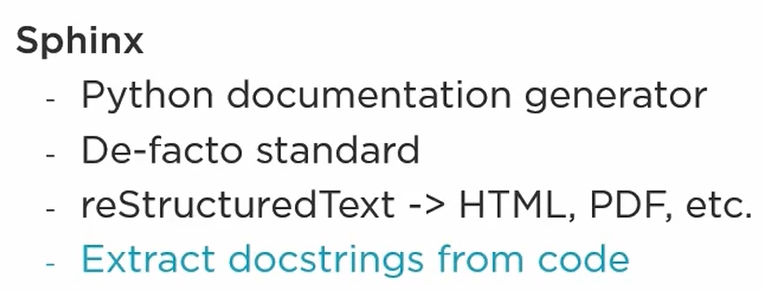

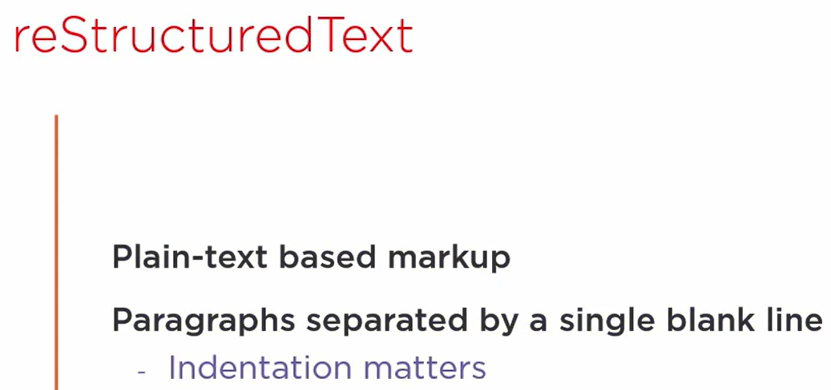

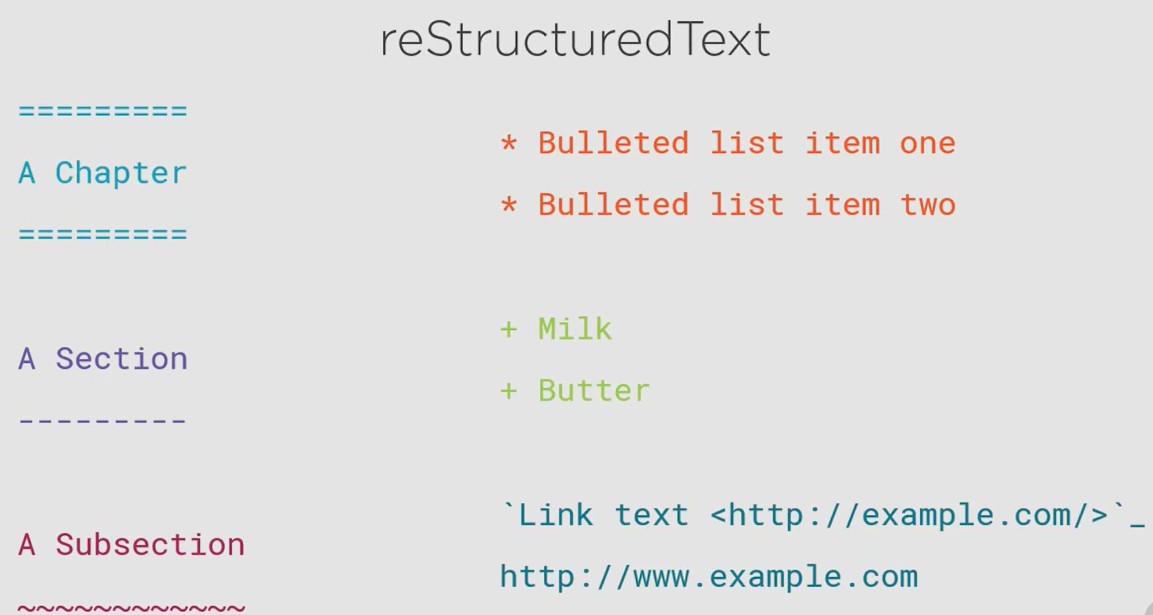

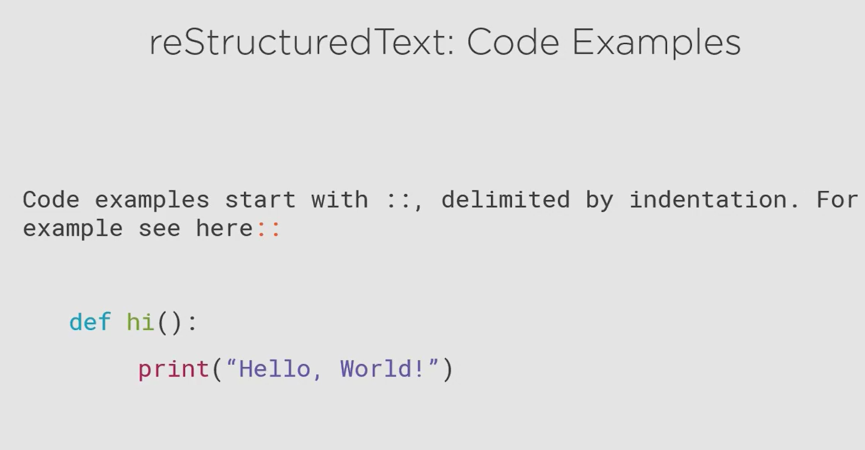

The block of code must have a blank line at the start and at the end.

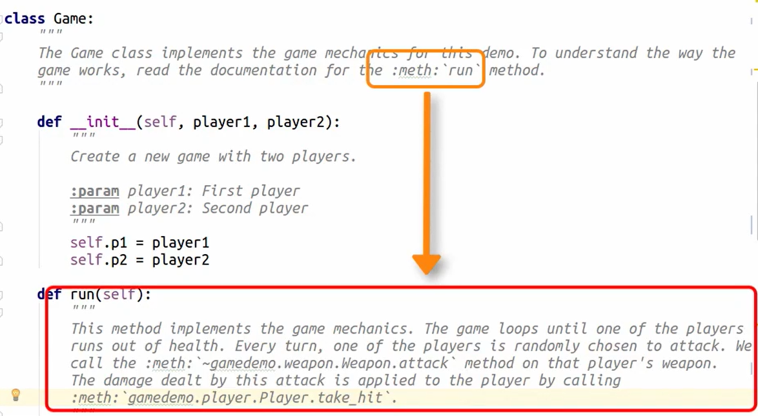

To auto generate documentation from code:

* Open the conf.py file and uncomment the following line

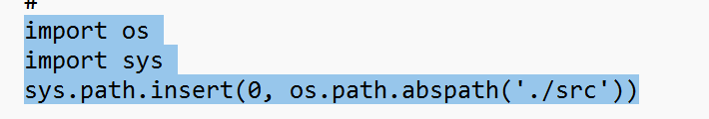

The last line contains a path which serves as the source, where the sphinx will look for code to generate documentation (configure it properly)

* In the same file, add the highlighted section

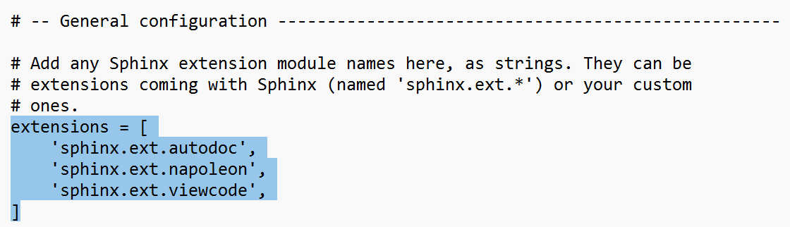

* Open cmd
* Run command **conda activate dev**
* Run command: **cd C:\`Dev\SphinxDoc**
* Make sure directory **C:\`Dev\SphinxDoc\out** is empty
* Copy the directory for which you want to generate doc to this directory: **C:\`Dev\SphinxDoc\src**
* Run the command **sphinx-apidoc -o ./out ./src**
* Run command **make clean**
* Run command **make html**
* Final HTML page can be found in **C:\`Dev\SphinxDoc\_build\html\out**

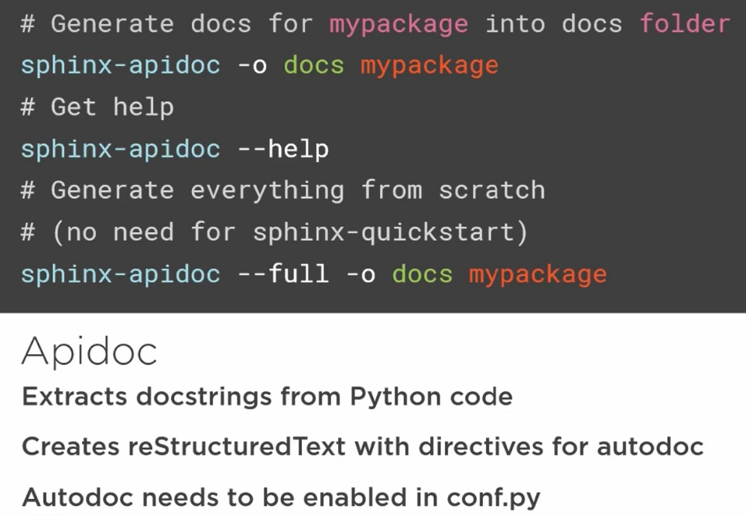

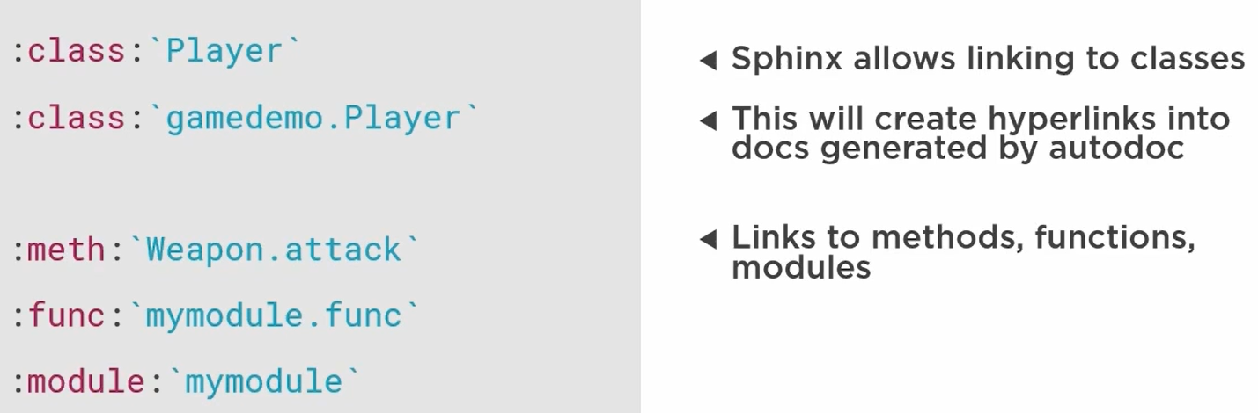

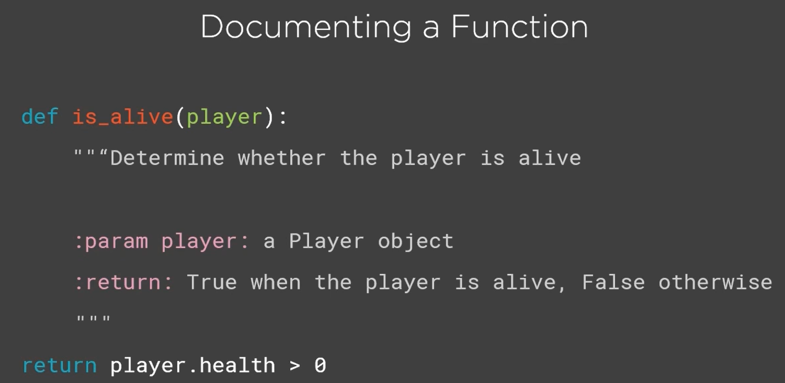

## Improve Code with Type Checking

### Type Checking

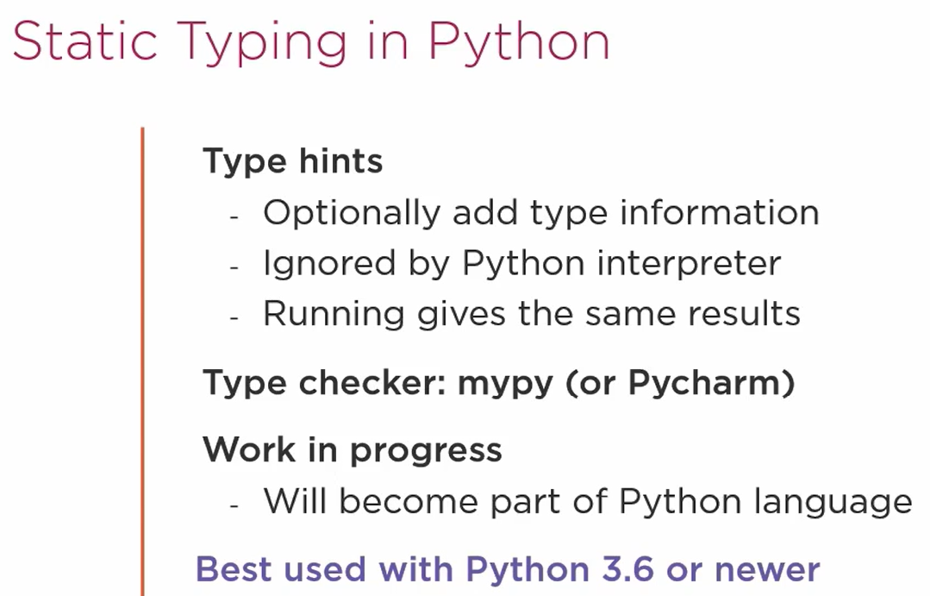

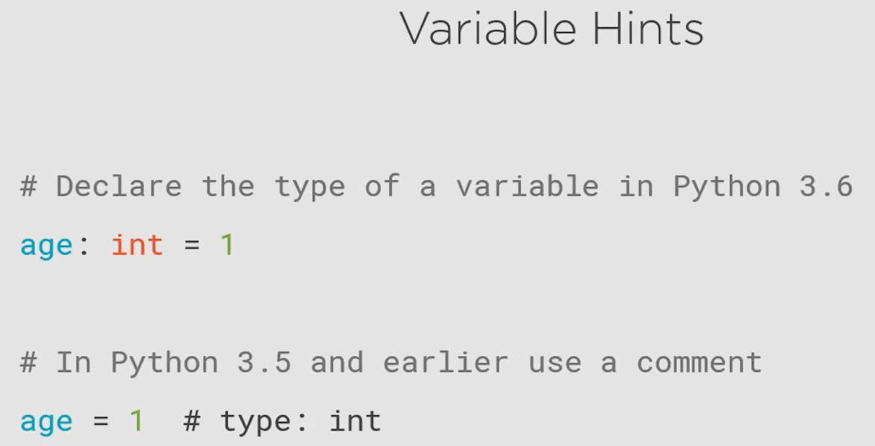

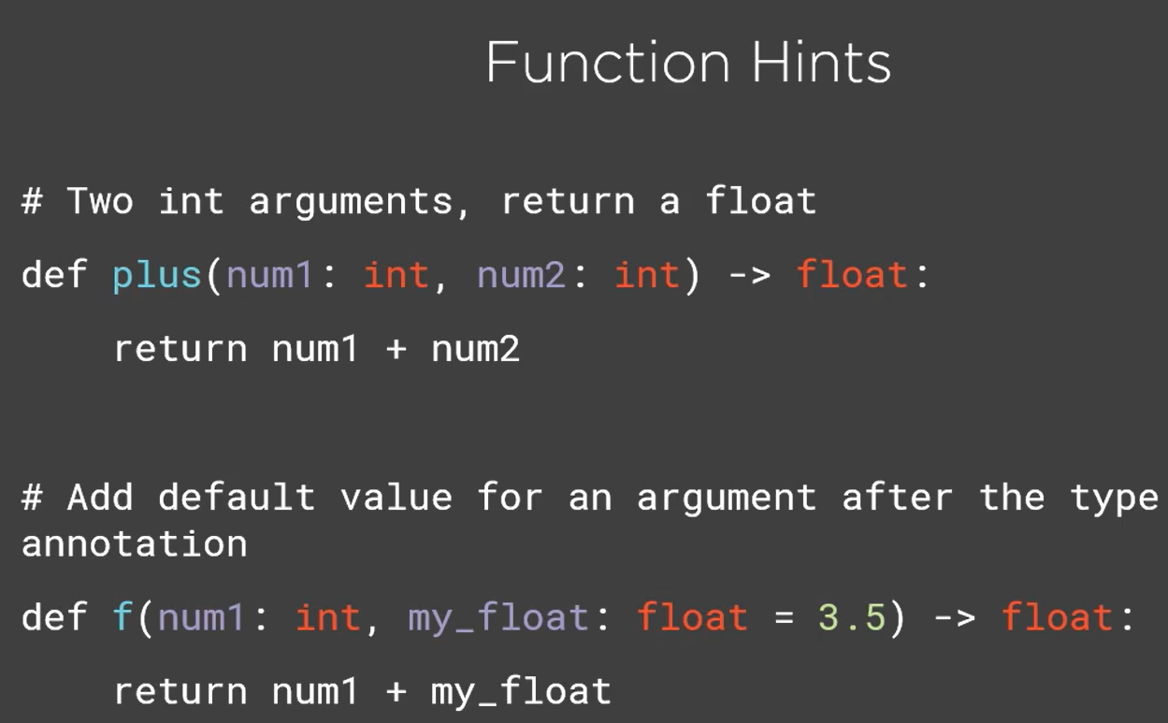

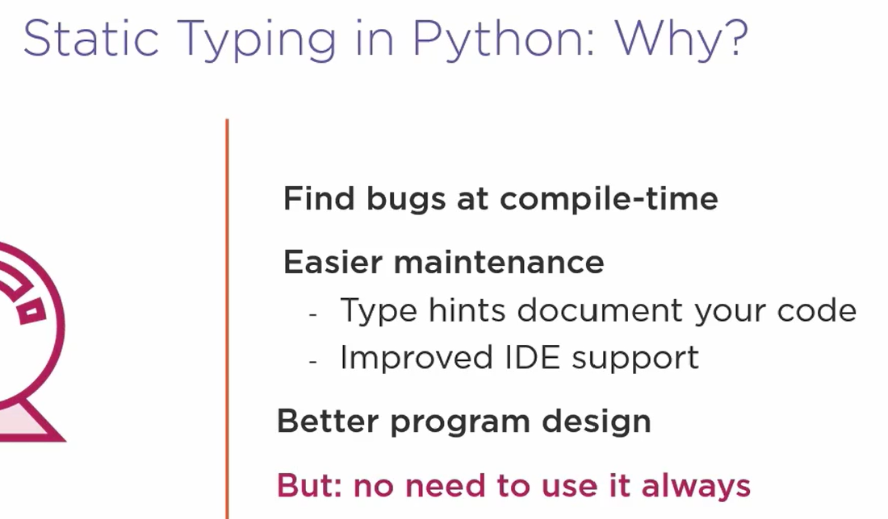

Refer [Type hints cheat sheet (Python 3) - mypy 0.961 documentation](https://mypy.readthedocs.io/en/stable/cheat_sheet_py3.html) for writing type hints.

### mypy



* Install the package mypy using pip
* Run the following command to perform type checking:
  + mypy <folder_or_filename_with_extension>

# Python Anti-patterns

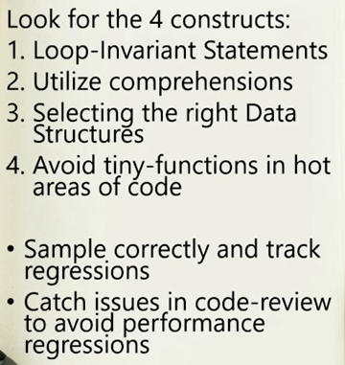

1. Loop Invariant

Avoid writing expressions that do not change in a loop, put it outside the loop

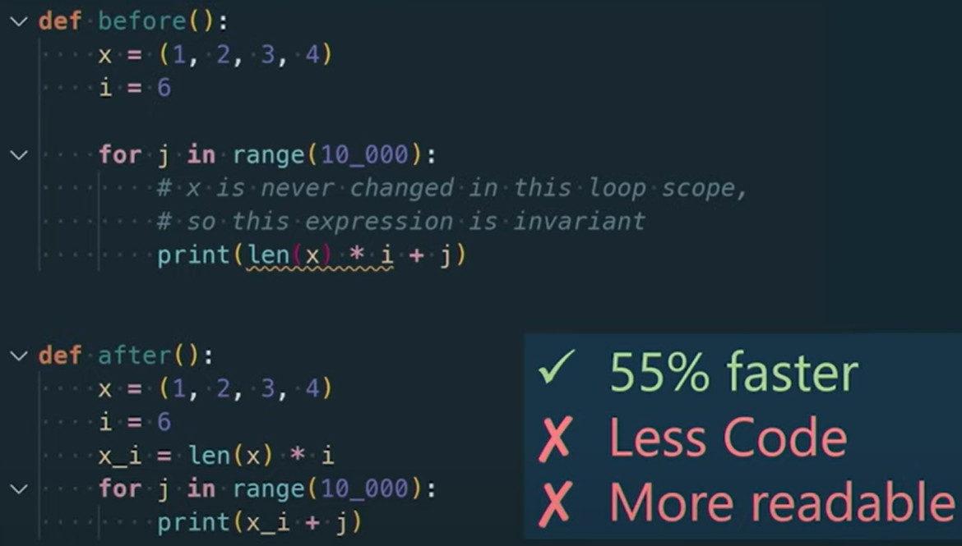

1. Utilize comprehensions

Make sure to utilize comprehensions whenever possible, they are faster.

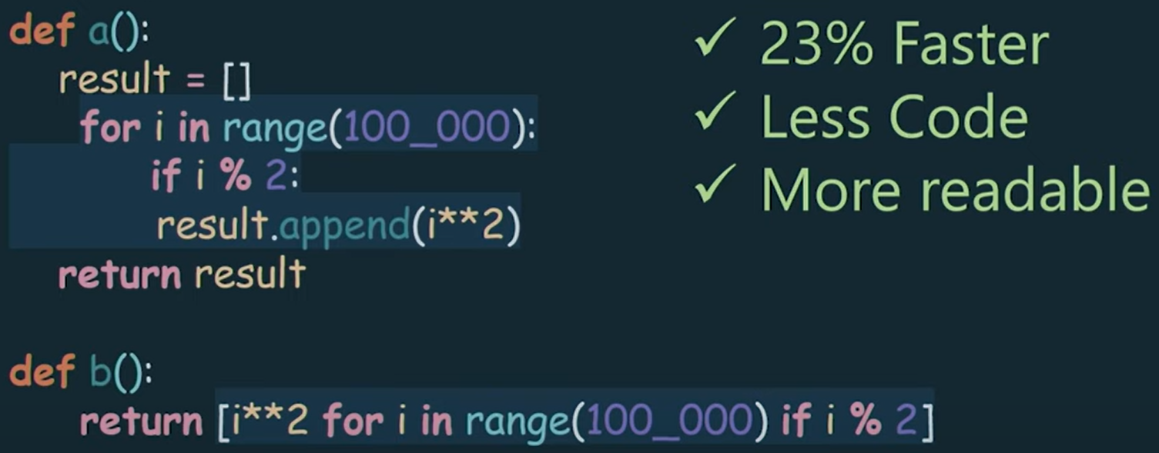

1. Select the right data structure

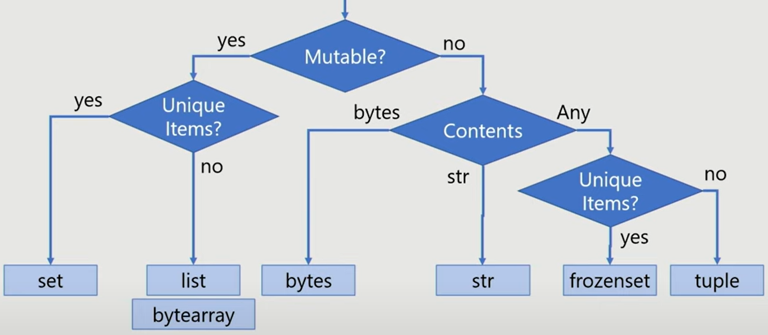

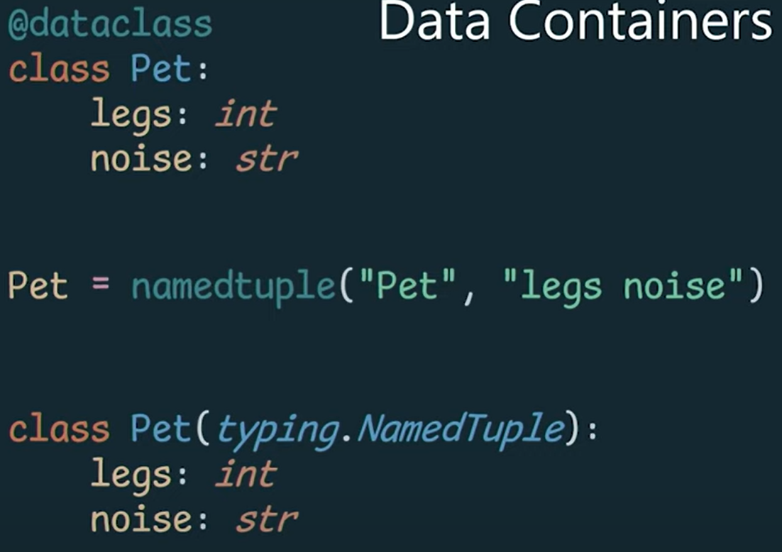

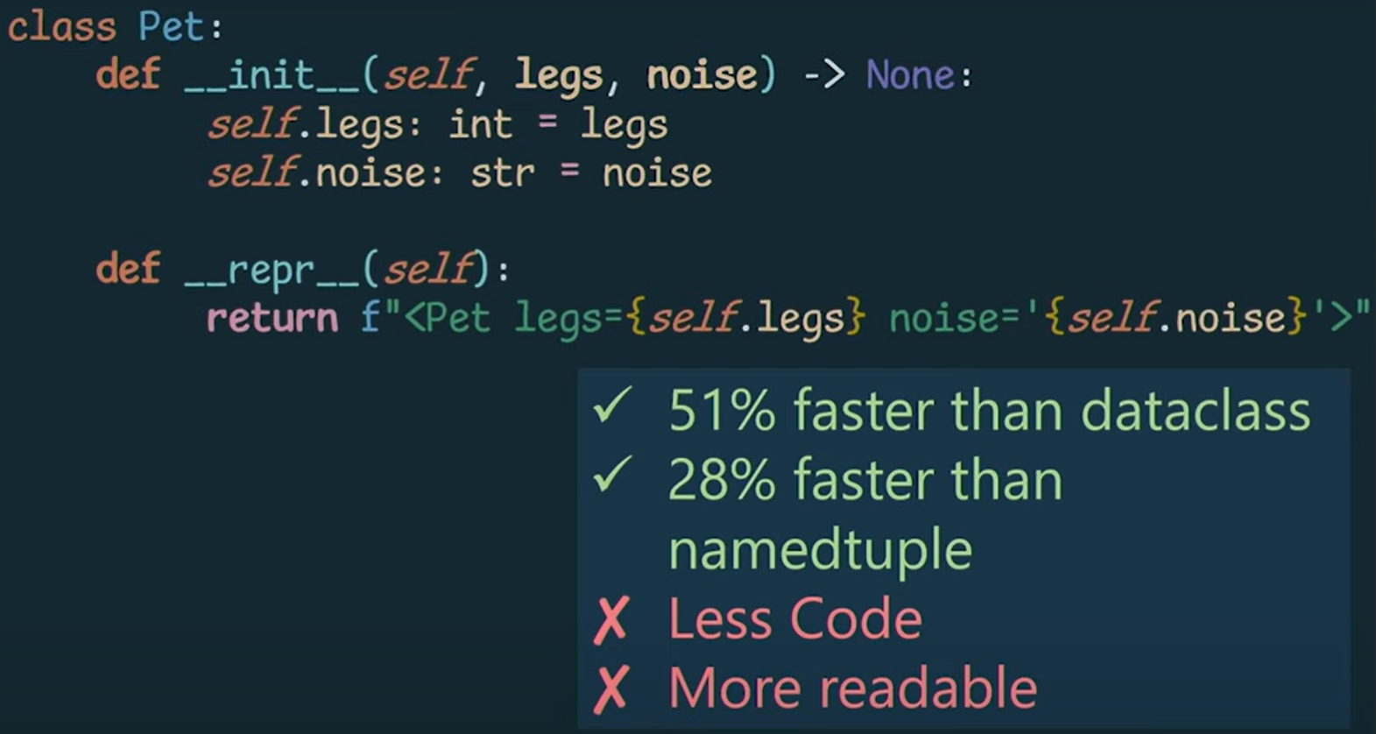

1. Avoid function call in hot areas of code

Function b() is faster

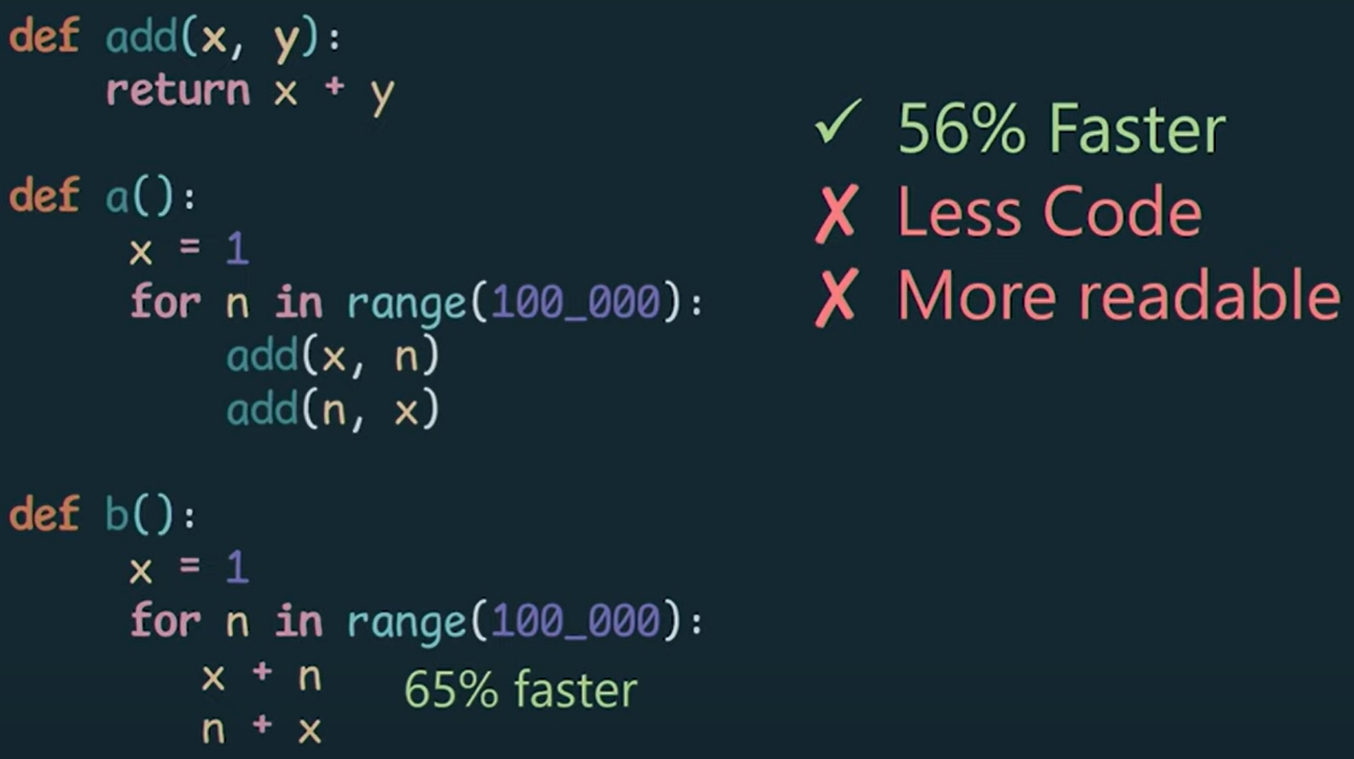

# Concurrency in Python

Refer python-concurrency folder in programs.

## Concurrency Concepts

* Concurrency is the execution of multiple instruction sequences at the same time.
* **General rule: Always start with simplest single threaded code, make sure it works end to end, all major exceptions are handled and the unit tests are running, then start refactoring for concurrency.**
* **Best practice in Python Concurrency: Do not mix different types of workloads. Python’s concurrency mechanisms are optimized for either IO-bound or CPU-bound tasks, mixing these two in one operation or function is a bad idea, always separate them.**

Example: Within a single function, in a loop downloading file, reading it, modifying it, saving it, uploading it, this is a bad idea as downloading and uploading a file is IO-bound task whereas reading, modifying, saving are CPU-bound task.

Instead, download all the files in one function. Read, modify and save all of them one by one in a different function. Then upload all the files in a different function.

Here we separated our tasks, downloading (IO-bound) from modifying (CPU-bound) from uploading (IO-bound).

### Types of concurrency

Based on the concurrency that operates on the level of a single machine:

1. Parallel Programming

* True sense of parallelism (**parallel execution**) where multiple CPU cores are being used to execute multiple tasks at the same time.
* Best suited for CPU intensive tasks, example – string operations, search algorithms, graphics processing, any number crunching algorithms

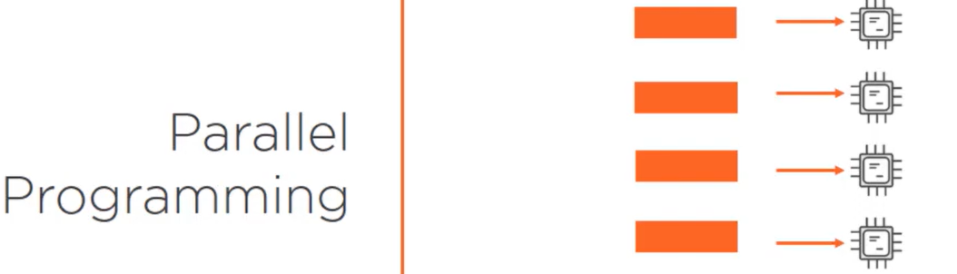

1. Asynchronous Programming

* Not truly parallelism (**may or may not be parallel execution**), this works on the concept of context switching which gives you the appearance that things are working simultaneously but may or may not be in reality.
* Beware that multiple threads on a multi core machine can actually run in parallel (**bringing true parallelism**)
* Best suited for IO bound tasks, example – db reads writes, web service calls, copying downloading uploading data

### Concurrency in Python

1. threading

* module introduced in Python 1.5
* create thread objects that are mapped to native OS threads
* this is used for concurrent execution of code (**not parallel execution**)
* CPython has the limitation where threads are limited to executing Python code serially by a mechanism known as Global Interpreter Lock (GIL)
* Hence, here concurrency is limited to what you get when OS switches between threads

1. multiprocessing

* module introduced in Python 2.6
* parallelism (**parallel execution**) that uses sub-processes instead of threads
* it avoids the GIL and allows Python to take advantage of multiple processor cores

1. concurrent.futures

* module introduced in Python 3.2
* provides a common high-level interface for using thread pools or process pools

1. asyncio

* introduced in Python 3.4
* to enable asynchronous programming

## Threading

* thread is the smallest sequence of instructions that can be managed by operating system
* multiple threads can run in parallel if there are multiple cores available
* in case of a single core, context switching happens between various threads
* do not spin up very large number of threads (like 100), you won’t get benefits and would run out of memory
* Pattern 1: Thread will be a worker executing the target function (Check function **download_image** in thumbnail_maker.py in code)

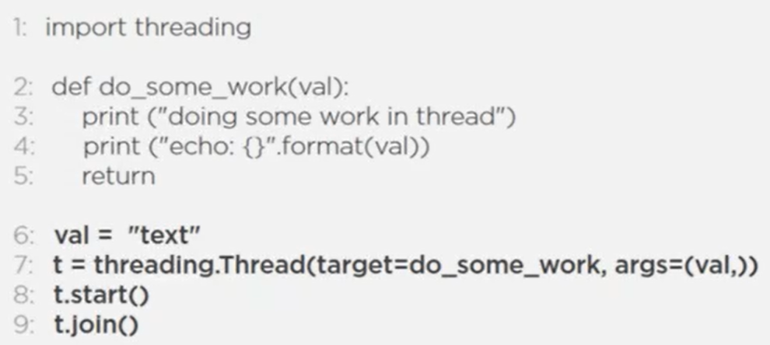

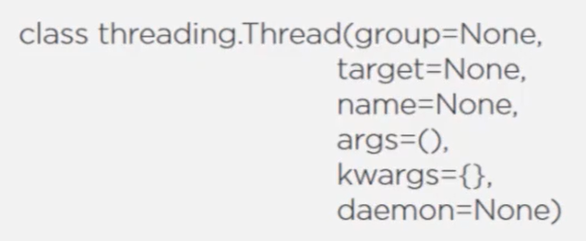

* Pattern 2: Thread as a unit of work

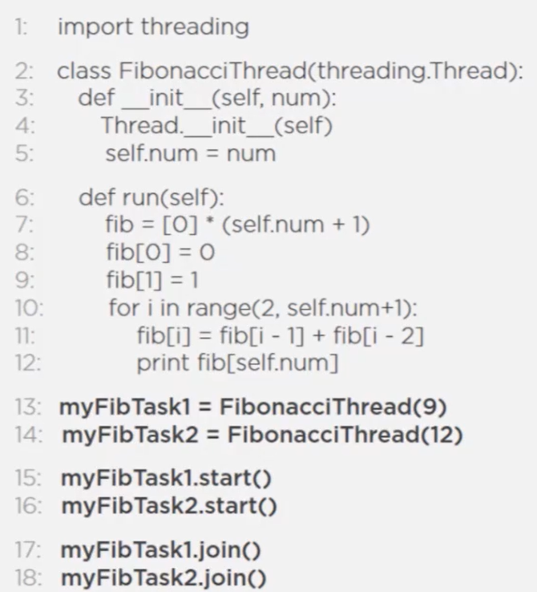

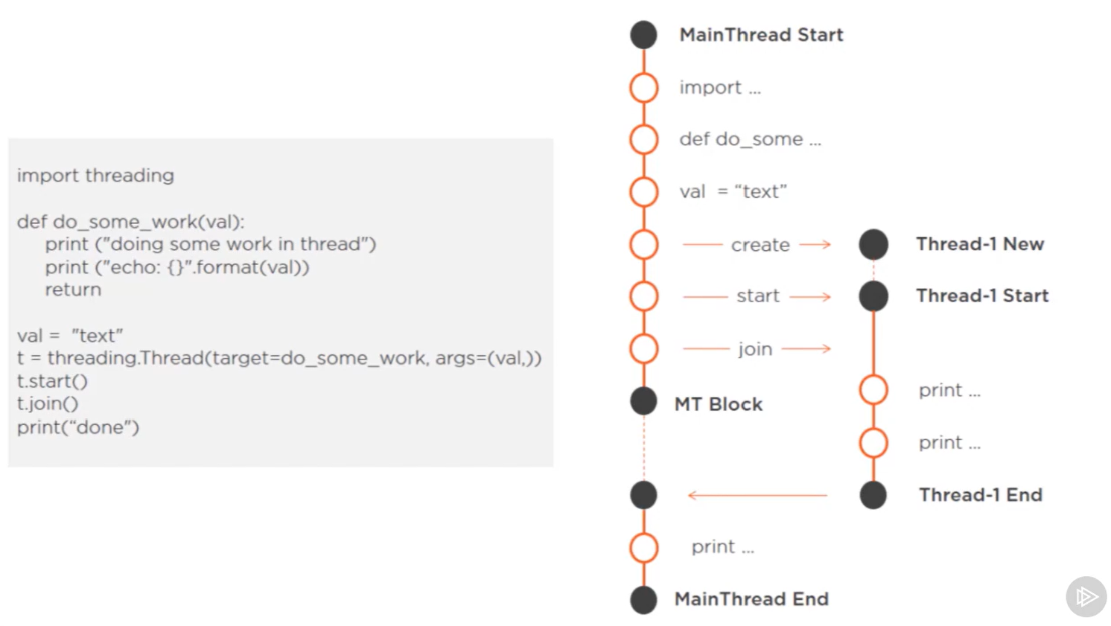

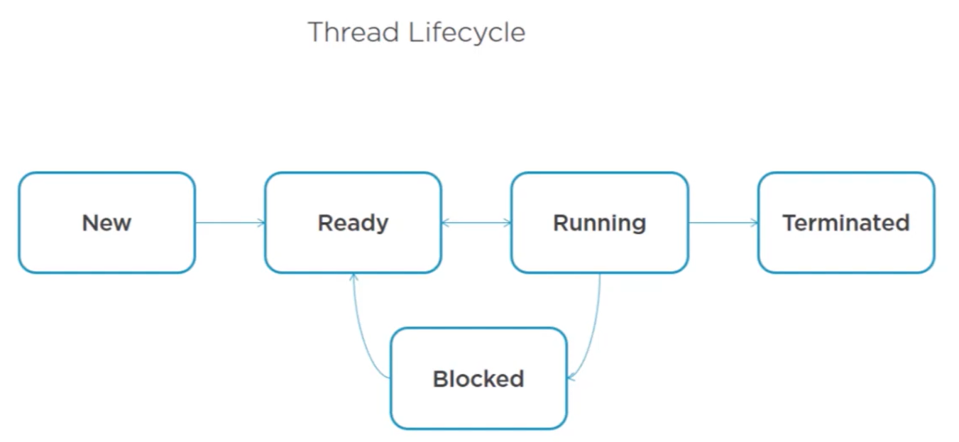

### Issue in threading

Race condition where data gets corrupted:

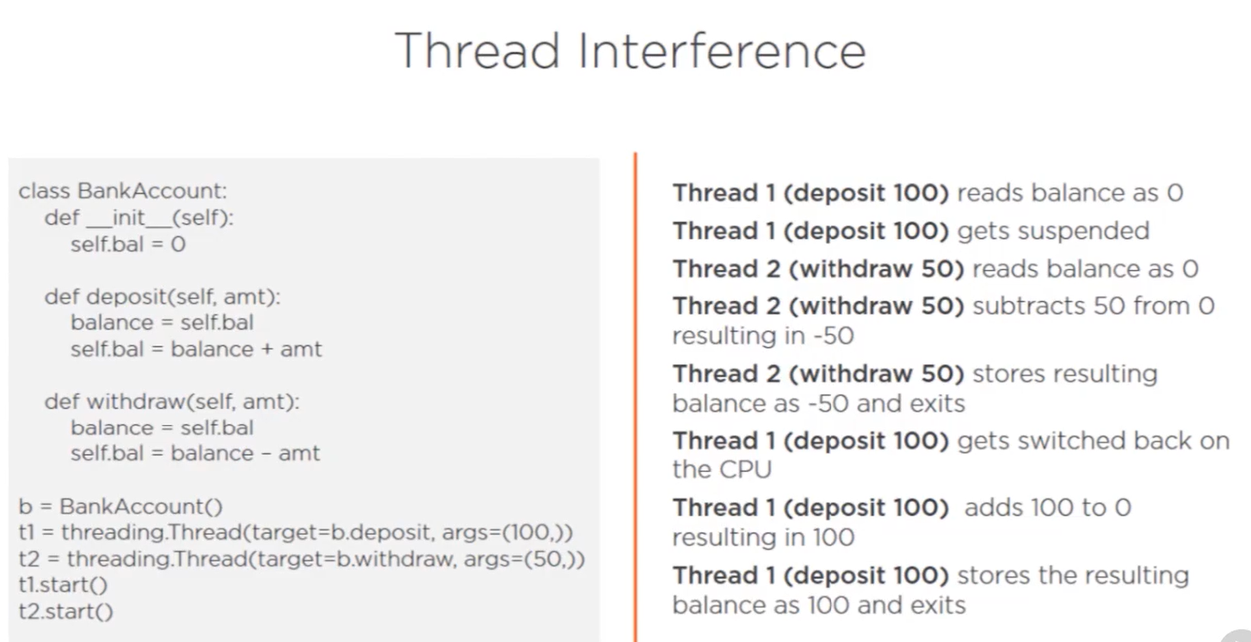

### Thread Synchronization

* The issue of race condition can be solved using thread synchronization.
* Not required for atomic operations.
* Not required if the shared resource is not modified i.e. when there is no write on the shared resource

Following ways to implement thread synchronization:

* threading.Lock
* Check the __init__ function for ThumbnailMakerService class in thumbnail_maker.py in code.

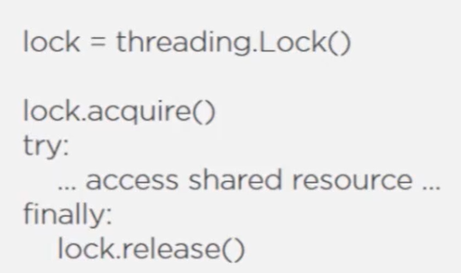

This can be simplified to:

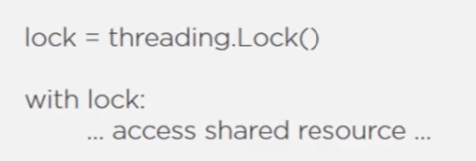

The following code does not block the thread even if lock couldn’t be acquired, this can be handy when you want to execute some code on the thread if the lock couldn’t be acquired.

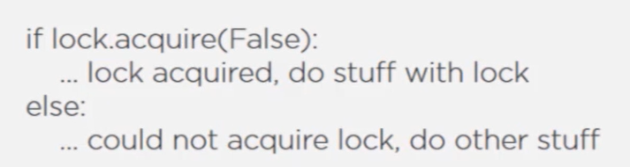

Another way to do the same thing, but not very good:

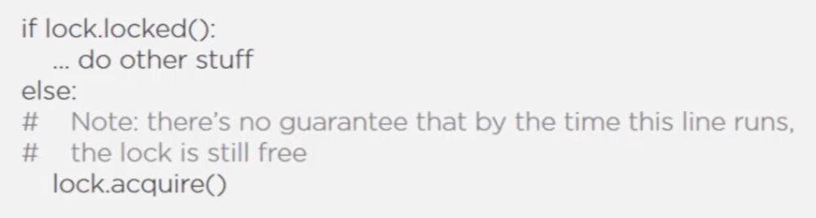

* threading.RLock
* RLock stands for re-entry lock
* With regular lock, lock can be acquired only once, even by the same thread. If a thread tried to acquire a lock that it already owns, it will block.
* The RLock fixes this by allowing a thread to acquire a lock it already holds. If a thread tried to do so, it would just continue.
* threading.Sempahore
* can allow one or more threads to run a critical section at the same time, lock allows only one thread
* counter can’t go below zero and above the supplied max value when initializing, defaults to one if not supplied
* **this can also be useful when you want to limit the number of threads to execute at the same time**, for example – a site has limit of downloading not more than 4 pictures at a time. So use semaphores to limit the number of threads that can execute the logic of downloading at the same time.

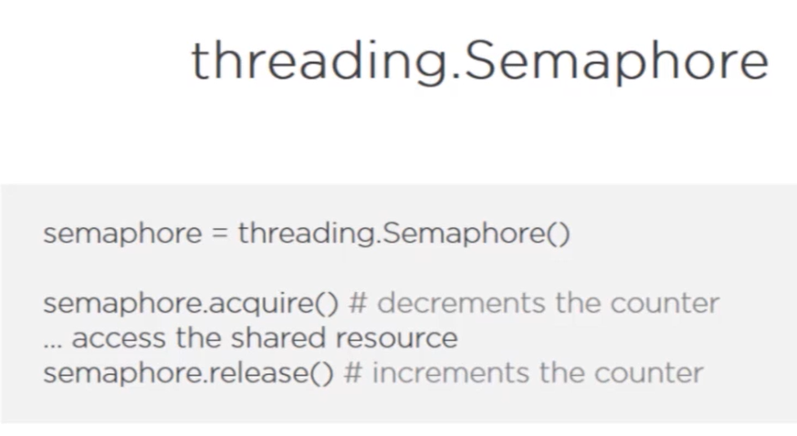

* BoundedSemaphore prevents from releasing unlimited number of times, if try to release more number of times than acquire, an error will be thrown which does not happen with normal semaphore

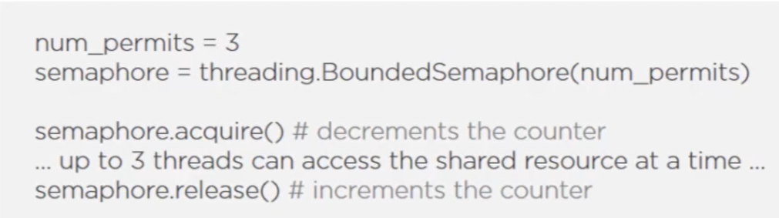

* with statement can be used to simplify
* threading.Event

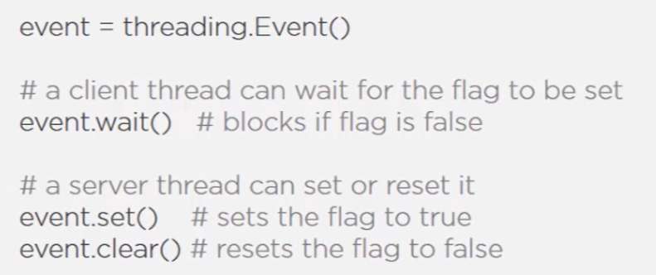

* threading.Condition
* combines the properties of lock and event

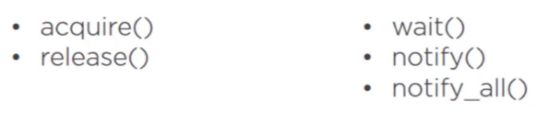

* Producer Consumer implemented using Condition:

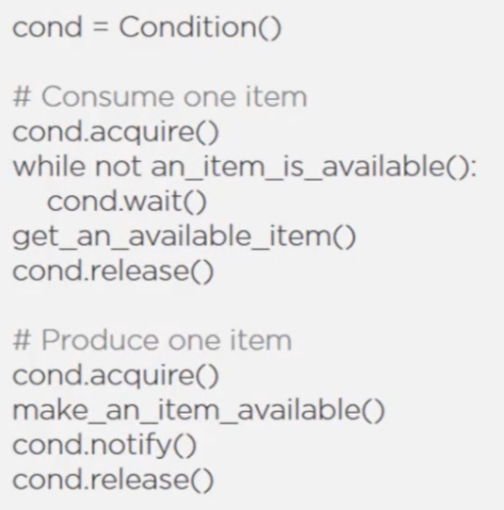

* **Inter-thread communication using Queues**
* Best way
* Makes it easier to exchange messages between multiple threads.
* Queue handles all the locking semantics for us
* Implement producer consumer easily
* Code is clean, less chances of error
* 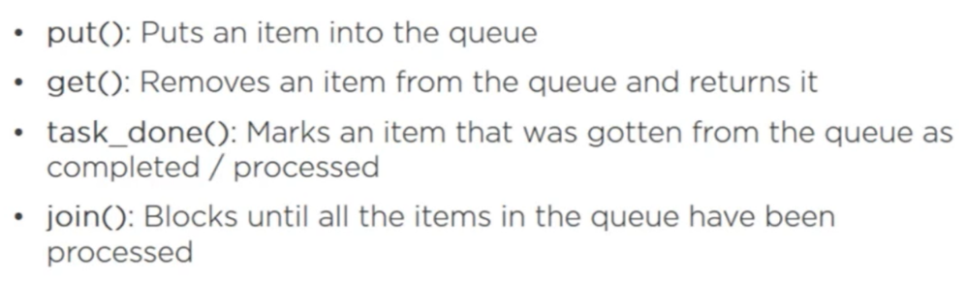
* Check code: thumbnail_maker_queue.py

### Best Practice

* Keep accessing shared memory for multiple threads to a minimum.
* When you have shared resource, use thread synchronization techniques.

### Global Interpreter Lock

* A lock that prevents multiple native threads from executing Python code at the same time.
* What this means is irrespective of the number of processing cores you have, you will only one have one Python thread running at a time.
* Hence, there is **no way to actually achieve parallelism through Python threading**.
* Hence, use Python threading only in cases where you are doing IO-bound operations, context switching will happen giving every thread some time to execute (but only one thread at a time)
* GIL workarounds:
  + GIL-less Python Interpreters like Jython, IronPython
  + Python Multiprocessing

## Multiprocessing

For CPU-bound tasks.

Pros and Cons of using multiprocessing:

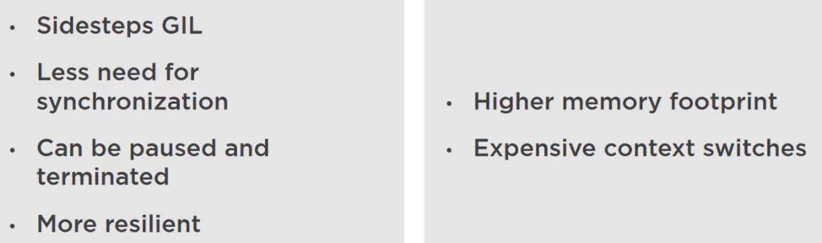

### Multiprocessing API

Very similar to using threading.

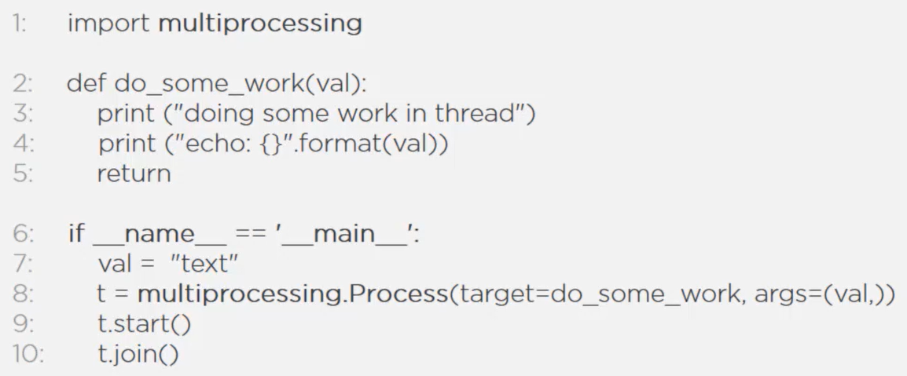

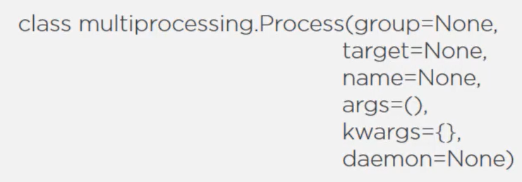

* Dameon process is a child process that does not prevent its parent process from exiting.
* A parent process will never exit until all its non-daemon child processes have exited.
* A daemon process is not allowed to create its own child processes.
* Terminate processes via APIs: is_alive(), terminate()

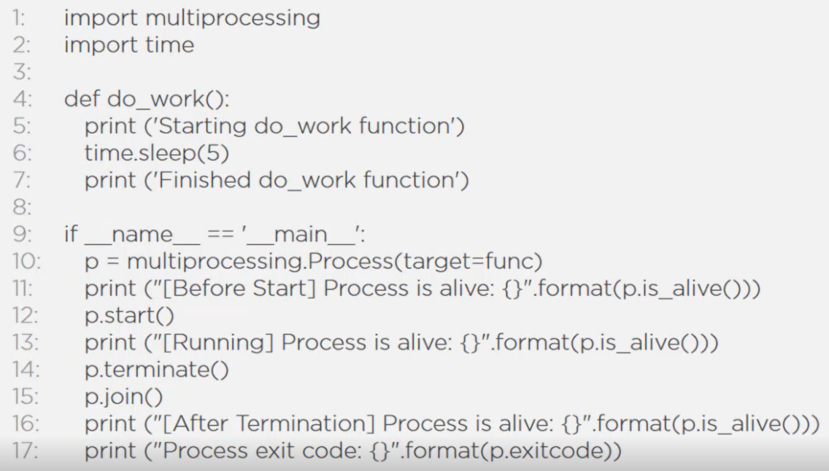

* Process.terminate() should be used carefully, try using the Poison Pill Method (putting None in the shared queue) for killing processes. If there are no shared resources among processes, then Process.terminate() is fine to use.
* Challenges with Process.terminate():

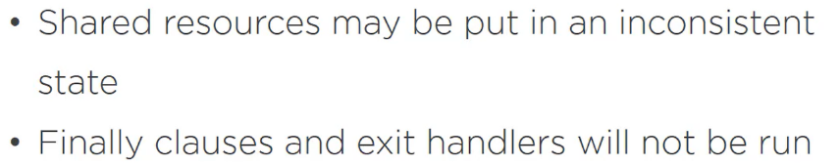

### Process Pool

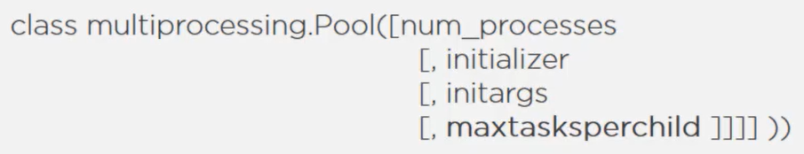

* The initializer parameter accepts a function that will be run by each process at the start.
* The initargs parameter is the tuple accepting args for the initializer function. This need not be pickleable.
* maxtaskperchild parameter means after executing a specified number of tasks, a worker process will be killed and replaced with a new worker process. This ensures that a long-running worker process periodically has to release any system resources it holds.
* Use multiprocessing.Pool.map() to submit task to processes

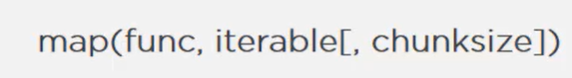

This will map function to each of the item in the iterable. Hence, there will be len(iterable) number of processes.

* Note that map() is a blocking call, and main process will be blocked until all the results become available, a list of result is returned in the same order of iterables.

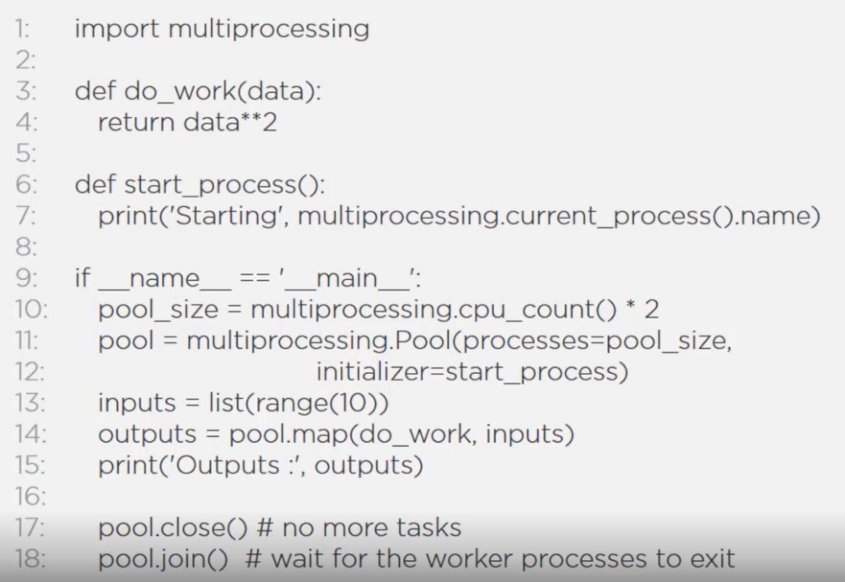

* There is another function map_async() which does not block the main process. It allows to specify an optional callback function which can act on the results of each function call as they become available.

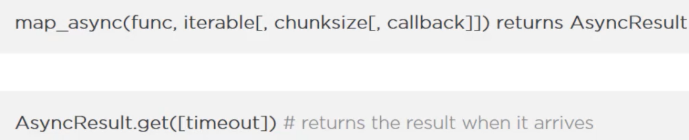

AsyncResult.get() will block until all the results are available.

* map() limits you to apply only a single function on an iterable of arguments. Another function allows you to send any number of different functions and arguments to the process pool.

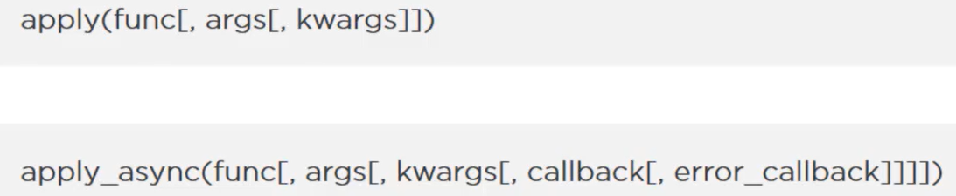

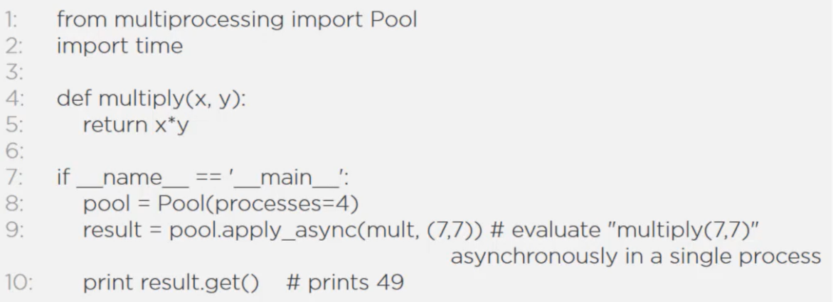

### Inter-process Communication

Processes do not share memory. So, inter-process communication is not as simple as one process writing data to a shared memory and other process reading the data from shared memory in a synchronized manner (this is what happens with thread).

* Pipe

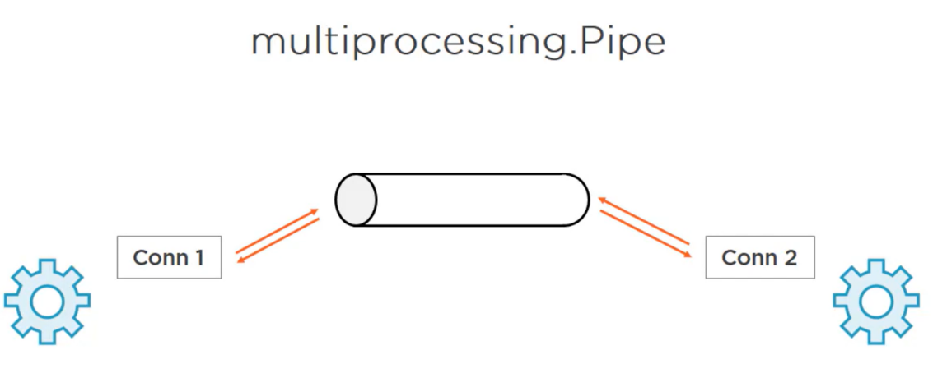

* Does not guarantee data consistency since there are no locking or synchronization techniques implemented.
* Use queue to have data consistency.
* Queue

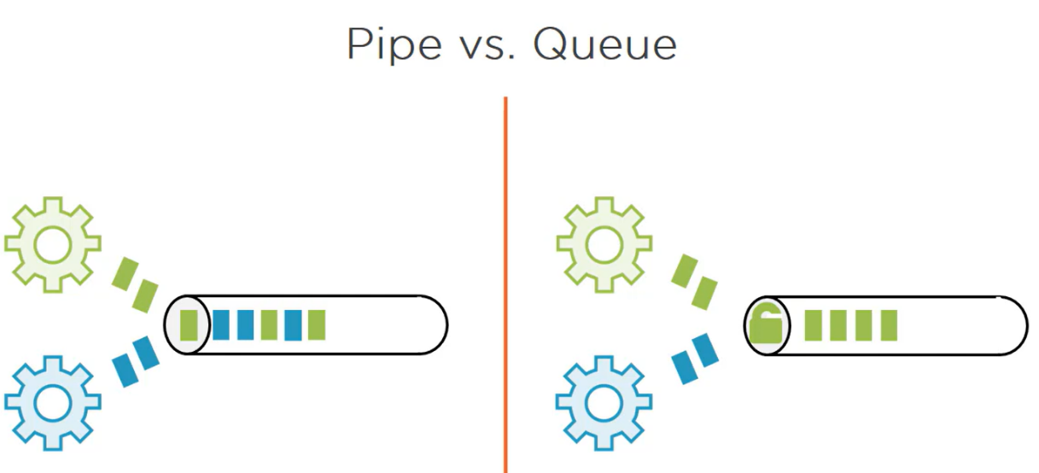

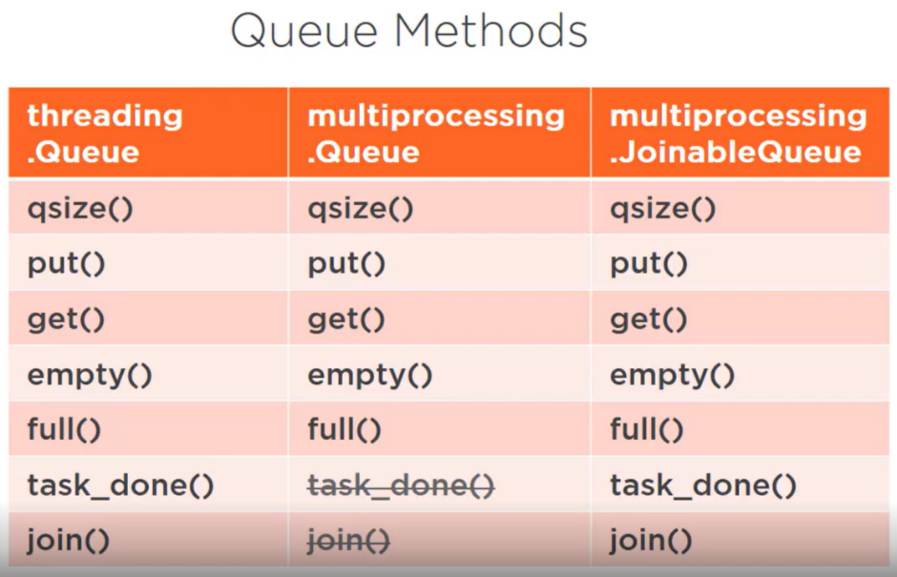

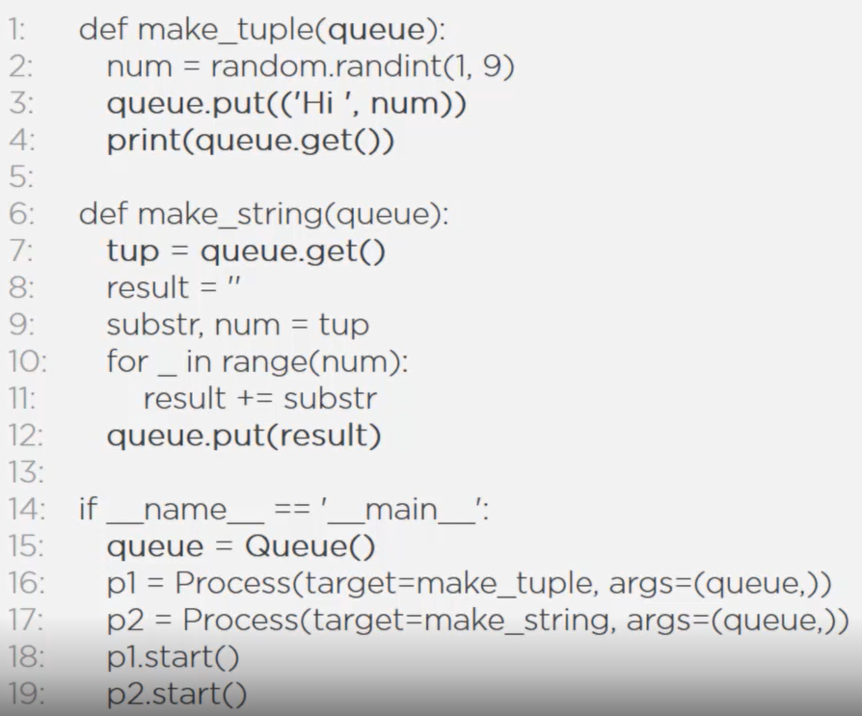

### Sharing state between processes

* It is best to keep shared state between processes to a minimum.
* Queues and other message-passing mechanisms are great way to design systems that minimize or eliminate state sharing.
* But, for some reason if you need shared state between processes, there are two ways to do so:



### Process Synchronization

* Very similar to threading.
* Again, this should not be required often.
* And, remember processes do not share same memory space (but threads in a process does).
* Uses queues or pipes to pass messages between processes if required.

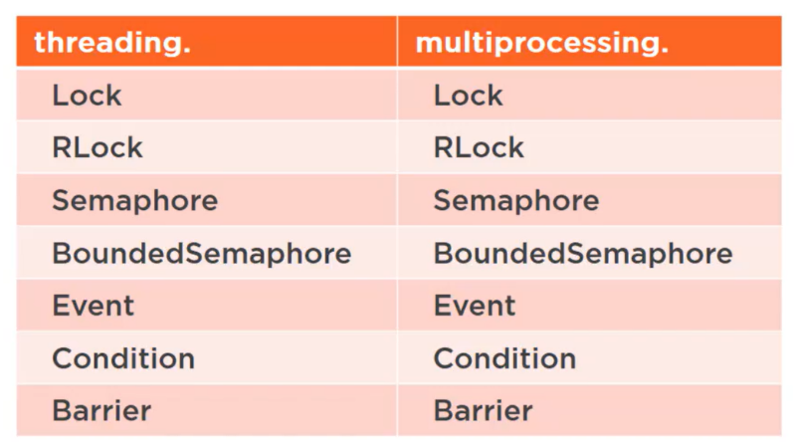

## Abstracting Concurrency

* Two ways of executing code concurrently using threads or processes.
* As a result of the similarities between two, we develop some abstractions that will help us standardize the way we interact with threads or processes and deal with results.
* Executor API from concurrent.future module, exposes three methods: submit, map and shutdown.







* Executor class is an abstract class, so we need to instantiate either of the two sub-classes:

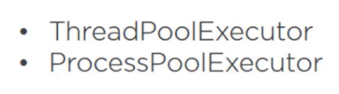

### ThreadPoolExecutor



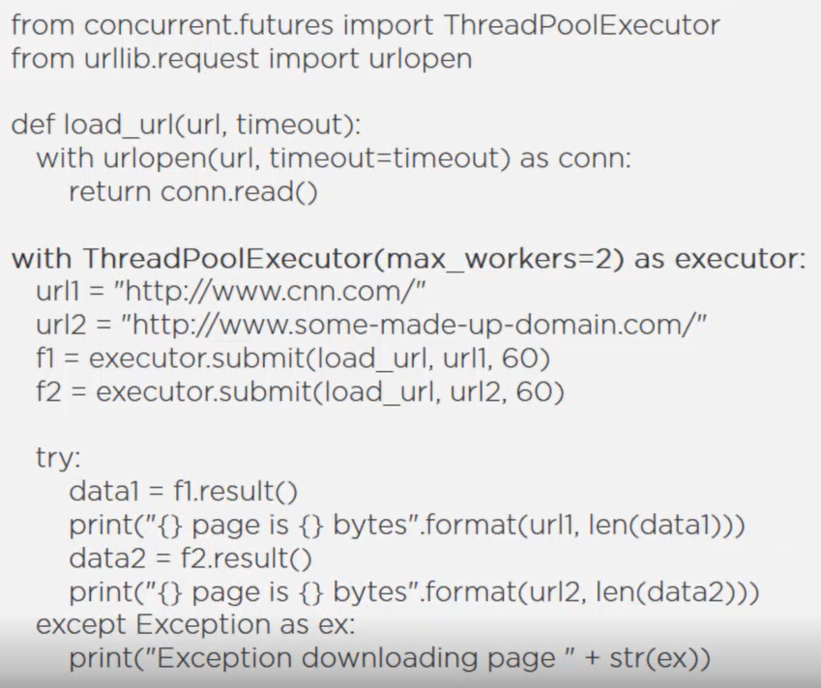

### ProcessPoolExecutor



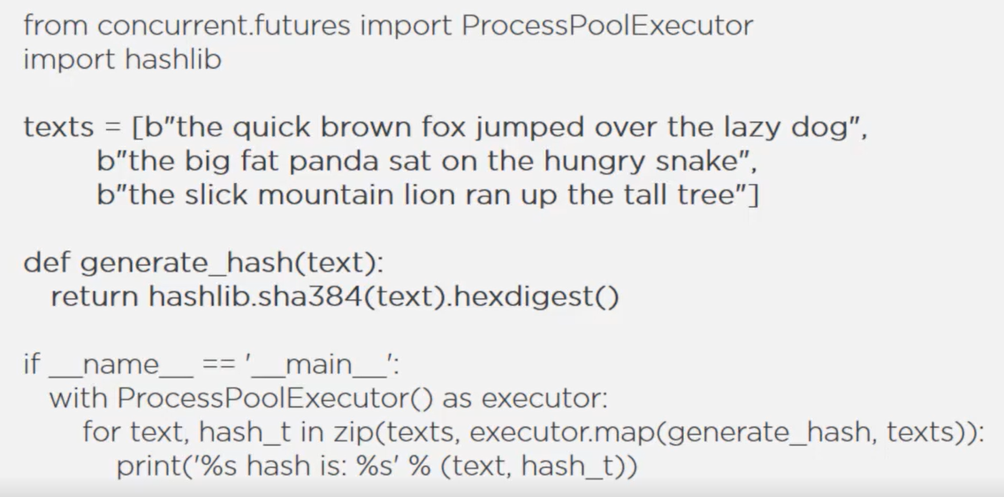

### Future

* Future object is returned by the submit function.
* An object that acts as a proxy for a result that is yet to be computed.
* Future methods:





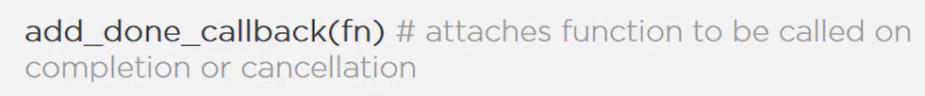

* Module functions:

Wait for all future objects to complete or get canceled



If don’t want to wait for all futures to complete but would rather process results as they complete, then use the following function. Retuns an iterator that yields results as they are completed for futures. 

## Asynchronous Programming (asyncio)

### Single Threaded Asynchrony

* The single-threaded asynchronous model is a concurrency model in which a single thread achieves concurrency by interleaving the execution of multiple tasks.
* Suitable for IO-bound tasks.



* Based on event driven architecture

It is a software design that orchestrates behaviour around the production, detection and consumption of events

* This is better than creating threads as threads consume extra memory plus there is a cost associated with context switching, this becomes very visible when we are working at scale, specially in a backend server serving thousands of requests.
* A more efficient solution is to have one thread handle multiple IO-bound tasks, which is what happens in single treaded asynchrony.
* When the task needs to wait for some IO operation to complete, instead of blocking, the thread suspends the task and moves on to a task that is ready to execute. When the IO gets completed, the thread gets notified, and then it can resume the task that it suspended.
* In order to implement this asyncio model, most languages and frameworks turn to an event loop (responsible for getting items from an event queue and handling it)

### Cooperative Multitasking with Event Loops and Coroutines

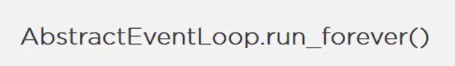

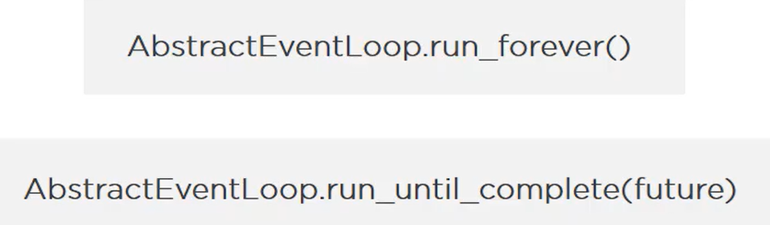

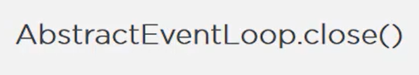

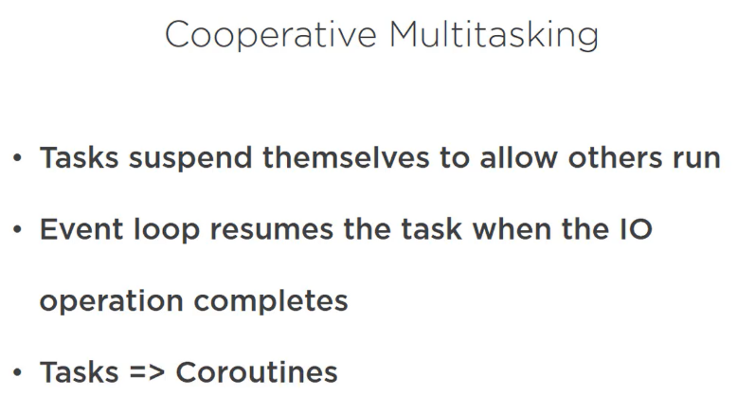

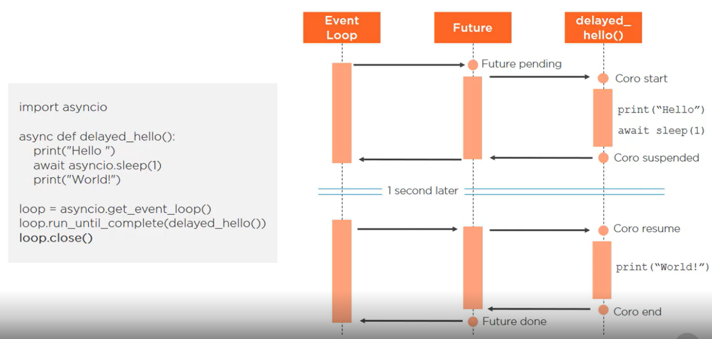

### Asyncio Concepts

* When you have multiple coroutines and you want to wait for all of them to finish

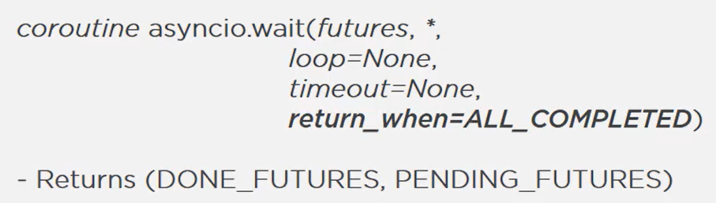

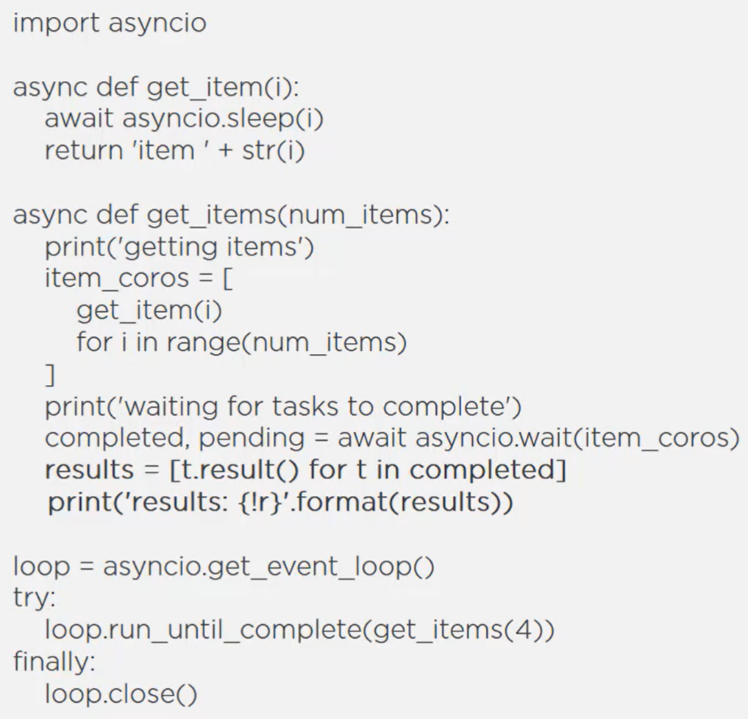

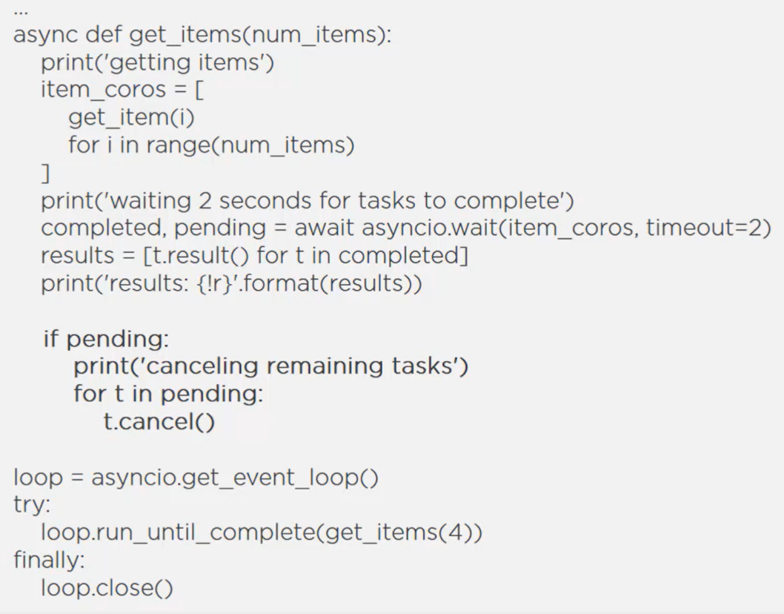

We can use asyncio.wait_for() when we want to wait for a single task to complete.

* Instead of waiting for all the tasks to complete, you want to yield the tasks as they complete:



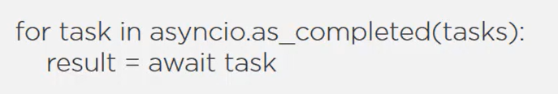

* Instead of returning a collection of futures, the gather method returns a single future that aggregates the result from the past and future. The results are aggregated in order of the original sequence, not necessarily in the order of the results.



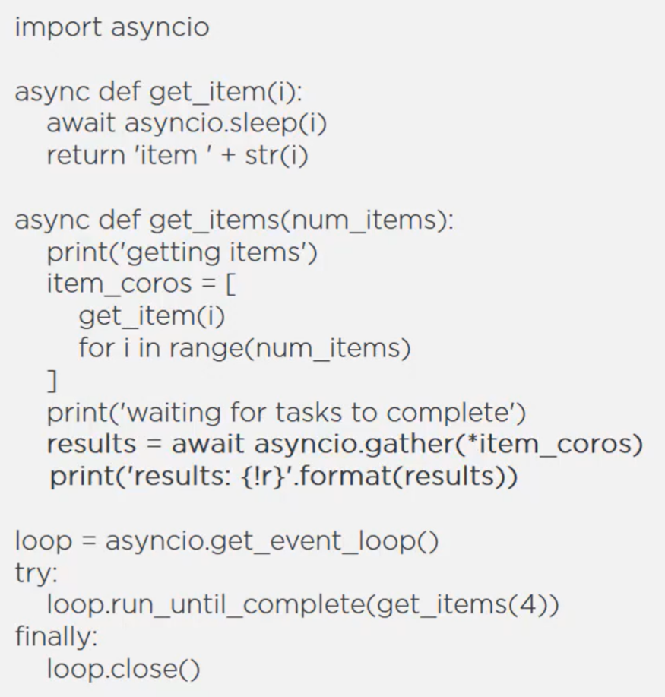

### Asyncio Libraries

* aiohttp

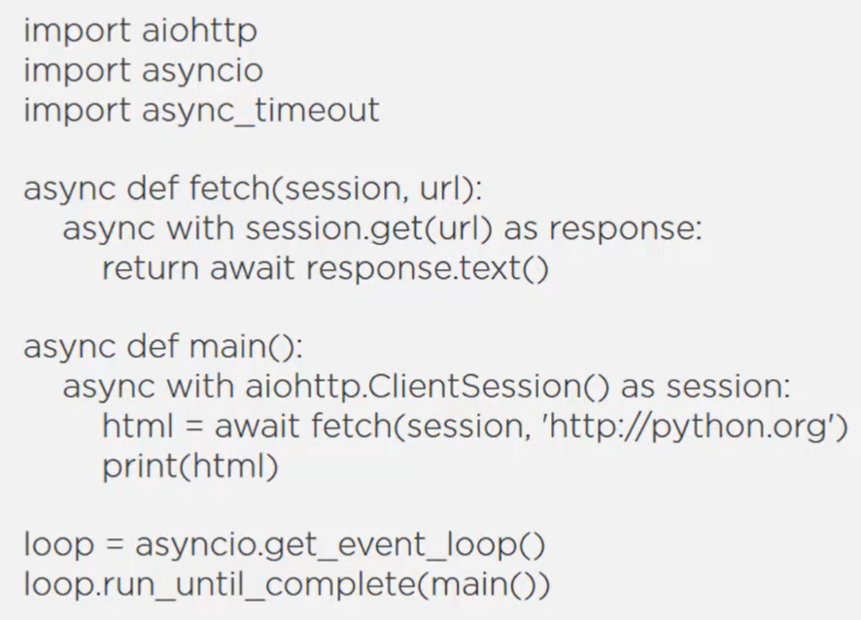

* aiofiles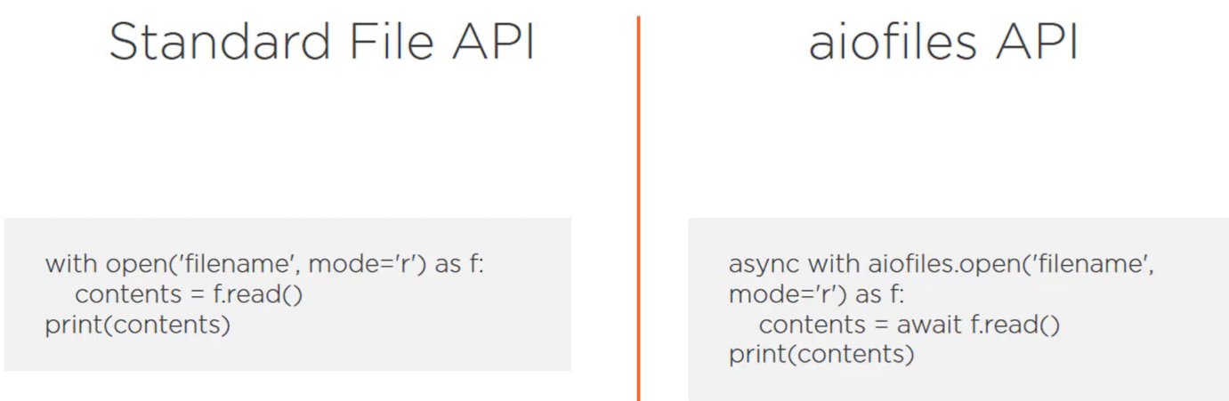

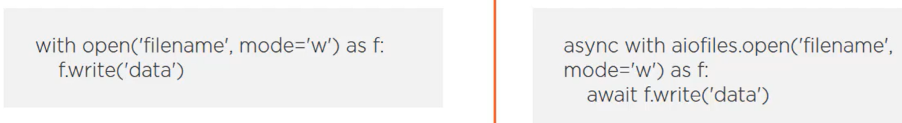

### Combining Coroutines with Threads and Processes

* Blocking in a coroutine function can be very harmful to the system.
* If we need to call a blocking function or library, instead of calling it directly, we should delegate that call to an executor.

